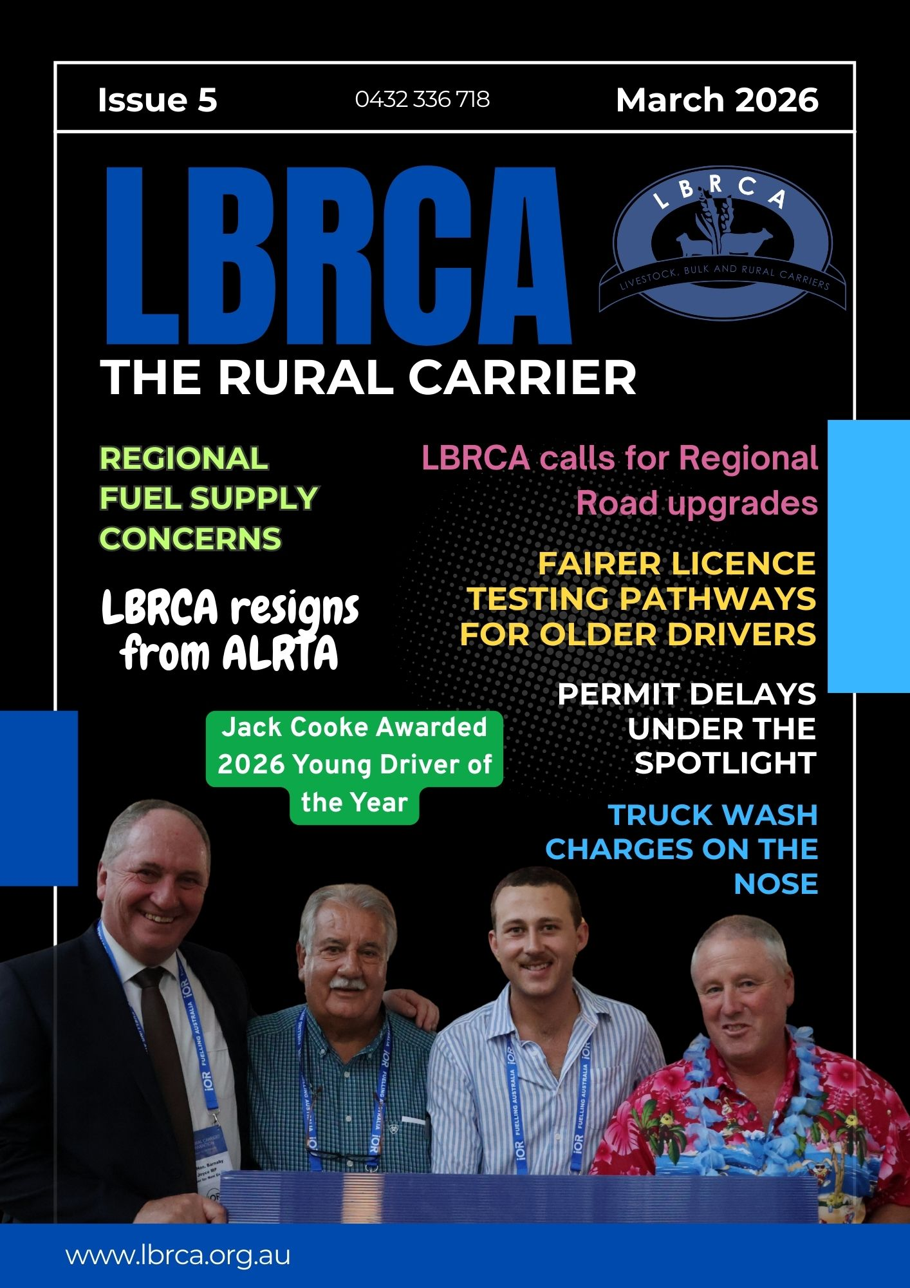
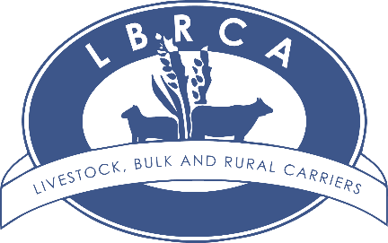
Contents

President’s Update Page 5

Regional fuel supply concerns and implementing a fuel levy Page 10
Government fuel security roundtable Page 14
2026 LBRCA rural carrier’s convention wrap up Page 15
Meet the New 2026 LBRCA Executive Committee Page 25
Fairer Licencing testing pathways for older drivers Page 26
Jack Cooke named 2026 Young Driver of the Year Page 28
ALRTA and LBRCA part ways Page 29
LBRCA calls for review of truck wash charges Page 33
LBRCA welcomes new members Page 35
Avoiding a criminal conviction with a Section 10 Order Page 36
Outstanding Contribution to Industry Award Recipient Page 39
NHVR shuts down non-compliant transport operator Page 41
Exclusive member discount for members with Hubfleet Page 42
Upgrade for Kyeamba Gap Rest Area Page 43
RLX and iOR fuel supply partnership Page 45
New Master Code – What LBRCA members need to know Page 46
LBRCA raises member safety concerns on Kidman Way Page 49
LBRCA raises fuel tax credit issue with the ATO Page 50
Future of Narrabri saleyards under review Page 51
NHVAS is changing – What LBRCA members need to know Page 53
LBRCA raises concerns over heavy vehicle permit delays Page 56
Industry calls for urgent investment to Waterfall Way Page 57
Identifying roads that need reclassification Page 58
CoRLink Animal Welfare Accreditation Page 61
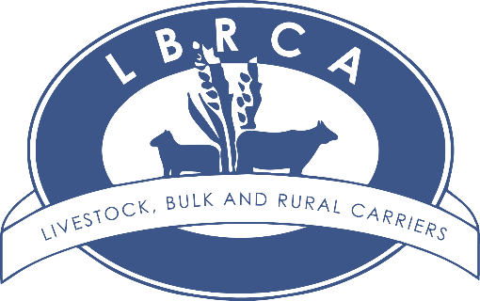
Welcome to Issue 5 of the Rural Carrier


The past month has been a significant period for the Association, highlighted by the 2026 LBRCA Rural Carriers Convention in Coffs Harbour, which brought together more than 260 delegates from across Australia.
The convention once again demonstrated the strength of the rural transport community, with important conversations on safety, productivity, workforce development and the future of freight across regional supply chains.
Advocacy remains at the heart of our work. In this edition you will read about LBRCA’s efforts to address heavy vehicle permit delays, improve driver licensing pathways for experienced operators, and push for safer freight routes across regional NSW. We have also formally raised member concerns about dangerous road infrastructure, including issues on Kidman Way and the ongoing challenges associated with the closure and underinvestment in Waterfall Way.
We also are alerting members to important regulatory updates, including the new NHVR Master Code and the transition from NHVAS to the upcoming Heavy Vehicle Accreditation (HVA) scheme.
Something to celebrate is the people who make our industry strong. We congratulate Jack Cooke, the 2026 LBRCA Young Driver of the Year, recognise Dusty Russell for his outstanding contribution to the transport industry, and warmly welcome several new members who have recently joined the LBRCA community.
Many of the issues raised in this edition began with feedback from members on the ground. Your insight helps ensure the realities faced by rural transport operators are heard by decision-makers and acted upon. Thank you for your continued support of the LBRCA and for the vital role you play in keeping Australia’s rural freight task moving.


Bec Coleman
LBRCA Chief Operating Officer
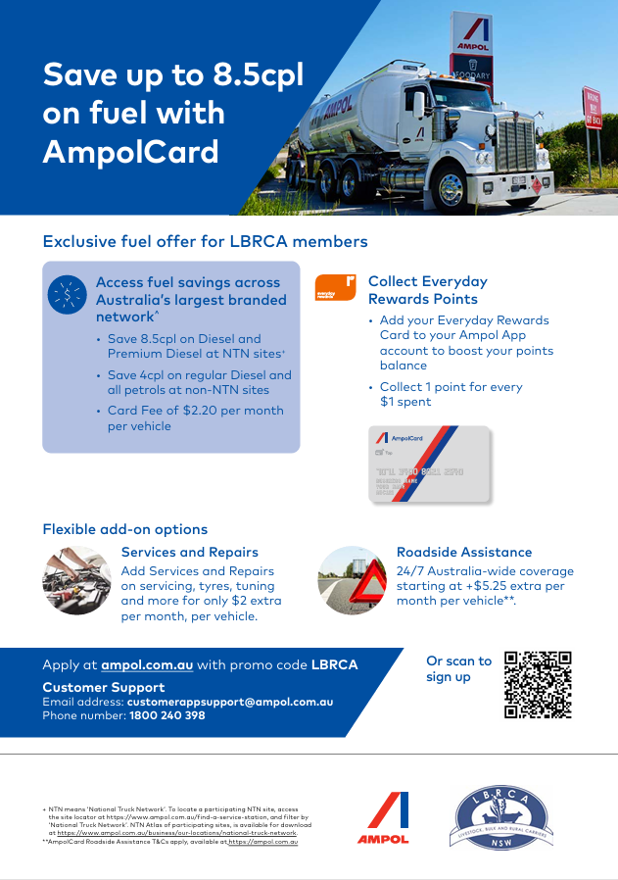

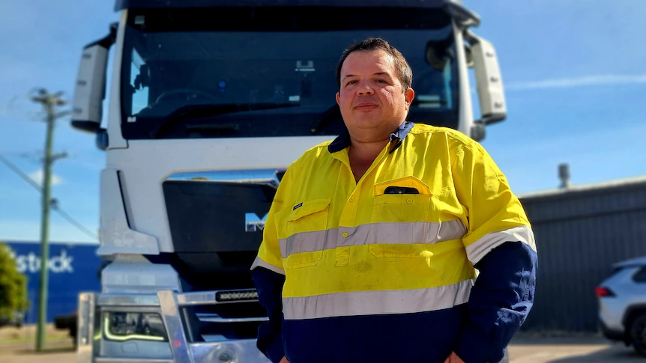
President’s Update – Road maps, not road blocks

By Wade Lewis, LBRCA President
The past few months have been a defining period for the LBRCA. As we move forward following our recent Convention in Coffs Harbour, one theme has become very clear: our focus is firmly on the road ahead.
At our conference I spoke about the idea of “Road Maps, Not Roadblocks.” At this watershed moment for our Association, that message could not be more relevant.
A New Chapter for LBRCA
As members are aware, the LBRCA made the decision earlier this year to resign from the Australian Livestock and Rural Transporters Association (ALRTA).
This was not an easy decision after more than 40 years of shared history. Many dedicated people have volunteered their time, resources and countless hours away from their families and businesses advocating for the betterment of our industry. Those contributions should never be underestimated.
However, leadership sometimes requires difficult decisions.
This was not a knee-jerk reaction or a spur-of-the-moment move. It was a decision that had been building over many years as differences in approach, priorities and representation became increasingly difficult to reconcile.
Throughout this time the LBRCA has remained focused on one simple principle: standing up for rural transport operators.
We represent all rural carrier businesses — livestock, bulk and rural freight — not just one sector of the industry.
And through that approach we have continued to deliver real outcomes for operators across regional Australia.
Leading Reform for Rural Operators
Over recent years LBRCA has led a number of important reforms that continue to deliver tangible benefits for members and the wider industry.
These include:
- Opening thousands of kilometres of road network for higher productivity vehicle access at no cost to members
- Driving Farm Gate Access reform across regional networks
- Leading livestock loading training and safety programs
- Delivering free rollover prevention education for operators
- Working with regulators to improve heavy vehicle access across regional freight corridors
- Developing a modern national animal welfare accreditation framework to replace outdated and ineffective legacy systems
Our voice mattered because it reflected the real challenges faced by operators on the ground.
But as we look forward, the focus is not on the past. The focus is on what comes next.
Road Maps for the Future
The theme of Road Maps, Not Roadblocks reflects the direction the Association will take over the next 12 months. Australia is experiencing a once-in-a-generation shift. Population growth, increased freight demand, changing technologies and new expectations around sustainability are reshaping the transport task.
The question is not whether change is coming.
The question is whether we help design it — or simply react to it.
A road map means clarity. It means planning beyond election cycles and investing in projects that connect regions to cities, producers to ports and communities to opportunity.
But a road map is about more than infrastructure. It is about people. It means:
- Skilled workers who feel valued
- Apprentices who see transport as a career
- Drivers with access to safe rest facilities
- Operators supported by smart regulation, not buried in red tape
Standing Up for Regional Australia
One of the most important parts of this road map is ensuring regional Australia is not left behind. When regional roads fail, freight stops moving. When freight routes fail, small towns suffer.
Many regional councils are under enormous financial pressure. Recent reports have highlighted the challenges faced by rural councils responsible for thousands of kilometres of freight routes with very limited ratepayer bases.
For example, Central Darling Shire, which covers an area roughly the size of Tasmania, maintains around 2,400 kilometres of road with only about 1,800 ratepayers. Situations like this highlight why sustainable funding models for regional freight networks are critical.
Investment in regional infrastructure is not charity — it is economic strategy.
Fuel Security and Regional Supply Chains
Recent global events have once again highlighted the critical importance of secure and reliable fuel supply for Australia’s transport industry — particularly for operators working across rural and regional areas.
The LBRCA has been actively advocating on behalf of members to ensure the challenges facing regional freight operators are clearly understood by government and industry decision-makers.
As part of this work, I participated in the recent NSW Fuel Security Roundtable, hosted by the NSW Minister for Energy, the Hon. Penny Sharpe MLC. The roundtable brought together representatives from key industries and supply chain sectors to discuss fuel supply issues and the impacts on businesses and communities across the state.
Representing LBRCA at the invitation-only meeting, I reinforced the message that while Australia’s overall fuel supply remains stable, regional transport operators can face significant challenges when disruptions occur in the distribution and logistics of diesel, particularly to spot price wholesalers who supply much of regional Australia.
For rural carriers, diesel is not optional — it is the essential input that keeps livestock, grain, groceries and critical supplies moving across regional communities. When distribution constraints occur, the impacts are felt quickly by transport operators and the industries that depend on them.
LBRCA will continue working closely with government and industry to advocate for practical solutions that strengthen fuel distribution networks and ensure reliable diesel supply to regional freight operators.
Protecting resilient fuel supply chains remains a priority for LBRCA as we continue advocating for the rural transport businesses that keep Australia’s regional economy moving.
Celebrating Industry and Community
Our 2026 Rural Carriers Convention in Coffs Harbour was a fantastic opportunity to bring the industry together, with more than 260 delegates attending across the three days.
One of the most inspiring outcomes of the event was the generosity of our members and sponsors, who helped raise $17,100 for the Motor Neurone Disease Foundation — a powerful demonstration of the community spirit that defines this industry.
Supporting the Next Generation
A highlight of the Convention was recognising the next generation of professional drivers.
Congratulations to Jack Cooke from Stocktrans, who was named the 2026 LBRCA Young Driver of the Year. Jack represents the professionalism, safety culture and commitment we want to see continue across the industry.
We also congratulate finalists Jake Wassink of Thompsons Livestock Transport and Duncan Peter of Riordan Grains, both outstanding young operators who reflect the strong future of rural transport.
A Strong Team Moving Forward
I would also like to welcome and congratulate the newly elected LBRCA Executive Committee. Their dedication and leadership will be critical as the Association continues to strengthen its advocacy and representation across the industry.
The LBRCA is also in a strong organisational position.
The Association remains financially secure, supported by a capable secretariat under the leadership of Bec Coleman, and backed by a united membership committed to ensuring the LBRCA remains the peak voice for rural and regional carriers.
Collaboration is the Road Forward
A true road map requires collaboration. Government, operators, engineers, planners and communities must work together — not arguing about yesterday’s problems but designing tomorrow’s solutions.
Because roadblocks do not just slow trucks. They slow ambition. If we choose road maps, we choose safer roads, stronger supply chains, better jobs and more resilient regional communities.
The transport industry has always been about movement. Today we continue that journey together — with purpose, partnership and pride.
The LBRCA will not be the Association that creates roadblocks. We will be the Association that creates road maps — road maps that future generations will thank us for.
Thank you for your continued support.
Wade

Regional Fuel Supply Concerns Risk Disrupting Australia’s Food and Freight Supply Chains
The LBRCA has warned governments that emerging fuel supply constraints in regional and rural Australia could have serious consequences for the nation’s food and freight supply chains.
Feedback from LBRCA members across Australia indicate that access to diesel fuel in regional areas is becoming increasingly difficult, with supply to secondary wholesalers tightening as global oil markets react to escalating tensions in the Middle East.
LBRCA represents the operators responsible for transporting livestock, grain, fertiliser and essential agricultural inputs across regional Australia.
While the focus has largely been on fuel prices, access to supply is the more immediate concern for operators working outside major metropolitan centres.
LBRCA President Wade Lewis said diesel is the lifeblood of the rural freight task.
“Every tonne of food, livestock, grain or fertiliser that moves across regional Australia relies on diesel. Without it, the trucks stop, the harvest stops and the supply chain breaks down,” Wade said.
“Transport operators servicing regional and rural communities depend heavily on secondary fuel wholesalers and regional distributors. If those supply channels tighten, it’s not just transport businesses that are affected – it’s the entire farm-to-fork supply chain.”
Farmers and rural transport operators have reported increasing difficulty securing sufficient diesel supplies as major fuel distributors prioritise their own retail networks and metropolitan markets.
“This is not simply about price volatility,” Mr Lewis said.
“The issue being raised by our regional members is access. When supply to secondary wholesalers is restricted, regional Australia is the first place to feel the impact.”
Rural freight operators are already managing rising operating costs and workforce pressures, and disruptions to diesel supply would place further strain on businesses responsible for keeping Australia’s food supply moving.
“Australia’s freight task doesn’t begin in the cities – it begins on farms and in regional communities,” Wade said.
“Livestock still need to move to saleyards and processors, grain still needs to move to port, and essential inputs still need to reach farms. None of that happens without diesel.”
LBRCA has called on the Australian Government to closely monitor fuel distribution across the wholesale market to ensure regional and rural supply chains are not disadvantaged.
“The priority must be maintaining continuity of supply across the entire national supply chain – not just metropolitan retail networks,” Wade said.
“Regional Australia cannot be left at the back of the queue when it comes to diesel supply.”
LBRCA has called on the Federal Government to maintain reliable diesel supply for rural freight operators during this period of global uncertainty. The issue goes beyond fuel prices at the bowser. Modern fleets also rely on AdBlue, making supply security critical for keeping trucks on the road.
What Members Should Do
- Members are encouraged to review fuel levy arrangements and recovery mechanisms now to ensure freight rates remain sustainable if fuel prices continue to rise.
- Members should also continue focusing on fuel efficiency by reducing idle time, improving route planning and minimising empty running.
- If your business experiences fuel supply disruptions, allocation limits, or AdBlue shortages, please report them to Bec at the LBRCA on 0432 336 718 or bec.coleman@lbrca.org.au so we can continue advocating with strong evidence.

Implementing a Fuel Levy
Fuel is one of the largest and most volatile operating costs for heavy vehicle operators. For businesses operating in the livestock, bulk and rural freight sectors, diesel price fluctuations can have a significant impact on profitability, particularly when freight rates are agreed months in advance.
A fuel levy (or fuel surcharge) is a common and practical mechanism used across the transport industry to manage this volatility. Rather than constantly renegotiating freight rates when diesel prices rise, a fuel levy allows operators to recover increases in fuel costs in a transparent and structured way.
Typically, a transport business sets a base diesel price when calculating its freight rates. When the actual diesel price rises above that base level, a fuel levy percentage is applied to the freight charge to reflect the increase in fuel costs. When prices fall, the levy can also reduce accordingly.
Introducing a fuel levy helps to:
- Protect operators from sudden diesel price increases
- Provide transparency for customers about fuel cost changes
- Maintain sustainable freight rates during periods of fuel volatility
- Support cashflow and business stability

Step 1 | Set a Base Fuel Price  Example: $1.50 per litre
Step 2 | Check the Current Fuel Price  Example: $2.40 per litre
Step 3 | Calculate the Increase  $2.40 - $1.50 = $0.90 increase per litre  $0.90 ÷ $1.50 = 60% increase in fuel cost
Step 4 | Apply the Fuel Levy  Example: Freight Invoice $1,000  Fuel levy applied: 60% x fuel component of freight (e.g. 30% of costs)  $1,000 x 30% = $300 fuel component  $300 x 60% = $180 fuel levy  Total Invoice: Freight $1,000 / Fuel Levy $180 | Total $1,180
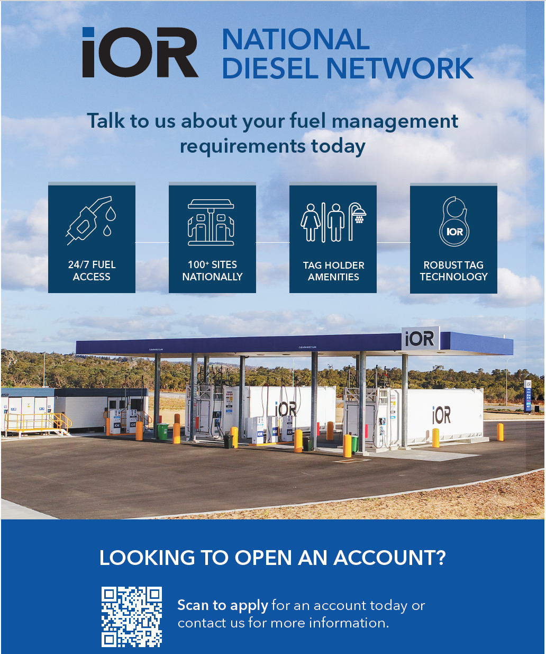
LBRCA participates in NSW Government fuel security roundtable
LBRCA President Wade Lewis participated in a Fuel Security Roundtable to address emerging concerns around fuel supply and price volatility across the state.
Hosted by The Hon. Penny Sharpe MLC, NSW Minister for Climate Change, Energy, Heritage and the Environment, the roundtable was held on Monday 16 March 2026 and brought together representatives from the transport and logistics sector, fuel suppliers, agriculture, mining, local government, unions and consumer protection groups.
The meeting formed part of the NSW Government’s response to global disruptions in fuel markets, which have raised concerns about supply reliability and rising prices—particularly in regional and rural communities.
While the Australian Government has advised that Australia’s overall fuel supply remains secure, authorities are closely monitoring the situation to ensure supply chains remain stable and essential services continue to operate without disruption.
The roundtable provided an opportunity for government agencies and industry leaders to share real-time information on supply conditions and coordinate responses should pressure on fuel markets escalate.
“The discussion confirmed what many operators in regional freight are already seeing on the ground,” Wade said.
“There is fuel coming into the country, but the issue is the logistics of getting diesel distributed through the supply chain, particularly to the spot-price wholesalers who supply much of regional Australia.”
As part of the state’s response, the NSW Government has established an incident monitoring process to track fuel availability across the state, verify reports of shortages directly with service stations and map areas experiencing supply pressures. The Office of Fair Trading will begin an expanded compliance program in the coming week, significantly increasing inspections of service stations to ensure prices reported through the state’s FuelCheck system are accurate and that retailers comply with consumer protection laws.

Strong Turnout at the LBRCA Rural Carriers Convention in Coffs Harbour
The Livestock, Bulk and Rural Carriers Association (LBRCA) brought the rural transport industry together in force at its 2026 Rural Carriers Convention, held in Coffs Harbour from 26–28 February, with more than 260 delegates from across Australia attending the highly anticipated event.
The convention once again proved to be one of the most important gatherings for operators involved in livestock, bulk and rural freight, providing a forum for industry leaders, drivers, suppliers, regulators and stakeholders to discuss the challenges and opportunities facing rural transport.
Industry Engagement and Important Conversations
Across the three-day program, delegates participated in a series of panel discussions, presentations and industry forums covering topics such as:
- Productivity and safety in heavy vehicle transport
- The future of Performance Based Standards (PBS) and high productivity vehicles
- Safety Management Systems and upcoming expectations from regulators
- Workforce development and training for regional transport businesses
- Technology and innovation, including the role of AI in transport operations
The convention provided a valuable opportunity for grassroots operators to share real-world experiences, ensuring that policy discussions remain grounded in the operational realities faced by rural carriers every day.

Special Guest Speaker Barnaby Joyce
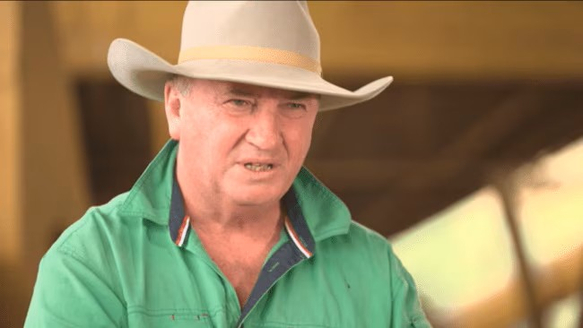
A highlight of the convention was an address by special guest speaker, Federal Member for New England, Barnaby Joyce, who spoke candidly about the growing concerns around diesel supply and energy security.
Mr Joyce warned that global tensions in the Middle East could place pressure on fuel availability in the coming weeks, raising concerns for industries heavily dependent on diesel, including agriculture and freight.
He emphasised that regional Australia relies on diesel to keep food and freight moving, noting that any disruption to supply chains could have significant implications for farmers, transport operators and ultimately the nation’s food security.
His address sparked strong discussion among delegates about the importance of fuel security for rural industries, reinforcing the need for government and industry to work together to protect Australia’s supply chains.
Industry Generosity in the Fight Against MND
While the convention focused heavily on industry issues, it also showcased the strong sense of community within the rural transport sector.
Delegates dug deep into their pockets during the event to support the fight against Motor Neurone Disease (MND), raising an incredible $17,100 through fundraising activities and the industry auction.
The contribution demonstrates the generosity and solidarity of the transport industry, with many operators personally affected by the disease or passionate about supporting the broader community.
A Strong Future for Rural Transport
The LBRCA convention continues to play a critical role in bringing the industry together to share knowledge, strengthen networks and shape the future of rural transport in Australia.
With strong attendance, meaningful discussions and overwhelming support for important causes, the 2026 Coffs Harbour convention once again demonstrated the strength and unity of the rural transport community.
As delegates returned to their businesses across regional Australia, the message was clear: when rural carriers come together, the industry is stronger, safer and better prepared for the challenges ahead.

Exhibition
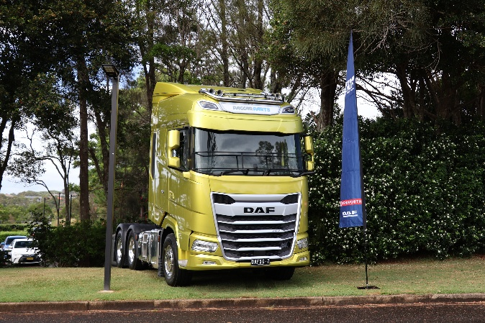
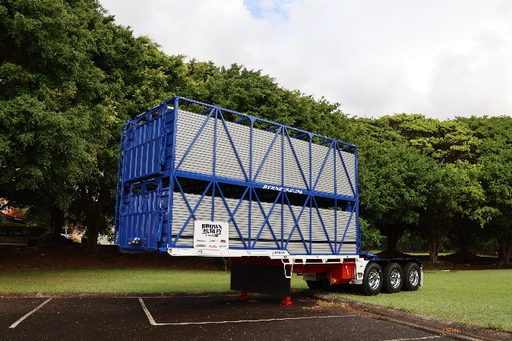
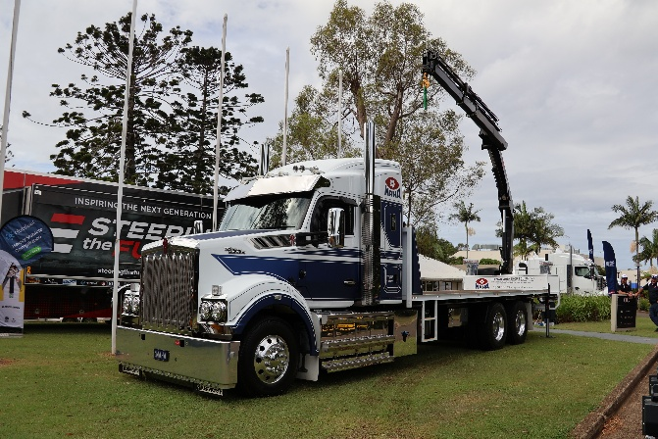
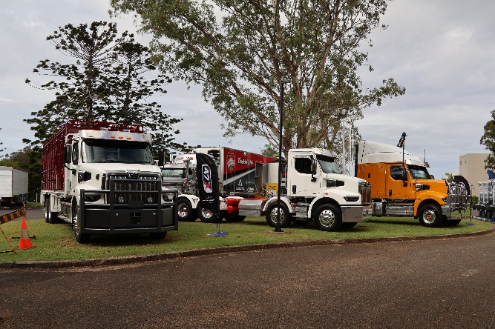
LBRCA Rural Carriers Convention 26-28 February 2026 Coffs Harbour
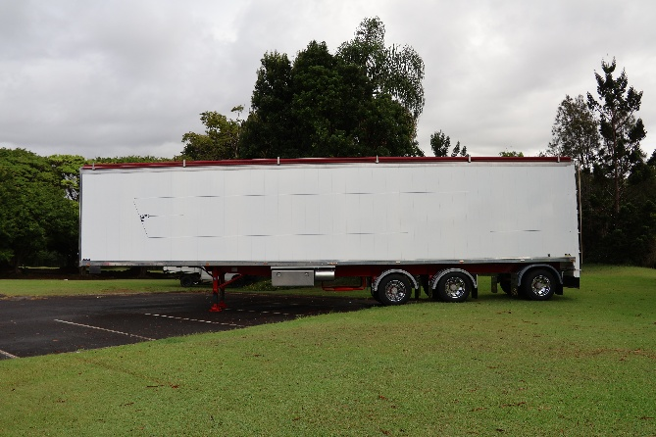
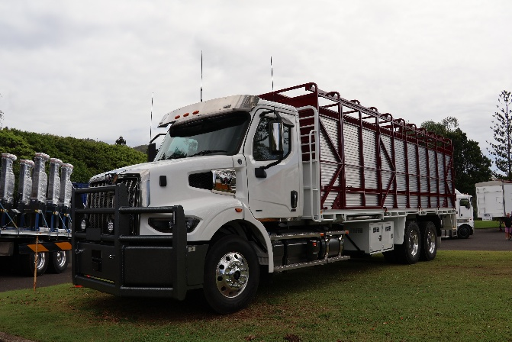
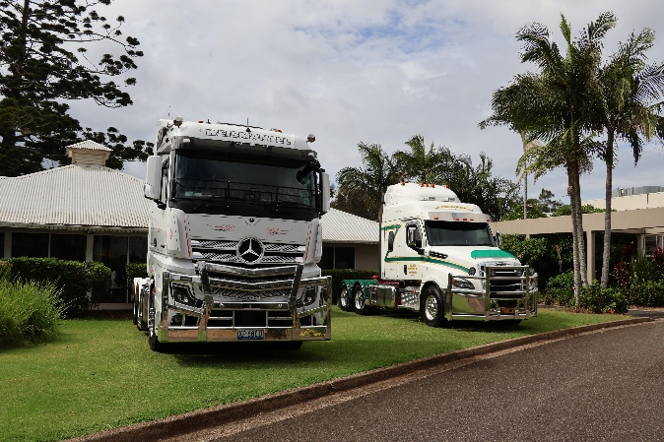
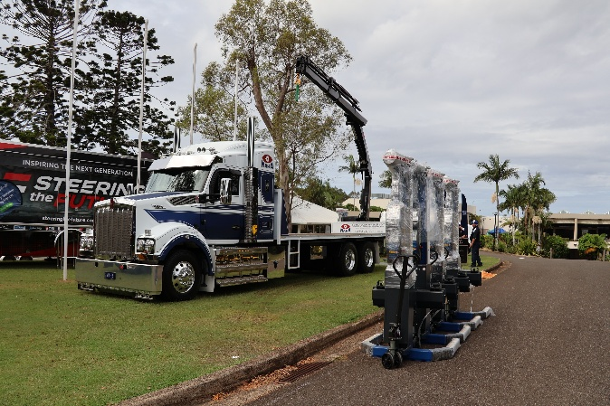
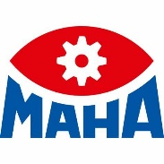
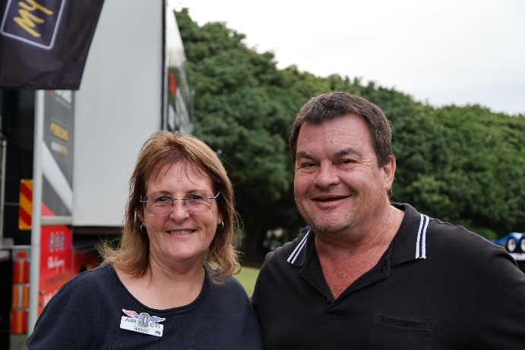
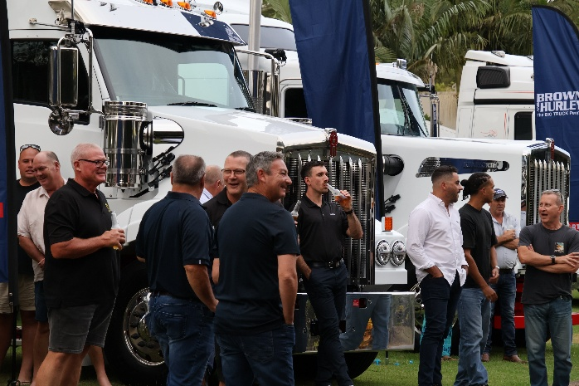
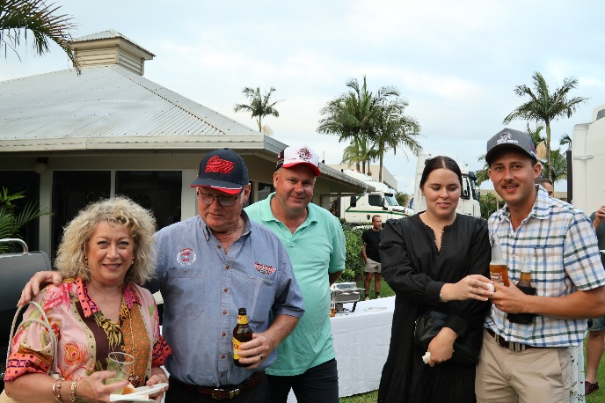
MAHA Australia Thursday Welcome BBQ
LBRCA Rural Carriers Convention 26-28 February 2026 Coffs Harbour
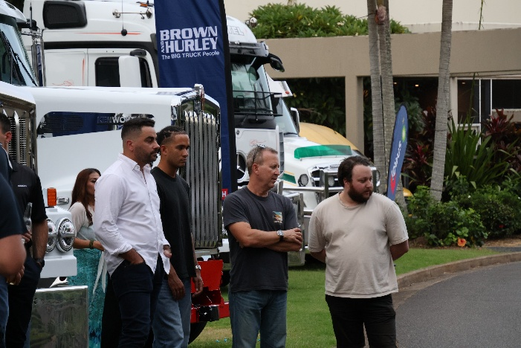
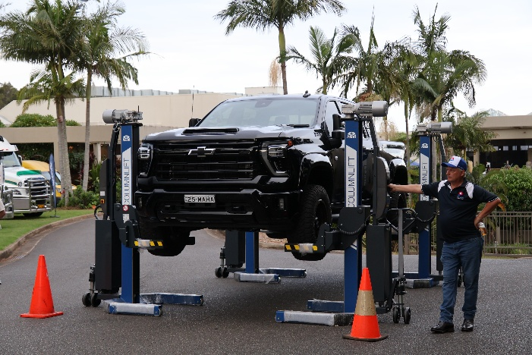
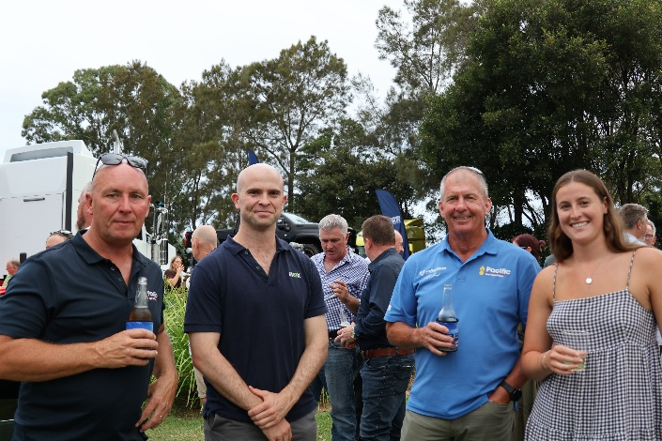
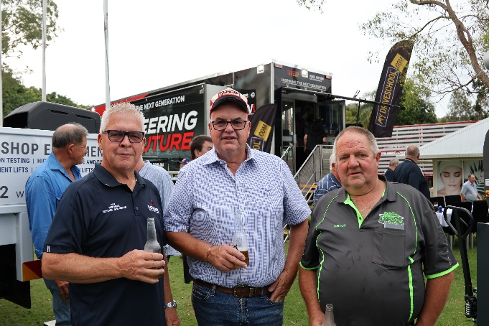
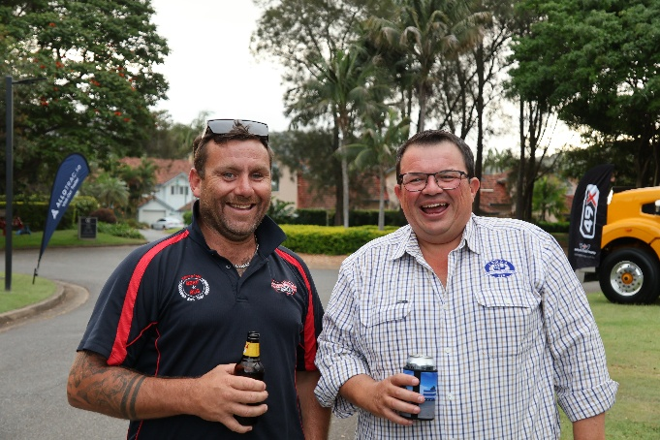

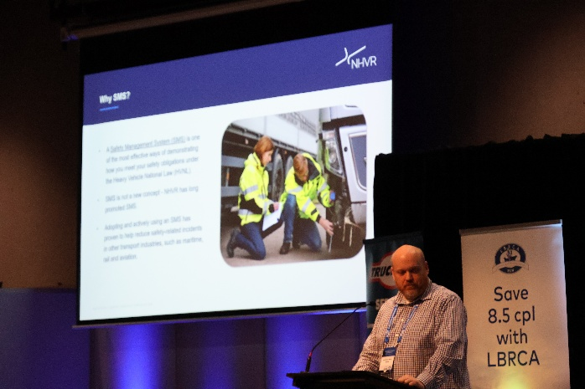
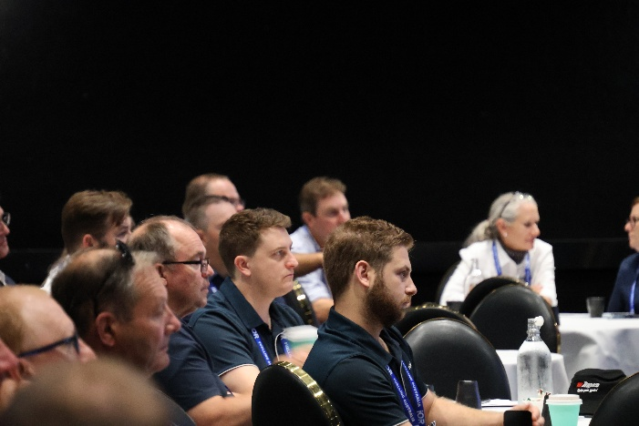
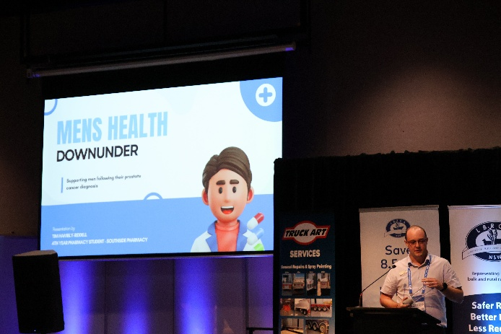
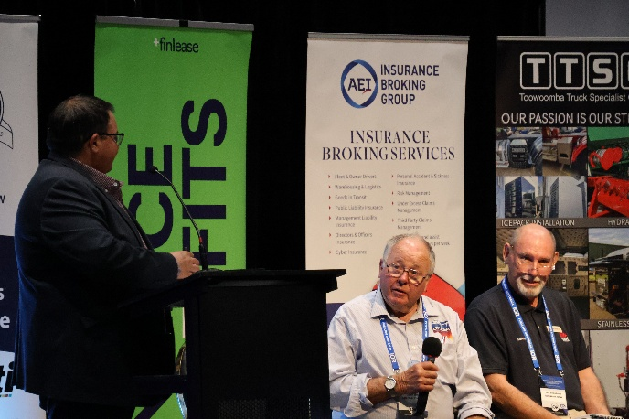

The Program
LBRCA Rural Carriers Convention 26-28 February 2026 Coffs Harbour
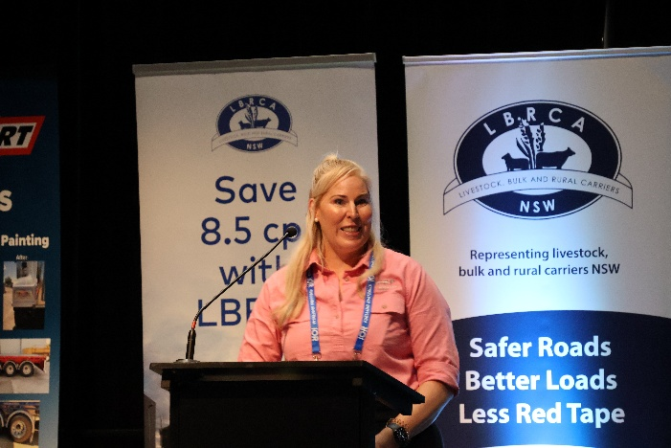
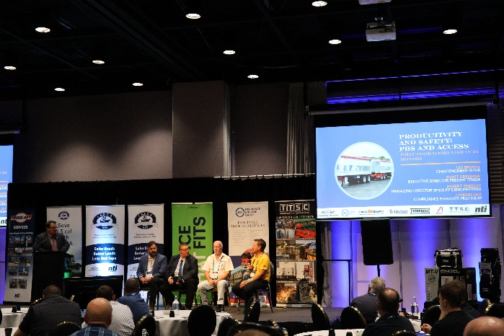
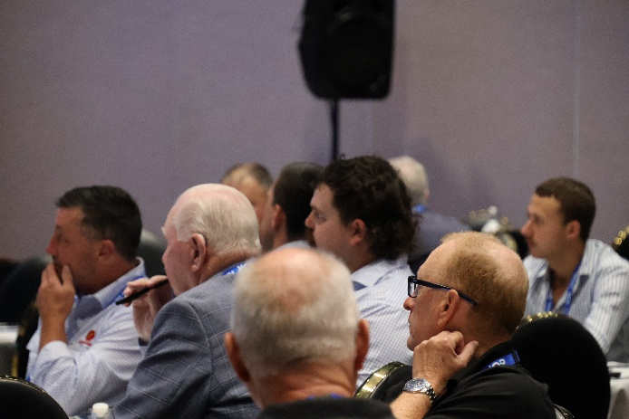

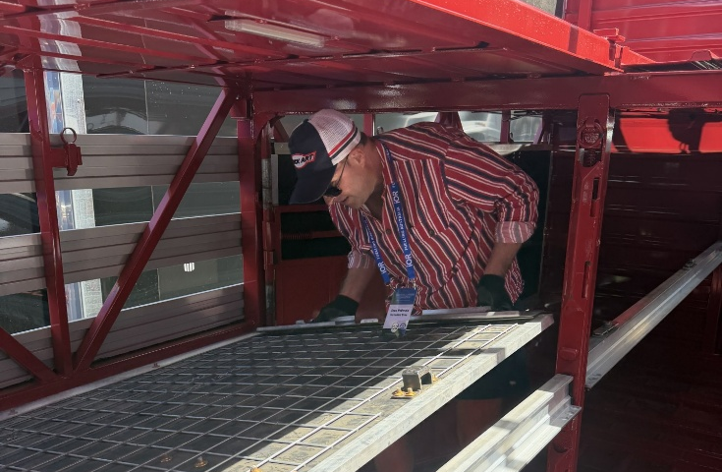
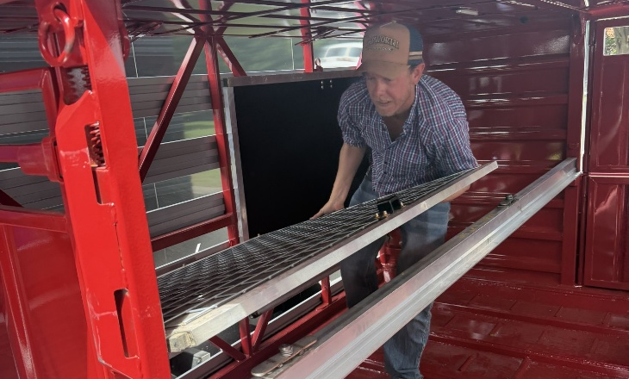

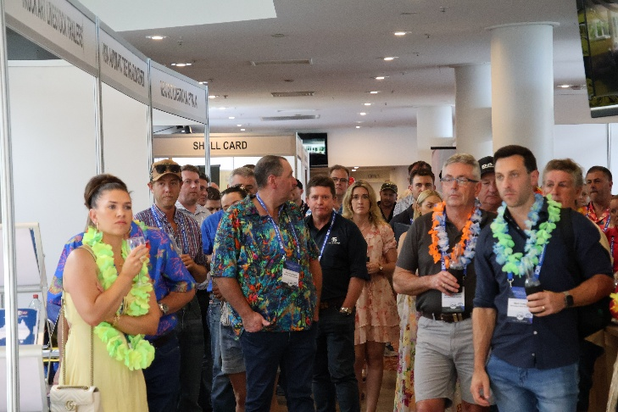
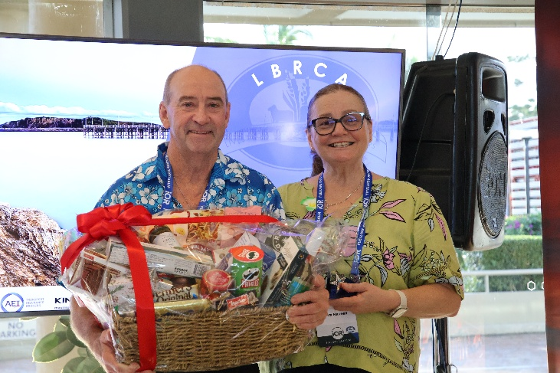
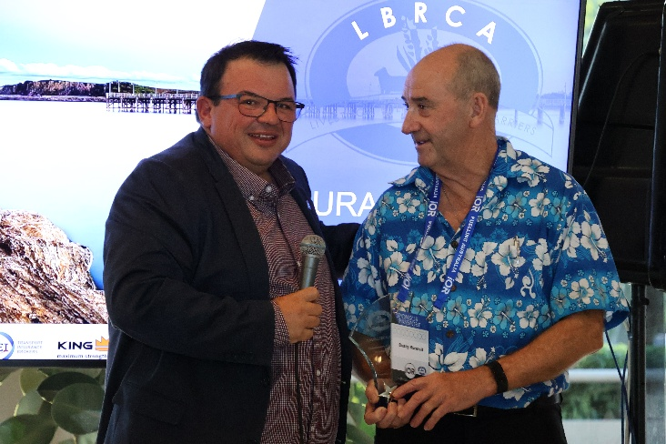
Penske Friday Afternoon Happy Hour
LBRCA Rural Carriers Convention 26-28 February 2026 Coffs Harbour
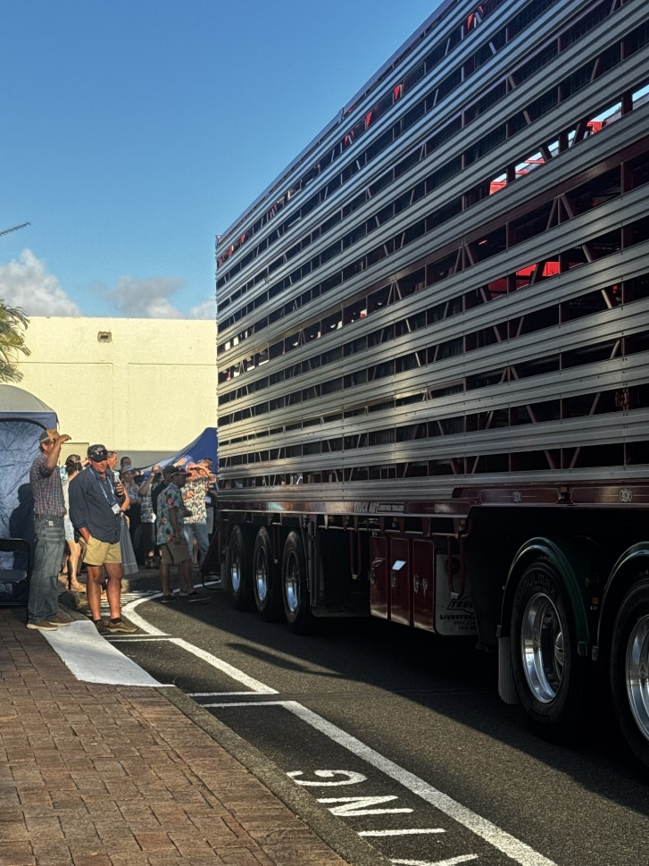
Partners Program
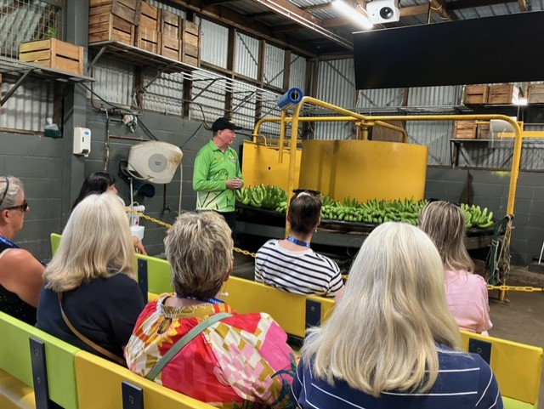
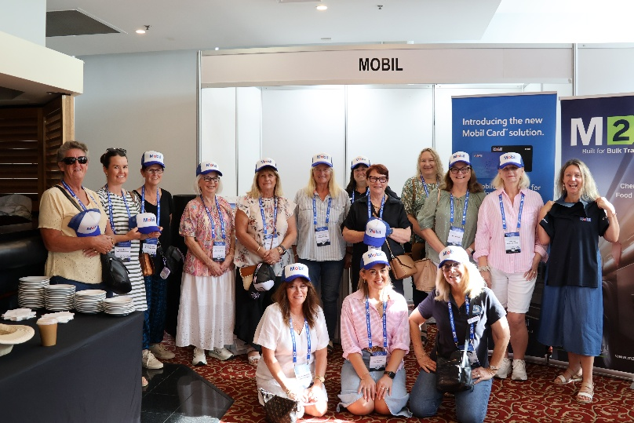
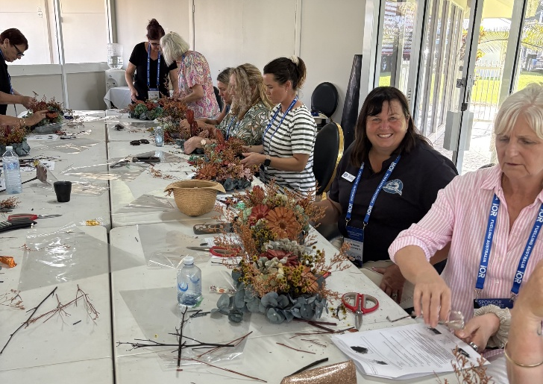
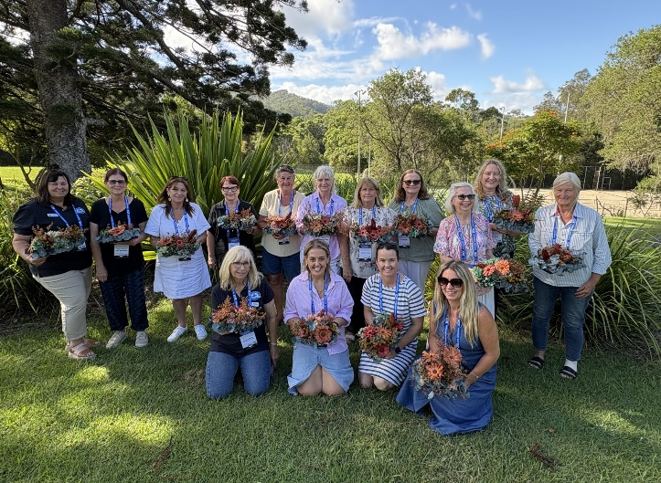
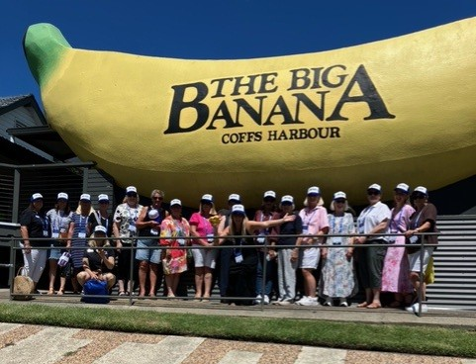
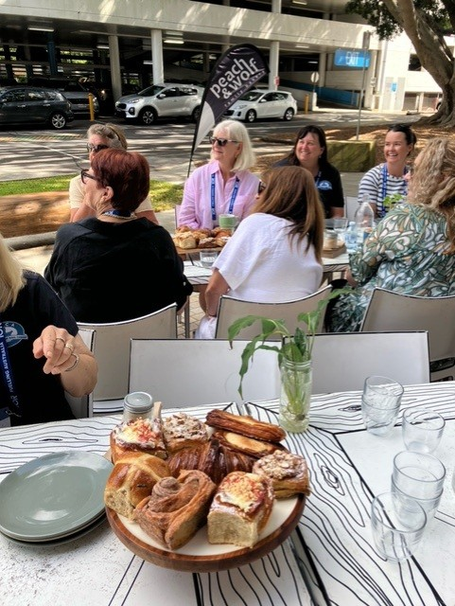
LBRCA Rural Carriers Convention 26-28 February 2026 Coffs Harbour
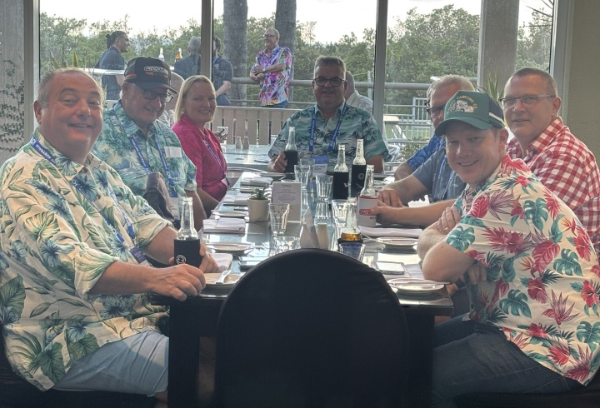
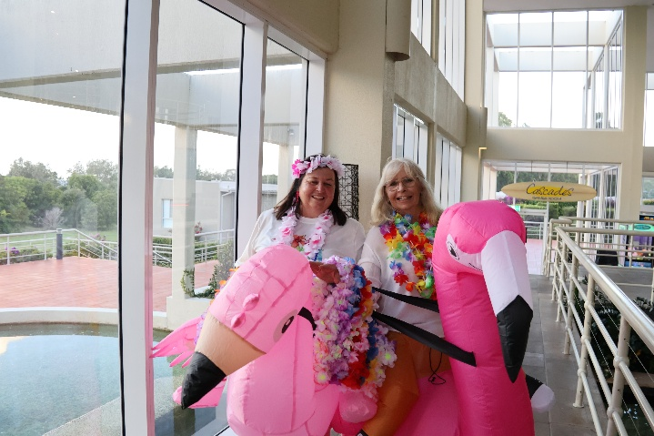
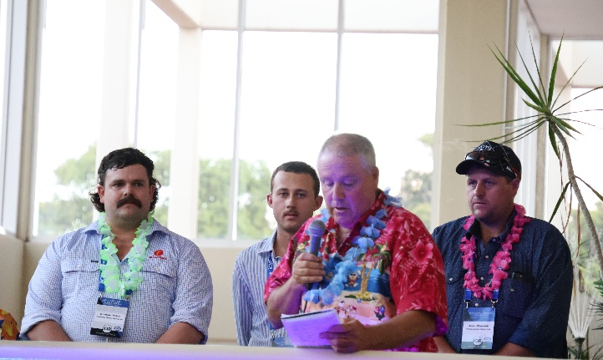

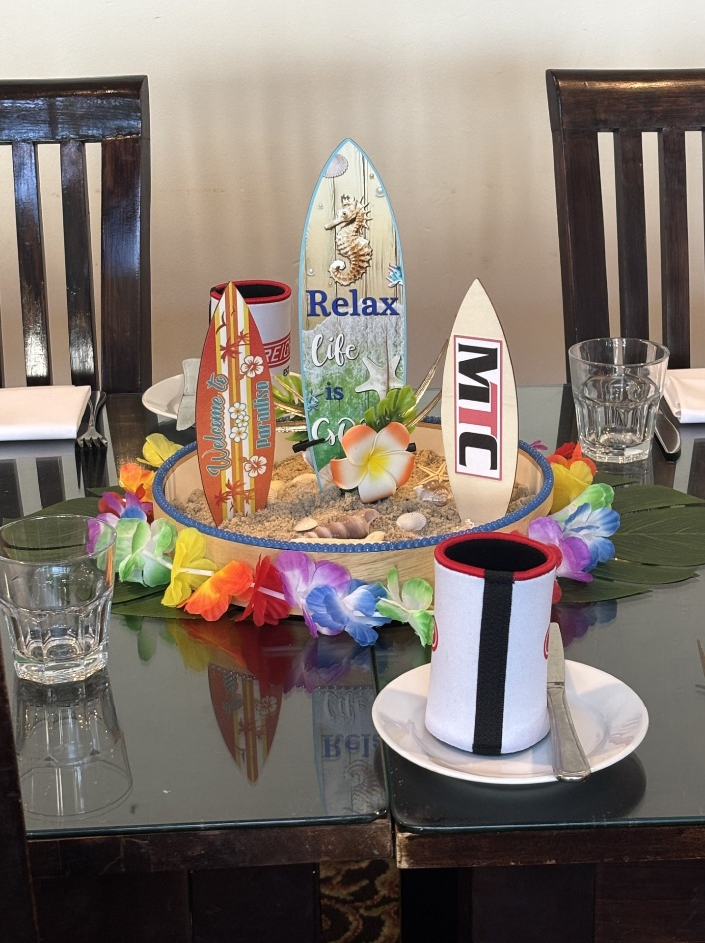
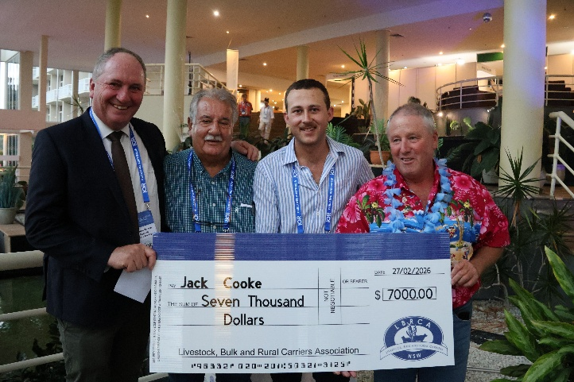
Mavin Truck Centre Friday Night Dinner

LBRCA Rural Carriers Convention 26-28 February 2026 Coffs Harbour

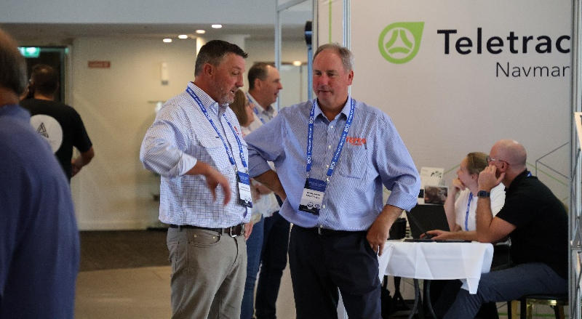
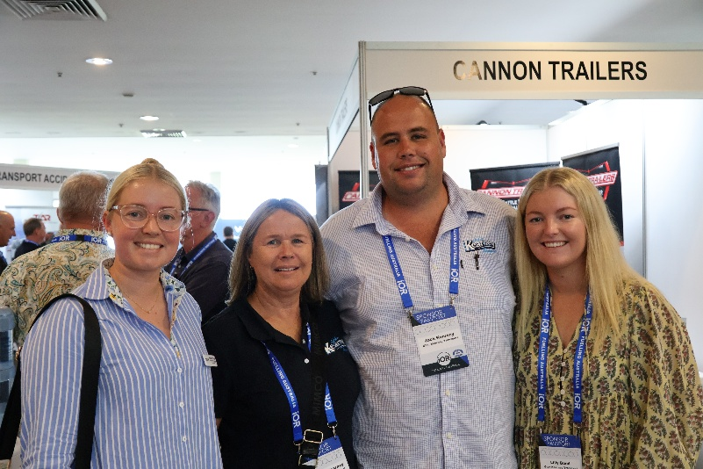
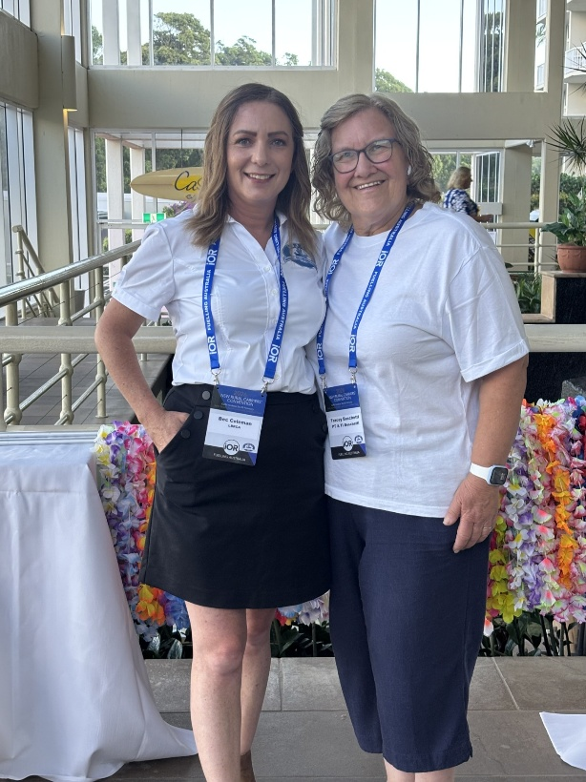
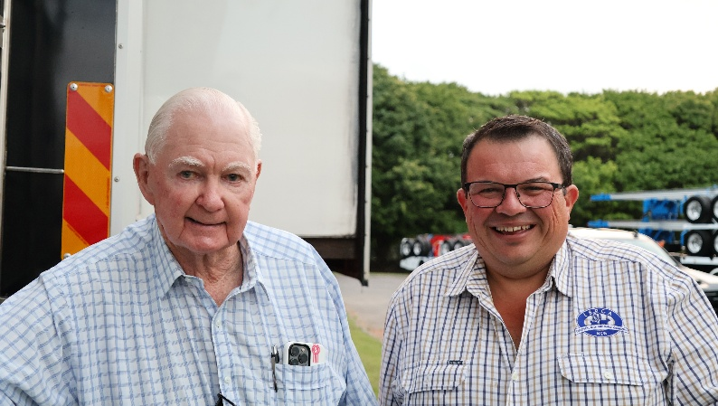
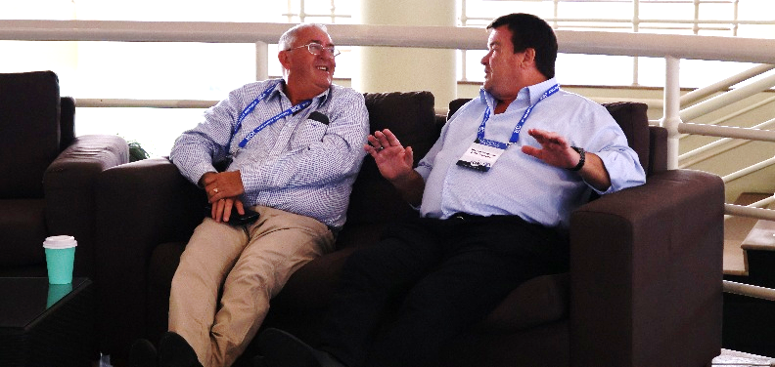
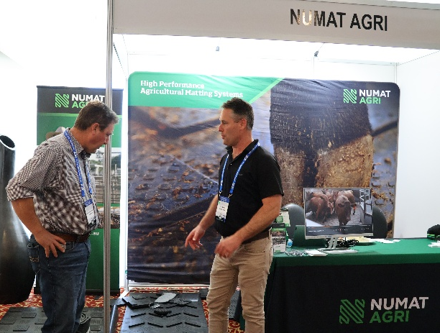
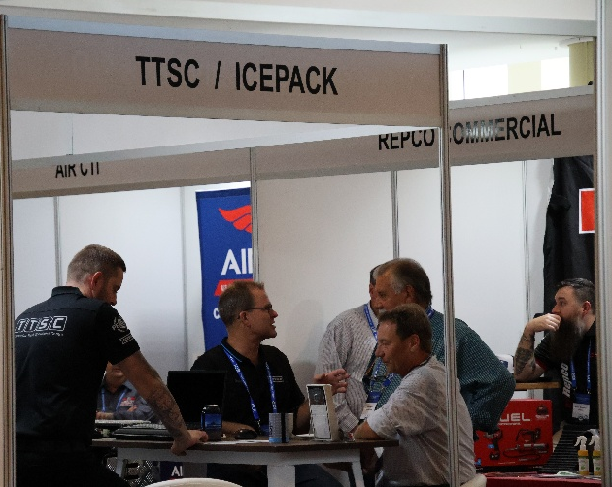
Networking
LBRCA Rural Carriers Convention 26-28 February 2026 Coffs Harbour

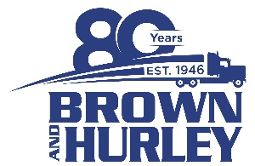
Brown & Hurley Coffs Harbour Gala Dinner and Auction
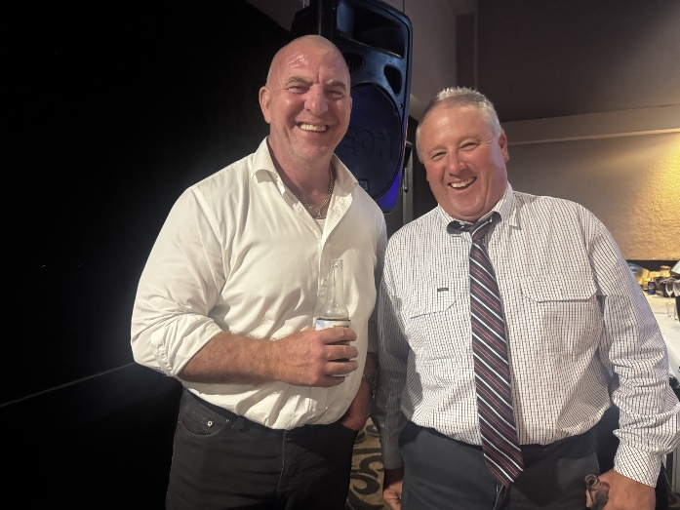
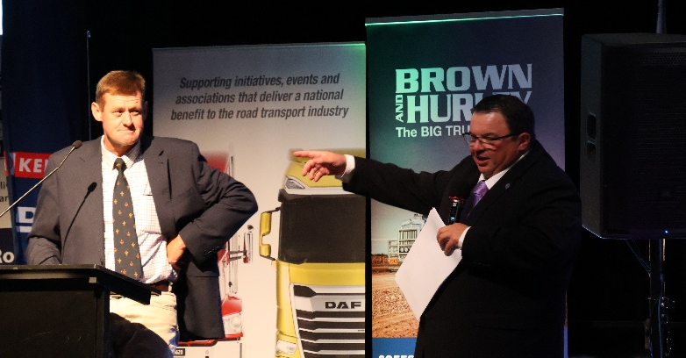
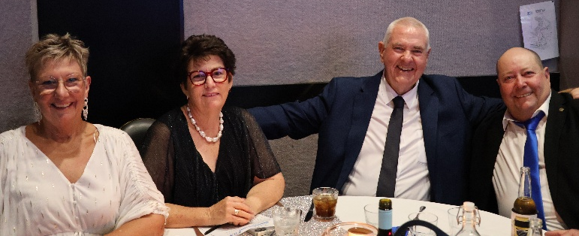
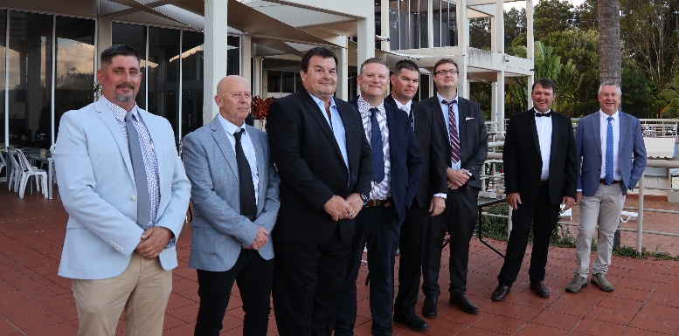
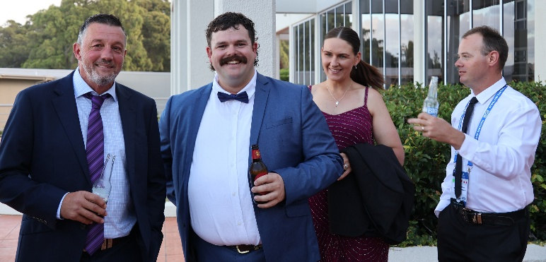

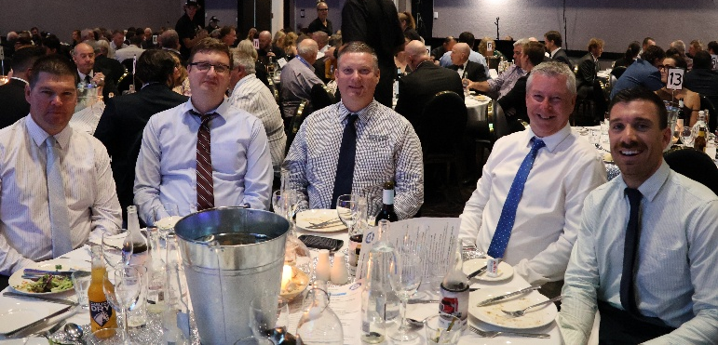
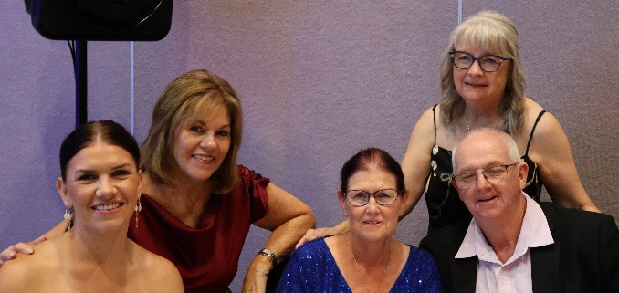

LBRCA Rural Carriers Convention 26-28 February 2026 Coffs Harbour

2026 LBRCA Executive Committee
The Annual General Meeting of the LBRCA was held on Saturday 28 February, in conjunction with the LBRCA Rural Carriers Convention.
During the meeting, members reviewed the Association’s progress over the past year and formally elected the Executive Committee for the coming term, reaffirming the organisation’s commitment to strong leadership and continued advocacy for rural and regional transport operators.
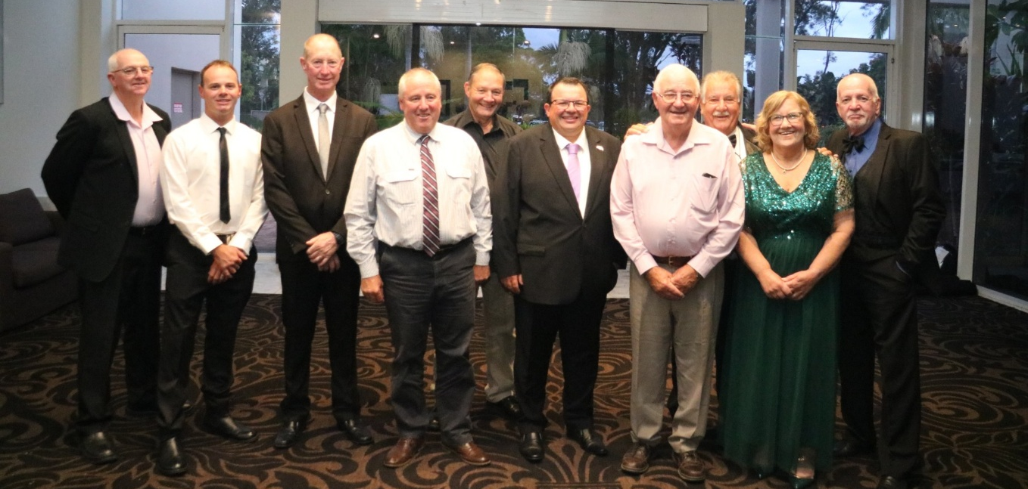
President | Wade Lewis | 0477 609 070
Vice President Livestock | Lynley Miners | 0412 780 673
Vice President Bulk | Kelvin Baxter | 0428 575 059
Treasurer | Alan McKenzie | 0418 147 961
Secretary | Tracey Boschetti | 0427 820 715
Regulator Representative | Timmy Mitton | 0439 267 645
Sponsorship Representative | Stephen Haslem | 0428 669 542
Young Driver Representative | Jack Cooke | 0475 425 648
Livestock Fleet Operator | Peter Dawson | 0428 695 529
Livestock Fleet Operator | Joe Sepos Snr | 0428 497 781
Bulk Fleet Operator | Andy Divall | 0427 298 200
Bulk Fleet Operator | Lyndon Jay | 0417 287 027

LBRCA advocates for fairer licencing testing pathways for older drivers in NSW
The LBRCA continues to actively advocate for practical reforms to the heavy vehicle driver licence testing system in NSW, particularly for experienced drivers required to undertake age-based retesting.
Many of LBRCA’s members rely on older, highly experienced drivers who have spent decades operating heavy vehicle combinations safely across regional and rural road networks. Ensuring these drivers can maintain their licences through a fair, accessible and practical testing system is critical to both industry workforce stability and road safety.
Ongoing concerns with testing availability
Through ongoing engagement with Transport for NSW (TfNSW) and Service NSW, LBRCA has raised significant concerns about the limited availability of heavy vehicle licence testing appointments across regional areas.
Members have reported persistent difficulties securing testing appointments over several years, with some locations experiencing long waiting periods and frequent cancellations.
One recent example provided to LBRCA highlighted the challenges faced by operators in regional NSW. A member had their scheduled driving test at Griffith cancelled by Service NSW just one hour before the appointment.
When attempting to rebook, there were no available appointments for several weeks across nearby locations including Finley, Deniliquin, Hay, Leeton or Griffith.
The only option offered at the time was to downgrade the driver’s licence from MC to HC. Unwilling to accept this outcome, our member ultimately secured a testing appointment in Moree — approximately 800 kilometres away.
Practical risks for operators
The current system also presents a practical challenge if a driver fails their MC licence test. Under existing arrangements, drivers who fail the assessment are no longer permitted to operate multi-combination vehicles.
In many regional situations this creates an immediate problem, as there may be no lawful way for the driver to return the heavy vehicle combination home.
LBRCA has raised these concerns directly with TfNSW as part of ongoing discussions on improving the licensing framework.
Progress on alternative assessment pathways
Transport for NSW has acknowledged the industry’s feedback and confirmed that work is underway to improve the process.
Importantly, TfNSW has advised that following LBRCA’s advocacy, the Heavy Vehicle Competency Based Assessment (HVCBA) pathway is considered as a suitable alternative method for older heavy vehicle drivers to maintain their licences.
The HVCBA model allows accredited driving assessors to evaluate drivers against competency standards in real operational environments, providing a more practical and flexible approach compared with traditional testing systems.
TfNSW has indicated that work is currently progressing to finalise the legal and operational settings for this pathway, including how situations involving failed assessments will be managed.
Ensuring experienced drivers are treated fairly
On another front, LBRCA is continuing to advocate strongly to ensure older drivers are not disadvantaged by current licensing processes.
The Association believes that experienced drivers should not automatically lose their existing HC licence simply because they do not successfully complete an MC driving test. Given the significant workforce shortages already affecting regional transport, retaining safe, experienced drivers within the industry must remain a priority.
Next steps
LBRCA will continue to take the lead on this issue and continue to collaborate with TFNSW to identify practical reforms to the testing and licensing process for older heavy vehicle drivers. Our focus will remain on:
- Improving access to testing appointments in regional areas
- Implementing the HVCBA pathway for older drivers
- Addressing the operational risks when a driver fails a retest
- Ensuring experienced drivers are not unfairly forced to downgrade their licences

Jack Cooke Named 2026 Young Driver of the Year
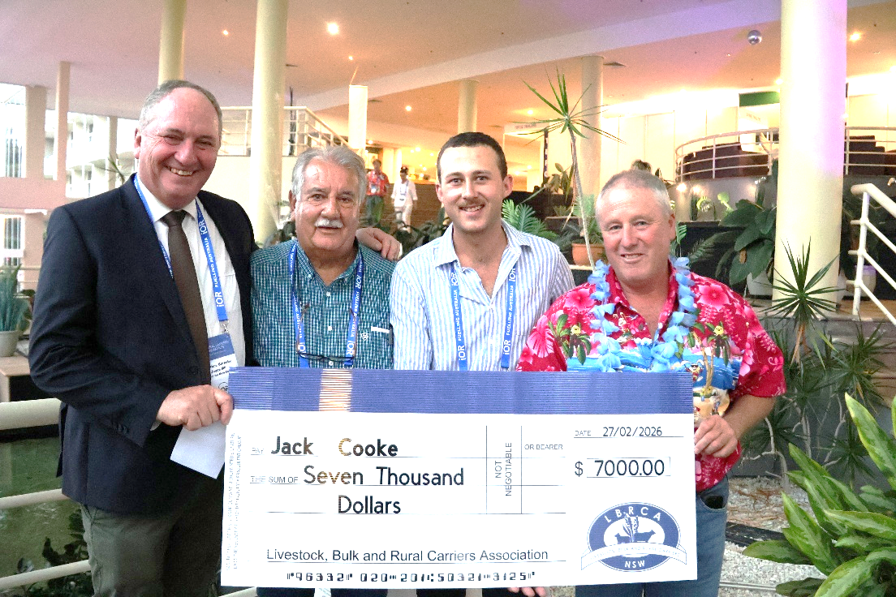
A 23-year-old livestock truck driver from Glen Innes, NSW, has been named the LBRCA 2026 Young Driver of the Year.
Jack Cooke, a third-generation truck driver who works for Stocktrans (part of the JS Group), was announced as the winner at the Friday Night Dinner on Friday 27 February in Coffs Harbour, held as part of the 2026 Rural Carriers Convention.
The Young Driver of the Year Award recognises emerging leaders in the industry who demonstrate best-practice driving behaviours, a strong commitment to safety, and professionalism across the heavy vehicle sector, particularly within the livestock, bulk and rural transport industries.
As the 2026 winner, Jack receives an industry study tour valued at $7,000, providing the opportunity to gain valuable insights into best-practice transport operations and further support his professional development within the industry.
The standard of entrants this year was exceptionally high, with two outstanding finalists also recognised: Jake Wassink from Thompsons Livestock Transport in Cowra, NSW, and Duncan Peter from Riordan Grains in Lara, Victoria. Their dedication, professionalism and passion for the industry reflect the strength of the next generation of drivers supporting Australia’s rural freight task.

LBRCA confirms resignation from ALRTA and strengthens independent advocacy
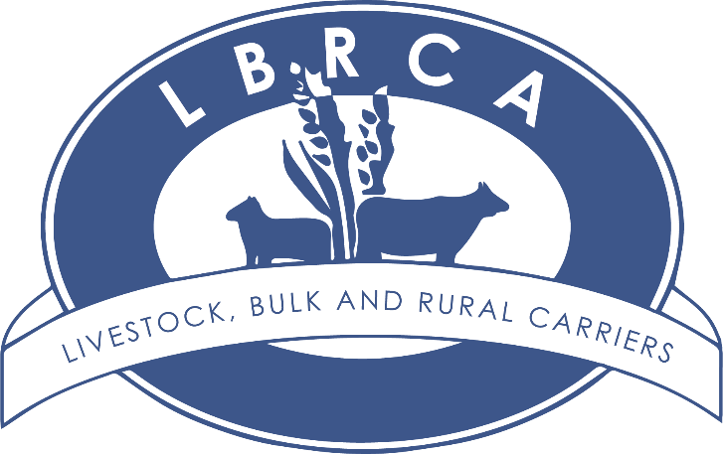
The LBRCA has formally confirmed that its members have voted to resign from membership of the Australian Livestock and Rural Transporters Association (ALRTA), following a Special Resolution in which a quorum was met in accordance with the LBRCA Constitution.
As a result of the vote, LBRCA’s resignation from ALRTA came into effect on 15 February 2026.
LBRCA President Wade Lewis said the decision to resign has not been taken lightly. It reflects ongoing and substantive differences in approach, priorities, and member interests, which LBRCA considers are no longer capable of being reconciled within the existing structure.
“The decision reflects a clear mandate from members to ensure the association can act decisively, independently, and in the best interests of livestock, bulk and rural transporters operating across rural and regional NSW.
As an association, we can now focus squarely on outcomes for our members—both at a state level and on national issues that directly impact transporters operating across rural and regional NSW,” Wade said.
“LBRCA will continue to engage constructively with governments, regulators, industry and stakeholders, but will now do so independently and with greater agility.”
Continuity for members and sponsors
LBRCA has confirmed that member representation, advocacy and services will continue without interruption.
The LBRCA Executive is currently working closely with industry sponsors including NTI, BP, Lowes, PACCAR and PACCAR Dealers, Cummins, V-DAQ, Byrne Trailers and Trailer Magazine to ensure continuity of member benefits and to negotiate future arrangements.
“These discussions are well progressed and are focused on ensuring members experience no disruption to existing sponsorship-supported benefits,” Wade said.
Strengthening policy and advocacy capability
As part of this transition, LBRCA is actively recruiting for a Senior Policy and Advocacy role to strengthen its capacity to support members on issues of national significance, while continuing to lead on NSW-specific priorities.
The expanded focus will include:
- Heavy vehicle access and productivity reform
- Regulatory and permit system improvements
- Safety and infrastructure outcomes for regional freight
- Animal welfare and Chain of Responsibility alignment
- National harmonisation where it delivers practical benefits to operators
A renewed focus on NSW and national outcomes
LBRCA will remain a strong and independent state association, while also taking an active role in national policy discussions where outcomes affect NSW members and the broader rural freight task.
“This is about ensuring transporters operating across rural and regional NSW have a strong, credible voice—one that is informed by on-the-ground experience and focused on practical, deliverable reform,” Wade said.
LBRCA will continue to engage openly with members, sponsors, government and industry stakeholders as it progresses this next phase.

Road Updates
Monaro Highway and Kosciuszko Road, Snowy Mountains
$5 million to deliver road maintenance work on the Monaro Highway and Kosciuszko Road. Work will include spray sealing at three locations on the Monaro Highway and 10 locations on Kosciuszko Road. Work is being carried out on weekdays between 7am and 6pm and is expected to take around three weeks to complete, weather permitting.
Hampden Bridge repairs underway in Kangaroo Valley

The NSW Government has begun a major repair program on Hampden Bridge in Kangaroo Valley as part of efforts to restore the 42.5-tonne load limit as soon as possible. Works to repair and replace damaged bridge components, with completion expected by late 2026, weather permitting. Once finished, the load limit will be reassessed. Works include replacing 21 timber beams within the bridge truss—each about 10 metres long and weighing around one tonne—as well as 11 steel hanger bars. Construction activity will increase in the coming weeks.
Day works will occur under stop/slow traffic control, with some night closures required to safely replace damaged elements.
Gwydir Highway upgrades west of Moree
Members travelling on the Gwydir Highway west of Moree will start to see improvements on the Gwydir Highway with road upgrade works underway. Transport for NSW will carry out road widening, pavement upgrades and minor drainage improvements along a 5.2-kilometre section of the highway about 53 kilometres west of Moree as part of Stage 2 of the Browns Creek upgrade program.
Work started on Monday 9 March and is expected to take around four months, weather permitting. Crews will work weekdays from 7am to 5pm and on alternate weekends. During works, drivers should expect single-lane closures, reduced speed limits of 40 km/h in work zones, and delays of up to 10 minutes. Reduced speed limits and lane closures may also remain outside work hours.
Oversize overmass (OSOM) vehicles wider than four metres will still be able to travel through the site but must contact the work crew on UHF Channel 15 when approaching the work zone during work hours.

Great Western Highway Remains Closed at Victoria Pass

The Great Western Highway remains closed in both directions between Coxs River Road, Little Harley and Victoria Street, Mount Victoria.
Transport for NSW can advise the closure will remain in place for at least three months while work is carried out to safety reopen the road.
Heavy Vehicle Detour:
- A detour for general access vehicles and Performance Based Standards (PBS) Level 1 heavy vehicles up to 20 metres long can detour via Darling Causeway and Chifley Road.
- Restricted access heavy vehicles operators who are unable to travel on a Notice Network and cannot delay their travel are advices to apply for an amended permit via NHVR Go.
- Class 1 Oversize and/or Over Mass (OSOM) vehicles and Special Purpose Vehicles (SPV) cannot currently be accommodated on the Chifley Road/Darling Causeway detour route.
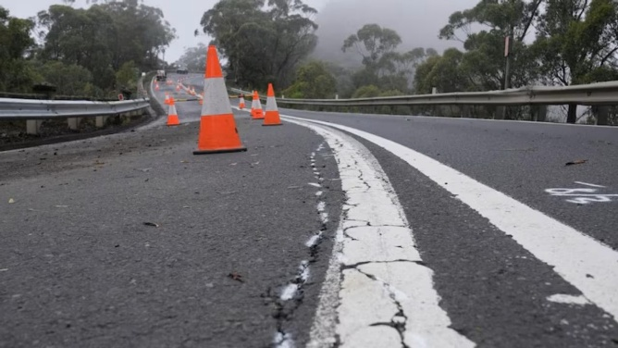
To check approved Notice Networks, heavy vehicle operators can use the NHVR National Network Map to find an alternative route for their combination: http://www.nhvr.gov.au/road-access/route-planner/national-network-map.com.au.
Important Note:
- Unless specified otherwise, operators of Class 1, 2 and 3 vehicles travelling under a Notice must consult their relevant enforceable network map to confirm a suitable approved altnenate route.
- Operators of Class 1, 2 and 3 vehicles travelling under a Permit must not travel off the approved route listed in the permit unless an updated permit is obtained from the NHVR.

LBRCA Calls for Review of Truck Wash Charges in Berrigan Shire
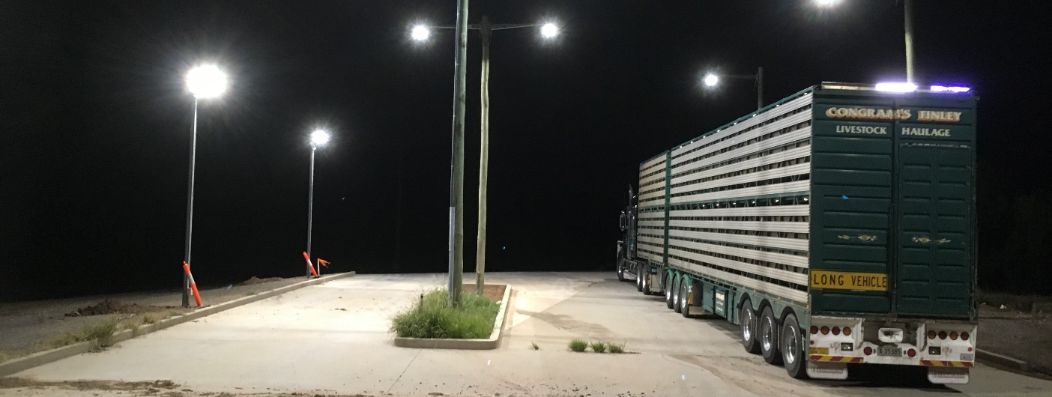
The LBRCA has formally written to Berrigan Shire Council raising strong concerns about the recent increase in truck wash charges at the Berrigan and Finley facilities.
Council has increased the cost of using the truck wash to $1.36 per minute, a price that industry believes is excessive and significantly higher than comparable facilities across the region.
While LBRCA acknowledges that local councils face genuine cost pressures, the scale of this increase comes at a time when transport operators are already dealing with rising fuel prices, insurance costs, labour shortages, and increasing compliance requirements. Additional cost pressures on essential infrastructure such as truck wash facilities place further strain on an industry that plays a critical role in supporting regional agriculture and food supply chains.
The new pricing places Berrigan Shire among the most expensive truck wash facilities within a 100-kilometre radius. By comparison:
- Wagga Wagga – approximately $1.14 per minute (filtered water)
- Corowa – approximately $1.09 per minute (filtered water)
- Deniliquin – approximately $0.95 per minute (filtered water)
- Jerilderie – approximately $0.82 per minute (unfiltered water)
- Griffith – approximately $0.58 per minute (unfiltered water)
- Hay – approximately $0.54 per minute (unfiltered water)
Industry has also highlighted that the Berrigan and Finley facilities utilise raw channel water, while several other regional truck washes supply treated drinking water.
Despite this, operators are being charged at a higher rate than many facilities using higher-grade water supplies.
In practical terms, the increase has a significant financial impact on operators. Washing out a B-double livestock trailer can take up to three hours, meaning the wash alone can cost around $246 per wash.
When labour costs are included, the total cost of a wash-out can exceed $350 per load.
During wet seasons, livestock trailers may require washing multiple times per week—or even daily—depending on operating conditions and animal welfare requirements.
For many operators, these costs are becoming unsustainable.
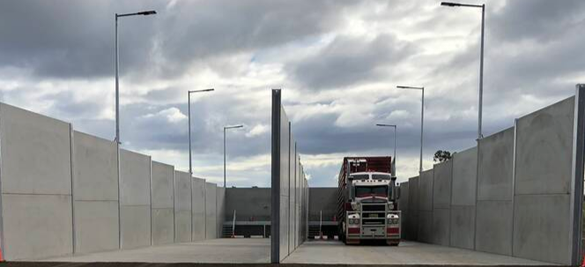
LBRCA has warned that if the cost of using compliant facilities becomes prohibitive, it may lead to unintended consequences such as reduced use of truck wash facilities, inadequate cleaning between loads, and increased risk of spreading biosecurity threats such as weeds and livestock diseases.
Truck wash facilities are critical infrastructure for livestock transport. They support animal welfare by ensuring clean transport conditions, strengthen biosecurity by preventing the spread of disease and contaminants, and improve road safety by reducing effluent spills on public roads.
For these reasons, LBRCA believes truck wash facilities should be treated as essential industry infrastructure rather than revenue-generating assets.
The Association has called on Berrigan Shire Council to reconsider the increase and work with industry to develop a fair and sustainable pricing model aligned with comparable regional facilities.
LBRCA welcomes new members
The LBRCA is pleased to welcome a number of new members who have joined the Association over the past four weeks.
We extend a warm welcome to each of the new members listed below and thank them for choosing to be part of the LBRCA community. Our members are at the heart of everything we do, and we look forward to supporting every regional transport business representing your interests, and working together to strengthen the livestock, bulk and rural transport sector.
Welcome aboard – we’re glad to have the following new members with us.
Cattle Made Livestock Transport Pty Ltd | Walwa, Vic
J & K's Ag Contracting | Manilla, NSW
JKC Carrying Co | Scone, NSW
Kearney Logistics Pty Ltd | Cobram, Vic
Mort & Co Transport Pty Ltd | Pittsworth, Qld
Road City Logistics Pty Ltd | Kensington Grove, Qld
Ward Livestock Transport | Cattle Creek, NSW
Wilsons Transport Narromine | Narromine, NSW

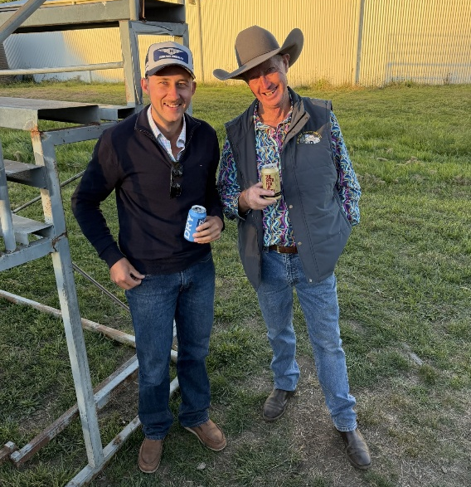
Member Catch Up
Livestock Carriers in Walcha
LBRCA Executive Member Stephen “Wilba” Haslem enjoyed catching up with 2026 Young Driver of the Year Jack Cooke from Stocktrans, Glen Innes, and Jack’s fiancé Olivia Bruce at the Walcha Show Yard Dog Trials held at the Walcha Showgrounds last weekend.
Avoiding a criminal conviction with a Section 10 Order: What you need to know (NSW)

By Belinda Hughes, Hughes Law Pty Ltd
If you are facing criminal charges, you will likely be worried about the implication of a criminal record and how it may limit your opportunities in life. A criminal conviction can affect current and future employment, your ability to travel, and the capacity to secure finance in the future.
For those accused of an offence in New South Wales, seeking a section 10 order may be a viable option to prevent a criminal conviction from impacting future opportunities.
In this article, we consider what a section 10 order entails, the offences eligible for consideration, the implications of such an order, the process of obtaining one, and the factors courts consider when deciding. The information is general only, and we strongly recommend you obtain professional advice relevant to your circumstances.
What is a Section 10 order?
Section 10 of the Crimes (Sentencing Procedure) Act 1999 (NSW) allows a court to find a person guilty of an offence and still discharge the matter without recording a criminal conviction. Essentially, it offers an opportunity for the court to show leniency, providing a second chance to those who have committed offences that are deemed relatively minor or out of character.
A number of offences may be dealt with by way of a section 10 order. The most common include less serious traffic offences, minor drug offences, petty theft, first-time offences, and criminal matters that are dealt with in the Local Courts. However, eligibility varies depending on the circumstances of each case and the discretion of the court.
The court can choose to apply one of three different types of section 10 orders. The first is a “Dismissal”, where no conviction is recorded. The second is a “Conditional Release Order”, where no conviction is recorded, but there are conditions, most commonly that the offender be of good behaviour and not commit any further offences for up to two years. The final section 10 order is “With Intervention Program”. In this case, no conviction is recorded, but this forbearance is conditional upon the offender completing an intervention or rehabilitation program, such as the Traffic Offenders Intervention Program.
How to Obtain a Section 10
The courts do not grant section 10 orders lightly. An offender’s lawyer must prepare thorough and convincing submissions to persuade a Magistrate or Judge to consider not recording a conviction after finding someone guilty. Supporting documents are usually presented with these submissions.
When seeking a section 10 order, it is vital to present mitigating factors that demonstrate remorse, good character, and contextual details regarding the offence.
When contemplating a section 10 order, the court will assess the nature and severity of the offence in question, considering factors such as the harm caused, the offender’s culpability, and any aggravating or mitigating circumstances.
The court will also take into account the offender’s personal circumstances, including their age, prior criminal history (if any), employment status, family responsibilities, and any efforts towards rehabilitation.
Demonstrating genuine remorse for the offence and efforts towards rehabilitation can significantly influence the court’s decision. This may include participating in counselling, undertaking educational programs, or engaging in community service.
Does a Section 10 Appear on a Police Check?
If the court orders a section 10 dismissal, no conviction will show on the accused’s criminal history if somebody carries out a police check for employment purposes. A section 10 order with a good behaviour bond or intervention program will appear on a police check for the duration of the bond or rehabilitation program.
Once the offender completes the bond or intervention program, the record will no longer show on the accused’s criminal history via a police check.
However, details of section 10 orders are retained as part of a person’s criminal record used by the court if a person is subsequently charged by the police.

Spent convictions
The objective of the spent conviction scheme is to provide an opportunity for those who have been convicted of certain offences to move forward with a ‘clean slate’ after a crime-free period.
The Criminal Records Act 1991 in New South Wales provides that after being convicted of certain (relatively minor) offences, and after serving a crime-free period of 10 consecutive years for adults and 3 consecutive years for juvenile offenders, the conviction will no longer appear in a criminal history check.
Generally, apart from certain exceptions, a person with a spent conviction will not need to disclose that conviction. However, criminal records are kept and used by the court if a person is subsequently charged by the police.
Conclusion

Navigating the criminal justice system can be daunting, section 10 orders offer a ray of hope for individuals facing more minor offences in NSW.
Understanding the intricacies of section 10 orders, the eligible offences, and the factors the courts consider is essential when seeking to avoid a criminal conviction.
While an experienced criminal lawyer can provide guidance and present a compelling case, a person facing charges can demonstrate remorse and rehabilitation efforts to increase their chances of securing a favourable outcome and moving forward with their lives, unburdened by the stigma of a criminal record.
If you or someone you know wants more information or needs help or advice, call 0422 388 370 or 13004HUGHES or email info@hugheslaw.com.au.

Dusty Russell recognised with Outstanding Industry Achievement Award
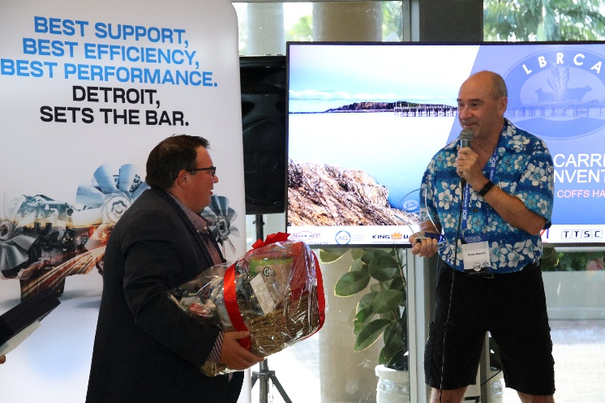
The LBRCA was proud to recognise Darryl (Dusty) Russell with an LBRCA Outstanding Industry Achievement Award at the 2026 Rural Carriers Convention in Coffs Harbour, acknowledging his remarkable contribution to the transport industry and long-standing support of LBRCA members.
Dusty commenced his career with Detroit Diesel Allison Australia on 26 April 2000 and retired on 31 October 2025, marking 25 years of outstanding service to the business and the broader transport sector.
For more than two decades, Dusty has been a familiar and valued presence at LBRCA conferences and industry events. Never simply an attendee, he was often among the first to arrive to help with event set-up and among the last to leave, spending time with members long after formal proceedings had finished. His genuine commitment to the industry and its people played a significant role in the strong and enduring relationship between LBRCA, Penske and Detroit.
Importantly, LBRCA members never viewed Dusty as just a sales representative. He was a trusted friend of the industry. Dusty took the time to understand operators, their businesses and their families. He celebrated their successes and supported them through the challenges that come with running transport businesses across rural and regional Australia.
Throughout his career, Dusty held a wide range of technical and customer-facing roles, including product support, programming Detroit-powered heavy vehicles, advanced fault diagnosis, and testing new engine platforms in real-world operating conditions. His exceptional technical knowledge and practical, no-nonsense approach made him a respected resource for operators, customers and colleagues alike.
In 2007, Dusty travelled to the United States where he visited the Detroit manufacturing plant as well as Western Star and Freightliner production facilities. Over the years he also had the opportunity to meet Roger Penske on several occasions in both Australia and the United States — experiences he greatly valued.
Dusty’s career spanned several company transitions, ultimately becoming part of Penske Australia and New Zealand. During this time, he worked closely with major fleets including Lindsay Australia Transport, Jim Pearson Transport and Wickham’s Freight lines, as well as Penske and Detroit dealerships across the country, building strong professional relationships and lasting friendships.
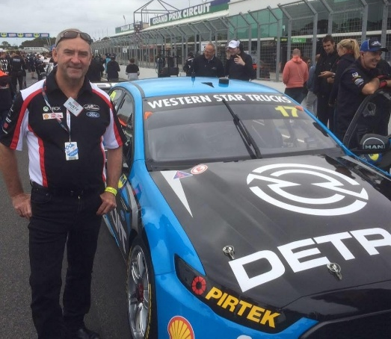
In 2018, Dusty was appointed as the dedicated product specialist for Western Star and Dennis Eagle vehicles, a role he held through to retirement and one he often described as the highlight of his career.
Dusty’s connection to the transport industry went well beyond the workshop and dealership floor. A regular attendee at industry events, he supported LBRCA conferences, national truck shows in Brisbane, Sydney and Melbourne, and the AgQuip Field Days — which he had attended annually since 1987.
Adding to his unique perspective, Dusty also spent time working as a part-time relief driver for Detroit customers, operating combinations ranging from road trains to B-double refrigerated vans and Western Star tanker combinations transporting ammonia. This hands-on experience gave him valuable real-world insight into vehicle and engine performance and allowed him to provide practical, informed advice to operators.
Detroit truly ran through Dusty’s veins. His passion for trucks, engines and the people who operate them was unmistakable. Known for his incredible memory of customers and their trucks, Dusty could recall stories and details from decades past as though they had happened yesterday.
For LBRCA members, Dusty Russell has been far more than an industry professional — he has been a loyal supporter, trusted advisor and genuine friend. The Outstanding Achievement Award recognises not only his 25-year career, but also the lasting impact he has had on the people and businesses that keep rural Australia moving.

NHVR shuts down non-compliant transport operator

The National Heavy Vehicle Regulator (NHVR) has secured a Supreme Court injunction preventing a Queensland transport company and its director from operating after repeatedly ignoring prohibition notices.
Over a two-year period, regulators detected more than 200 mechanical faults and nearly 70 offences across the company’s fleet. Inspections of 16 heavy vehicles found every vehicle to be defective.
Despite three prohibition notices issued to the company and one to the director directing them to stop operating, the business continued transport activities.
The court injunction means any further operations would breach a court order and could result in significant fines or imprisonment.
NHVR Executive Director of Statutory Compliance Paul Alsbury said the case reinforces that operators who ignore their safety obligations under the Heavy Vehicle National Law will be held accountable.
NHVR launches Freight PASS comparison tool
The NHVR has released Freight PASS, a free online tool that allows industry and road managers to compare the productivity, safety, pavement impact and environmental outcomes of different heavy vehicle configurations.
The tool enables users to assess factors such as operating costs, travel time, crash risk, emissions and pavement wear when completing a freight task with different vehicle types.
For example, moving from a 26m B-double to a 30m PBS A-double can reduce trip numbers by around 25 per cent while improving safety and productivity.
Freight PASS also helps road managers analyse pavement impacts and emissions and allows operators to test vehicle configurations before applying for access permits or expanding fleets. The tool is available through the NHVR’s digital platform, NHVR Go.

Hubfleet Partners with LBRCA to Deliver Compliance Savings for Members
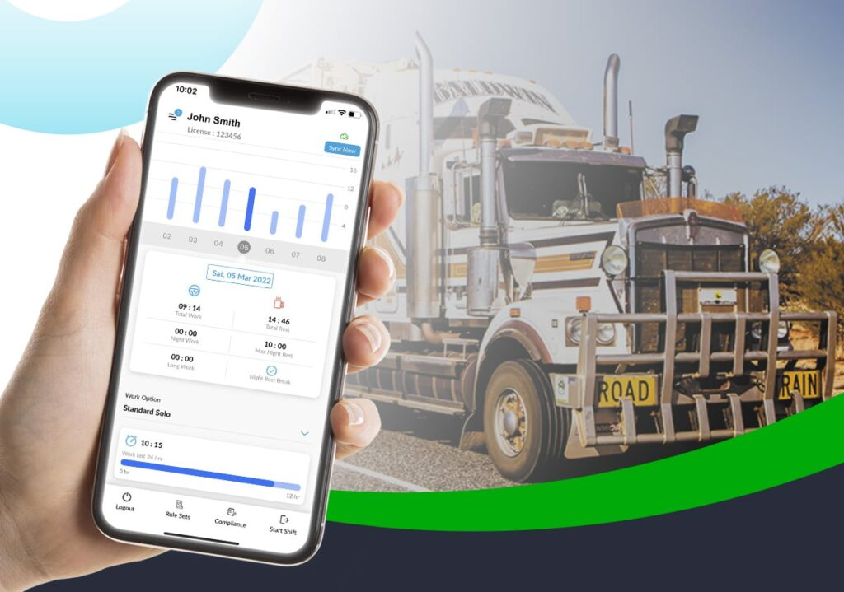

Hubfleet and LBRCA are pleased to announce a new partnership giving members access to an exclusive 20% discount on their first 12 months’ subscription to Hubfleet’s digital compliance platform.
Hubfleet is one of only 13 NHVR-approved Electronic Work Diary (EWD) providers in Australia, but it offers much more than electronic fatigue recording.
The platform is a complete digital safety management system, helping operators replace paperwork with simple digital tools that keep them audit-ready, compliant, and focused on their core business.
For drivers, Hubfleet’s EWD is a genuine game-changer. Unlike paper logbooks that round work and rest time into 15-minute blocks, Hubfleet records to the exact minute. That accuracy means drivers can legally reclaim up to 40 minutes of driving time each day.
The result is more productive hours on the road, without compromising fatigue safety rules. On top of that, roadside inspections become far less stressful. With Hubfleet, inspectors can instantly view accurate, legible records — eliminating the fear of unknown breaches, messy handwriting, or a misplaced logbook.
For operators, Hubfleet consolidates multiple compliance tasks into one platform. Fatigue management, Maintenance management, schedules, fault reporting, mass management and training records are all captured and stored securely in the cloud. Instead of spending hours chasing missing forms or filing paper records, operators have everything in one place — complete, legible, and audit-ready whenever it’s needed.
Perhaps most importantly, Hubfleet was built with drivers in mind. It’s simple, intuitive design has been developed with real-world feedback, making it easy to learn and adopt. Drivers appreciate a system that works for them rather than against them, while operators gain confidence in the accuracy and reliability of the data. This new partnership reflects the LBRCA’s commitment to providing members with real value — not just in financial savings, but also through tools that support safer, smarter, and more sustainable operations.
To access this exclusive offer, please contact Glyn, email glyn@hubfleet.com.au or phone 02 7908 4053 for your special member link.

Upgrade for Kyeamba Gap Rest Area

Kyeamba Gap East Rest Area on the southbound Hume Highway between Tarcutta and Holbrook is set for an upgrade following a $2.4million investment by the Federal and NSW governments.
The improvements will include a new toilet block with three flushing toilets, picnic facilities, lighting, upgraded drainage, signage, safety barriers and two dedicated heavy vehicle parking lanes.
Construction will take place weekdays from 7am to 5pm and Saturdays from 7am to 1pm, weather permitting, between 26 March and 29 May.
During the closure, the nearest alternative stops are located at Little Billabong (12km south) and Keajura (22km north).


Safer Local Roads and Heavy Vehicle Rest Area
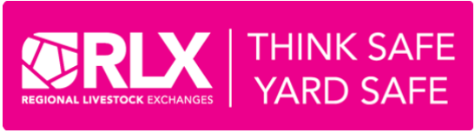
RLX – Report an Issue
To report a hazard, near miss, incident, or a regulatory visit-audit at a Regional Livestock Exchanges (RLX) site, simply scan the QR codes while on site, or via the RLX website www.rlx.com.au under About Us > Workplace Health & Safety > Report Issues.
The form collects the type of report, date and time of the incident and the details of the person submitting the report. You can also upload photos or files to support your report.

RLX and iOR Fuel Supply Partnership

LBRCA congratulates Regional Livestock Exchanges (RLX) and iOR on their new partnership to deliver dedicated transporter services at key saleyards, including bulk diesel, AdBlue and driver amenities.
The first facilities opened in November at NVLX Barnawartha (Victoria) and IRLX Inverell (NSW), making livestock transport operations easier and more efficient. A new site at Glen Innes will open this month.
iOR, an Australian-owned fuel company supporting regional industries for more than 40 years, will provide 24/7 access to diesel, AdBlue and amenities via tag access, along with competitive pricing and strong supply security through its national fuel network and Australian-based customer support. Members are encouraged to provide their input on potential future iOR service locations across RLX saleyards throughout Australia. LBRCA is keen to hear from members about where these services would be most valuable to support livestock transport operations.

New Master Code – What LBRCA members need to know

The NHVR has released the 2026 Master Code, a revised industry guide designed to help transport businesses understand and meet their Chain of Responsibility (CoR) safety obligations under the Heavy Vehicle National Law (HVNL). The Master Code does not introduce new laws, but it provides practical guidance on how businesses can meet their Primary Duty to ensure safety so far as reasonably practicable. For LBRCA members operating in livestock, bulk and rural transport, the Code is an important tool for demonstrating that your business is actively managing safety risks across your operations.

Why the Master Code matters

The HVNL places a Primary Duty on all parties in the transport supply chain to ensure heavy vehicle activities are safe. This includes:

Operators

Drivers

Schedulers

Consignors and consignees

Loading managers

Businesses that contract freight services

The Master Code helps bridge the gap between the legal duty and day-to-day operations, outlining common risks and practical steps businesses can take to manage them. For LBRCA members, it provides a recognised industry benchmark for safe transport operations.

What LBRCA members need to know

Key points from the 2026 Master Code include:

It focuses on risk management
The Code identifies where things can go wrong in transport operations and how to prevent incidents before they occur.

It applies to the whole supply chain
Responsibility does not sit only with drivers or operators. Anyone who influences transport tasks may have legal duties.

It supports Primary Duty compliance
Following the Master Code can help businesses demonstrate they are taking reasonable steps to manage safety risks.

It reflects real industry practice
The updated Code was developed with extensive industry input and builds on lessons learned since the original 2018 version.

What members should do now

LBRCA members should review the new Code and consider how it applies to their business operations. Recommended steps include:


Review your Safety Management System (SMS)
Check that your existing policies and procedures address key risk areas such as:

Fatigue management

Speed compliance

Mass and load management

Vehicle maintenance

Driver competency and training

Scheduling and delivery pressures

Check your supply chain relationships
Ensure customers, agents and contractors are not placing unsafe demands on drivers or vehicles.

Update internal procedures where needed
The Code may highlight improvements to areas such as:

Loading practices

Vehicle inspection systems

Documentation and record keeping

Incident reporting processes

Train staff and drivers
Make sure everyone in your business understands their responsibilities under the Chain of Responsibility framework.

The NHVR has emphasised that the new Master Code is not about increasing regulatory burden, but about giving industry clearer guidance on how to meet existing obligations.

For many LBRCA members, much of what is outlined in the Code will already reflect good operational practice. Used correctly, the Master Code can help businesses:

Improve safety outcomes

Protect drivers and the public

Strengthen compliance with HVNL obligations

Demonstrate due diligence if incidents occur

The livestock, bulk and rural transport sector operates in challenging environments with long distances, seasonal pressures and demanding freight tasks.

LBRCA encourages members to familiarise themselves with the Code and consider how it can strengthen their existing safety systems.
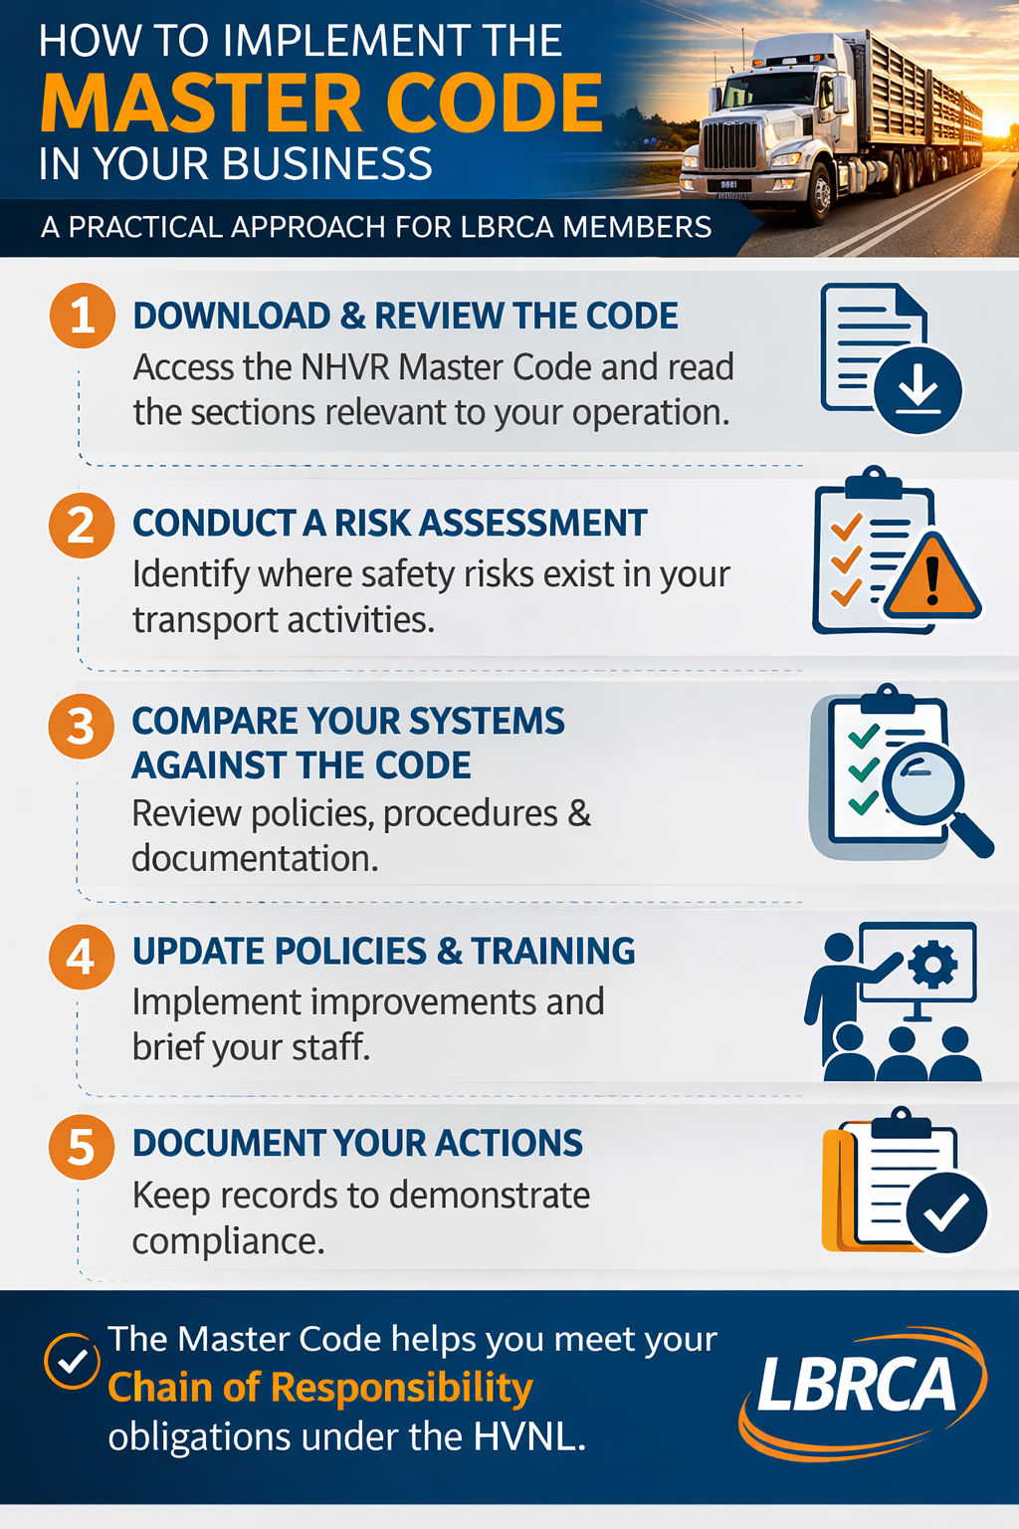

LBRCA Raises Member Safety Concerns on Kidman Way

The LBRCA has now formally raised member concerns regarding a dangerous section of Kidman Way at Willbriggie, near Darlington Point and south of Griffith, following further reports of heavy vehicle crashes and ongoing safety risks at the site.
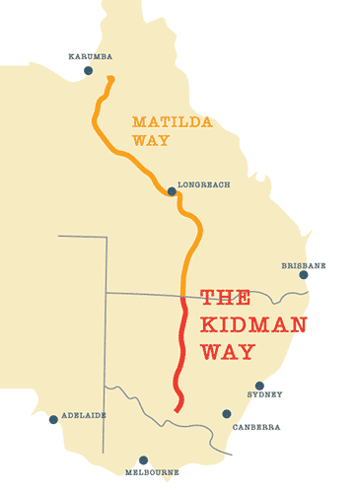
The issue was brought to LBRCA’s attention by a member who described the location as a particularly hazardous section of road, involving a narrow corner and bridge over an irrigation channel, with a safety rail and two nearby intersections. Members have reported that the layout makes it extremely difficult and stressful for heavy vehicles to pass safely, particularly when meeting oncoming traffic.
These concerns have been reinforced by recent incidents at the site, including another truck crash reported on Friday morning. Members have also pointed to previous heavy vehicle crashes in the same area, highlighting the need for urgent attention and a longer-term engineering solution.
LBRCA has now taken this concern forward as part of its ongoing advocacy for safer freight routes across regional New South Wales. We will continue to push for this section of Kidman Way to be assessed for upgrade, widening or redesign to improve safety for heavy vehicle operators and all road users.
We thank our members for continuing to be our eyes and ears on the road. It is this on-the-ground feedback that helps LBRCA identify emerging safety issues, raise them directly with government, and keep pushing for practical improvements where they are needed most.
When members speak up, it strengthens our voice and helps ensure the realities faced by regional transport operators are heard by decision-makers.
LBRCA Raises Fuel Tax Credit Administration Issue with the ATO

The LBRCA has written to the Australian Taxation Office (ATO) seeking consideration of a practical change to how Fuel Tax Credit (FTC) rate adjustments are implemented.
The issue was raised with LBRCA by members who highlighted the significant administrative burden created when FTC rates change part-way through a month or quarter.
While the FTC scheme itself remains an important support mechanism for heavy vehicle operators, the timing of rate changes can create unnecessary complexity for businesses managing their fuel records and tax reporting.
In recent years, FTC rates have changed on dates such as 1 August 2023, 5 February 2024, 5 August 2024, 3 February 2025 and 4 August 2025—all of which fall mid-month.
For transport operators, this means fuel purchases must be manually split across different FTC rates within the same reporting period.
For many businesses, fuel purchases are recorded through multiple fuel cards—often across providers such as BP, Ampol, Shell or iOR—with monthly statements processed through accounting systems.
When an FTC rate changes part-way through the month, operators must go back through each transaction and manually separate purchases before and after the rate change to calculate the correct credit.
The complexity increases further for businesses operating bulk fuel tanks, where internal fuel usage is tracked through weekly or periodic transaction records that must also be split to reflect the new FTC rate.
Currently, calculating Fuel Tax Credits remains a largely manual process, typically undertaken through spreadsheets using transaction data from several sources. Most accounting software packages do not automatically process FTC calculations, meaning the timing of rate changes directly affects the amount of manual work required in the office.
Recognising the impact this creates for transport businesses—particularly small and medium operators—LBRCA has written to the ATO requesting consideration of aligning FTC rate changes with standard BAS reporting periods.
Specifically, LBRCA has suggested that FTC rates be adjusted at the start of a BAS quarter, being:
- 1 January
- 1 April
- 1 July
- 1 October
Aligning rate changes with these existing reporting periods would significantly simplify record keeping, reduce administrative workload and improve compliance efficiency for transport operators.
LBRCA will continue to advocate for practical regulatory and administrative improvements that reduce unnecessary red tape for rural and regional freight operators.
If members have experienced similar compliance challenges or have suggestions for regulatory improvements, we encourage you to share them with the Secretariat. Your feedback helps ensure LBRCA can continue raising real-world industry issues with government and regulators.

Future of Narrabri Saleyards Under Review

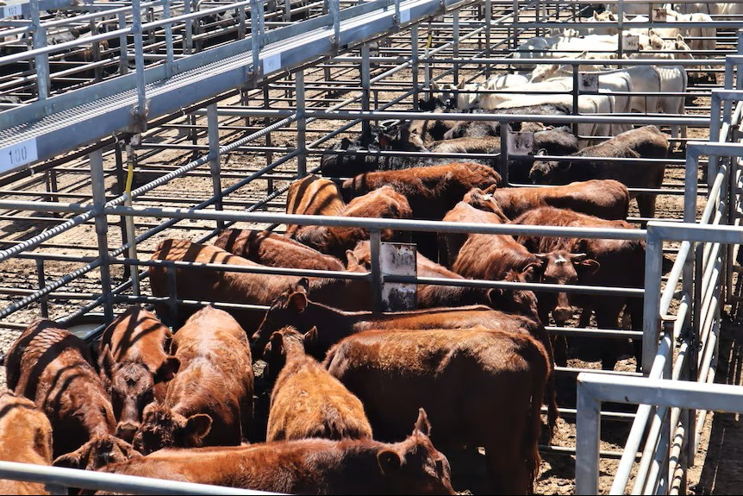
Narrabri Shire Council has commenced a review into the future use of the Narrabri Saleyards site, with industry input now being sought as part of the process.
The saleyards, which cover approximately 12 hectares, have historically played an important role in supporting the Shire’s livestock industry and local economy. However, the scale of operations at the facility has reduced significantly in recent years.
To explore future opportunities for the site, Narrabri Shire Council has engaged AEC Group to undertake a clear, evidence-based assessment of potential redevelopment options. The review will identify, evaluate and shortlist the most suitable future uses for the site using a structured assessment framework.
In similar regional communities, successful redevelopment outcomes have often included alternative agribusiness uses, such as livestock carrier support services incorporating hardstand areas, truck wash facilities and related infrastructure. Other options may include employment-focused developments such as distribution centres or warehousing, or a combination of community, environmental or mixed-use outcomes.
The LBRCA has been invited to provide an informed industry response on potential uses that could support livestock transport and rural freight operations.
LBRCA members are encouraged to share their ideas and feedback to help inform the Association’s response.

Members wishing to contribute can contact Bec in the LBRCA Secretariat via email at bec.coleman@lbrca.org.au.

NVHAS is changing – What LBRCA members need to know
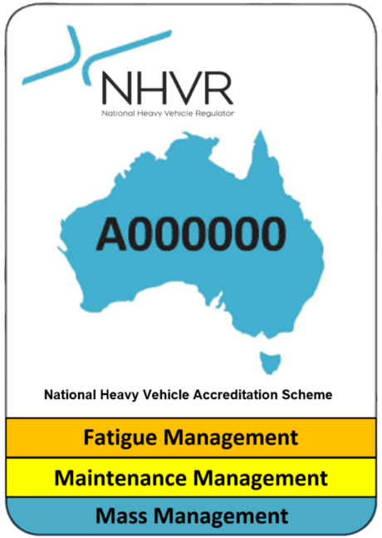
The National Heavy Vehicle Accreditation Scheme (NHVAS) will soon be replaced by a new system called Heavy Vehicle Accreditation (HVA) following changes under the Heavy Vehicle National Law Amendment Bill 2025.
The new scheme will be rolled out progressively from mid-2026, introducing a different approach to accreditation and safety management for transport operators.
A New Two-Tier Accreditation System
The HVA scheme introduces a tiered framework made up of:
- General Safety Accreditation (GSA) – the baseline accreditation for operators
- Alternative Compliance Accreditation (ACA) – required for operators seeking specific regulatory concessions for Mass or Fatigue
Unlike NHVAS, which audits specific modules such as Mass, Maintenance or Fatigue, the new system will assess operators against a whole-of-business Safety Management System (SMS).
This means audits will examine all safety-related transport activities across the business, not just individual modules.
What Will Be Audited?
To achieve General Safety Accreditation, operators will need to demonstrate their systems meet the Safety Management Standard 2026, which focuses on five key areas:
- Leadership and commitment
- Risk management
- People and training
- Assurance, monitoring and improvement
- Safety systems and processes
Importantly, GSA is required before operators can access any Alternative Compliance Accreditation.
What This Means for Existing NHVAS Modules
- Mass Management
Changes to the Mass Dimension Loading Regulations will increase General Mass Limits (GML) to align with Concessional Mass Limits (CML). This means accreditation will no longer be required simply to access CML weights.
However, operators needing additional concessions through schemes such as Higher Mass Limits (HML) or Performance Based Standards (PBS) will still require ACA – Mass.

- Maintenance Management
Maintenance accreditation will continue under the new system.

Operators will still be able to access exemptions from annual vehicle inspections in participating states, but they will first need GSA plus additional maintenance requirements.

- Fatigue Management
The current BFM and AFM categories will transition to a single performance-based fatigue model.
Operators will be able to choose work and rest hours that suit their operations within safe limits.
To make the process easier, pre-approved template work and rest schedules (including BFM-equivalent options) will be available to streamline accreditation.
What Members Should Do Now
While the changes won’t begin until mid-2026, operators should start preparing by:
- Reviewing their Safety Management Systems
- Ensuring risk management and compliance processes cover the whole business
- Preparing for SMS-based audits rather than module audits
The new HVA framework is designed to better align with Chain of Responsibility safety obligations under the Heavy Vehicle National Law.

Transition and Implementation Pathway
The NHVR will manage a phased transition approach to ensure existing NHVAS operators have time to prepare for the new HVA scheme.
- Existing NHVAS operators will not be required to transition to the new HVA scheme immediately when the amended law commences mid-year. They will be able to operate under the NHVAS scheme up until the expiry of their NHVAS accreditation.
- The NHVR transition approach will allow industry to either maintain their NHVAS accreditation (dependent on expiry), exit or request extensions where required to support transition (accreditation period can be a maximum of 3 years).
- The NHVR will communicate directly with operators to ensure that they are aware of their accreditation expiry dates and have adequate time to access available transition options.
- NHVAS and HVA will operate side by side during the transition period (however, operators can only be accredited in one scheme at a time).
- Safety Management System (SMS) tools and guidance material will be made available to support operators transitioning to the new scheme.
- Templated work and rest hours will be available to support industry to adopt Alternative Compliance Accreditation – Fatigue under the HVA scheme.
The templates have been tried and tested based on real-world operating conditions and reduce the time required for operators to prepare bespoke work and rest hours that meet safety expectations.
LBRCA will continue to keep members informed as further details and transition timelines are released.

LBRCA raises concerns over heavy vehicle permit delays
LBRCA has formally raised serious concerns with the NSW Government regarding significant delays in the heavy vehicle access permit system administered by Transport for NSW. Industry feedback indicates that a substantial backlog of permit applications is currently resulting in processing times of up to three months. These delays are having an immediate impact on members across New South Wales who rely on access permits to secure work.
For many members, permits are essential to operate approved routes. When approvals are delayed, vehicles sit idle, contracts are lost and businesses are unable to accept work despite having compliant vehicles and experienced drivers ready to go. Members have reported cases where operators have invested up to $900,000 in compliant PBS or higher productivity vehicles but have been unable to use them due to permit delays. In some cases, operators are losing between $15,000 and $20,000 per week in standing costs and lost revenue while waiting for approvals.
We’ve also heard reports from members that they have missed out on seasonal freight contracts worth hundreds of thousands of dollars due to permit renewal delays on routes that had previously been approved.
LBRCA has emphasised that this issue is affecting livestock, bulk and rural freight operators across the state and is undermining productivity, supply chain reliability and confidence in the regulatory system.
To address the issue, LBRCA has called for practical reforms including:
- Gazetting commonly approved routes by Notice to reduce the need for repeated permit applications.
- Introducing pre-approved or automated permits for established vehicle configurations and routes.
- Adopting a risk-based permit assessment approach that focuses on genuine infrastructure or safety risks.
- Improving alignment between Transport for NSW and NHVR systems to reduce duplication and delays.
LBRCA has made it clear that industry is not seeking reduced safety standards — but rather a permit system that is timely, efficient and fit for purpose.

Industry calls for urgent investment to Waterfall Way
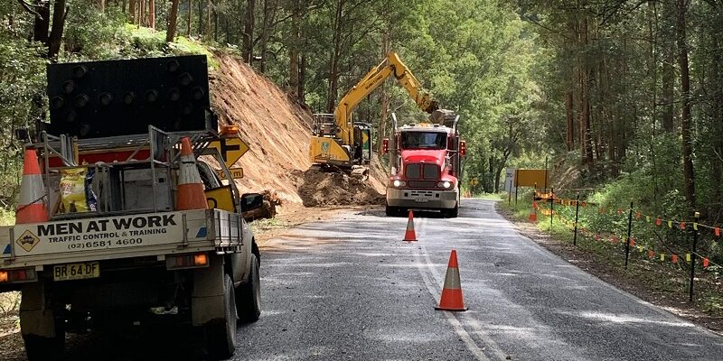
The ongoing closure and long-term underinvestment in Waterfall Way continue to place significant pressure on transport operators, local businesses and regional communities across the Northern Tablelands and Mid North Coast.
Waterfall Way is a critical freight and community link connecting the New England region with the coast. However, repeated closures, deteriorating road conditions and limited investment in long-term resilience have created ongoing disruption for those who rely on the route to move livestock, agricultural produce, essential supplies and freight.
These disruptions force transport operators onto lengthy detours, increasing fuel costs, travel times and operational pressures.
LBRCA President Wade Lewis recently attended a community meeting in Dorrigo where a packed room of transport operators, local businesses, farmers and community members came together to discuss the ongoing challenges and the urgent need for long-term solutions.
The strong turnout highlighted the importance of Waterfall Way not just for freight, but for the economic and social connectivity of the region. Participants agreed that while temporary repairs are often necessary, what is ultimately required is a long-term commitment to investment, improved resilience and infrastructure upgrades that reflect the importance of this key regional corridor.
LBRCA will continue to work alongside industry, local communities and government to advocate for sustainable solutions that ensure Waterfall Way remains a safe, reliable and productive route for regional freight and communities alike.

Members’ input needed: Identifying roads that need reclassification for heavy vehicle access

The LBRCA is calling on members to help identify roads across New South Wales that should be reclassified to better support heavy vehicle access and freight productivity.

Across the state, many roads that are routinely used by livestock, bulk and rural freight operators remain classified under access levels that no longer reflect the way those roads are actually used or the standard to which they are built.

In many cases, operators are forced to rely on individual permits or take lengthy detours simply because a road has not yet been formally assessed or reclassified to allow appropriate heavy vehicle combinations. These outdated classifications can create significant challenges for transport operators.

They can limit access for PBS vehicles, B-doubles and other higher productivity combinations, increase travel distances, add unnecessary costs and place additional pressure on regional supply chains.

LBRCA is currently working with government agencies and road managers to advocate for improved freight access across the state. A key part of this work involves identifying roads that may be suitable for reclassification or inclusion in heavy vehicle access networks. By updating road classifications where appropriate, governments can:

Improve freight efficiency across regional supply chains

Reduce unnecessary detours and travel distances

Better utilise existing road infrastructure

Support safer and more productive heavy vehicle operations

Strengthen the resilience of regional freight networks

However, accurate industry input is essential to ensure that the right roads are prioritised.

How Members Can Help

LBRCA is asking members to provide information on roads where access restrictions are creating operational challenges. This may include roads that:

Could safely accommodate B-doubles, PBS vehicles or higher productivity combinations

Are regularly used by freight operators but require individual permits

Create significant detours due to outdated classifications

Connect key agricultural infrastructure such as saleyards, feedlots, grain sites, processors or livestock loading facilities

Are important “missing links” in regional freight corridors

Real-world operational experience from transport operators is critical in helping decision-makers understand where the current network does not align with industry needs.

Have Your Say

Members who wish to contribute are encouraged to provide details of roads that they believe should be reviewed or reclassified. Where possible, please include:

The road name and local government area

The type of vehicle combination affected

The operational issue or restriction currently experienced

Any impacts on travel distance, safety or productivity

This information will assist LBRCA in building a strong evidence base to support discussions with Transport for NSW and local councils about improving freight access across the NSW road network.

Together, we can help ensure the NSW road network better reflects the needs of modern regional freight and supports safer, more efficient transport for our industry.

Members can provide their feedback by contacting Bec in the LBRCA Secretariat on 0432 336 718 or email bec.coleman@lbrca.org.au.

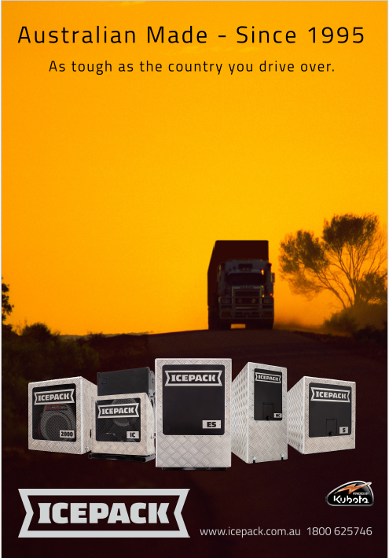

CoRLink Animal Welfare Accreditation
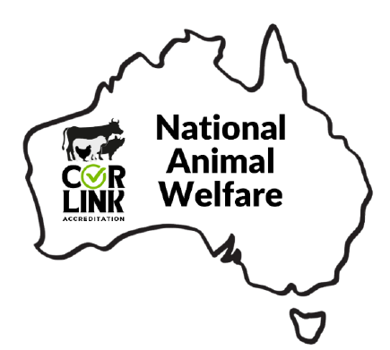
The CoRLink Accreditation National Animal Welfare Module has been developed industry to provide an industry business management framework consistent with legislation and enforcement across Australia with regard to animal welfare, and provide guidance for all persons involved in, and responsible for livestock handling, preparation, and transport.
﻿The development of the National Animal Welfare Module Business Standards is based on scientific knowledge, recommended industry practice, and wider community expectations with relation to livestock and animal welfare.
The Business Standards apply to all those responsible for the care and management of livestock that are transported, including drivers, transport companies, owners, agents and livestock handlers at farming enterprises, depots, saleyards, feedlots and livestock-processing plants.
The chain of responsibility for livestock welfare in transport begins with the owner or their agent and extends to the final receiver of the livestock.

BECOME CORLINK ACCREDITATED
Become a part of CoRLink and take the first step towards a safer, more professional future in the heavy vehicle industry. Together, we can make a difference on the road.

If you would like to become a CoRLink Accredited Operator
visit www.corlink.com.au.

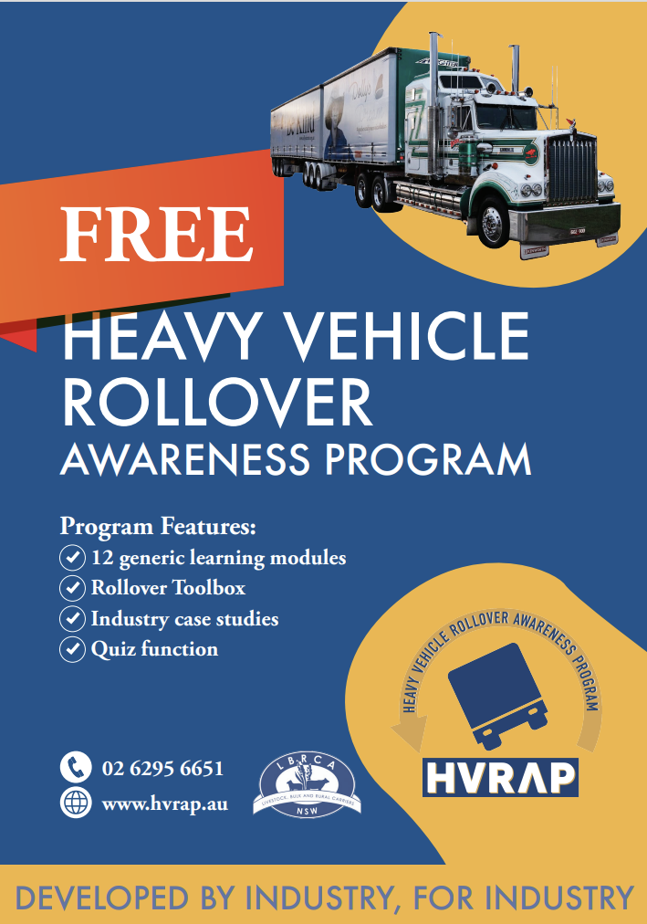

Advertise in The Rural Carrier

About the Magazine
The Rural Carrier Magazine is a monthly publication produced by the Livestock, Bulk and Rural Carriers Association (LBRCA). Delivered digitally to an estimated 600 members, industry stakeholders and suppliers via email and social media, with limited printed copies distributed, the magazine provides essential news and information tailored to support our members and the rural transport industry.
About the LBRCA
The LBRCA is a strong community of livestock, bulk, and rural carriers who transport Australia's vital agricultural products across regional and rural New South Wales. Our mission is to build a more productive, efficient, and safer industry for the future.
We offer members advocacy, support services, exclusive benefits, and vital networking opportunities.
Advertising Rates
Full Page Advertisement:
- 1 Insertion: $500 per insertion
- 6 Insertions: $400 per insertion
- 12 Insertions: $300 per insertion
Other advertising options available on request (POA).
Editorial Submissions
We welcome editorial submissions relevant to our members. Preference will be given to Blue Ribbon sponsors, advertisers, and conference exhibitors.
Contact
For bookings or editorial submissions, please contact:
matt@lbrca.org.au | 02 6130 1528 or
bec.coleman@lbrca.org.au | 0432 336 718
