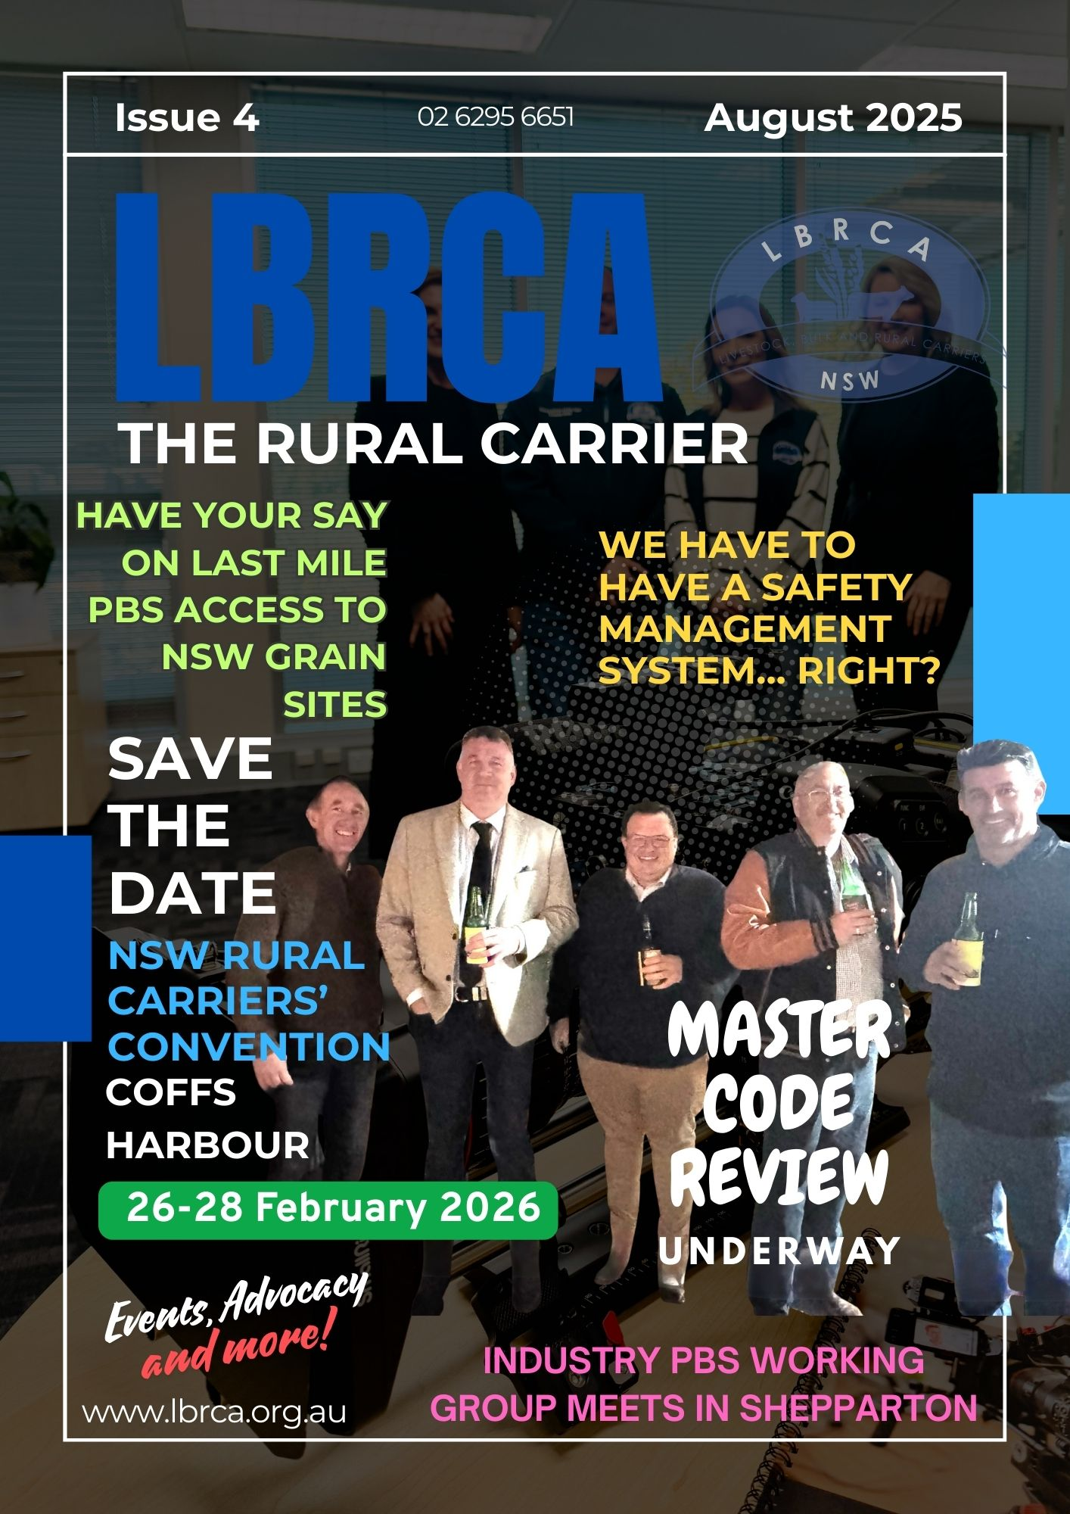
Contents

The Rural Carrier | Issue 5

Master Code of Practice Review
- NSW Roads Act 1993 Review
- The Facts About Safety Management Systems
- Hubfleet and LBRCA Partner
- New HV Check Weigh Site at Pine Creek
- Have Your Say on HV Rest Area for Deniliquin
- New Amenities for Drivers at Gunnedah Saleyards
- LBRCA is Heading to Queenstown
- LBRCA Participates in the Canberra Careers Expo
- Checklist for Directors of Companies
- Shepparton Hosts PBS Working Group
- LBRCA Participates in the LRTAV and LRTAWA Conferences
- LBRCA Member Meeting Schedule – Mark your Calendars
- WorkSafe ACT Transport Industry Forum
- Consultation Open for Goonoo Goonoo Road Upgrade
- Plus, much more….

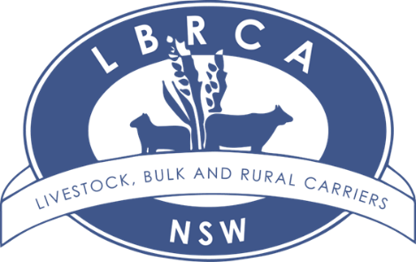

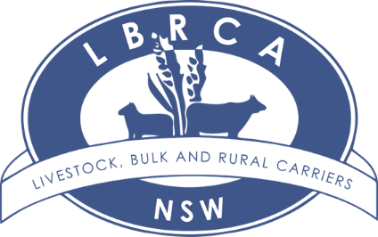
Welcome to Issue 4

Master Code of Practice Review
The NHVR is currently reviewing the Master Code of Practice, first registered in 2018, to ensure it remains relevant, practical and fit-for-purpose under the Heavy Vehicle National Law. The Master Code is a vital industry tool that helps operators and Chain of Responsibility parties manage risks such as fatigue, speed, loading, mass, vehicle standards and route planning. With the heavy vehicle sector evolving rapidly, the review aims to better align safety practices with modern operations and emerging risks.
Key changes proposed include shifting from a role-based format (e.g. driver, consignor, loader) to an activity-based structure (e.g. loading, maintenance, scheduling, route planning) to make the Code easier to apply across the supply chain. The revised draft also expands coverage to new hazards, embeds practical compliance tools, and is designed to be more user-friendly. A draft was released in August 2025 for consultation, with industry feedback invited ahead of the Code’s re-registration targeted for November 2025. LBRCA will be preparing input on behalf of members and encourages feedback to strengthen our submission.
NSW Roads Act – Have Your Say
The NSW Government is reviewing the Roads Act 1993, the law that governs how roads are managed and how heavy vehicles gain access. This is a rare chance to fix long-standing issues with inconsistent council decisions, permit delays and last-mile blockages. LBRCA will be lodging a submission on behalf of members and is calling for your input. Three options have been provided for discussion. This type of reform doesn’t come around too often so this is our chance to have our say and ensure what we need is reflected in the new Act.

Learn more about what we have been working on over the last month in this edition of The Rural Carrier.


Bec Coleman
LBRCA Chief Operating Officer

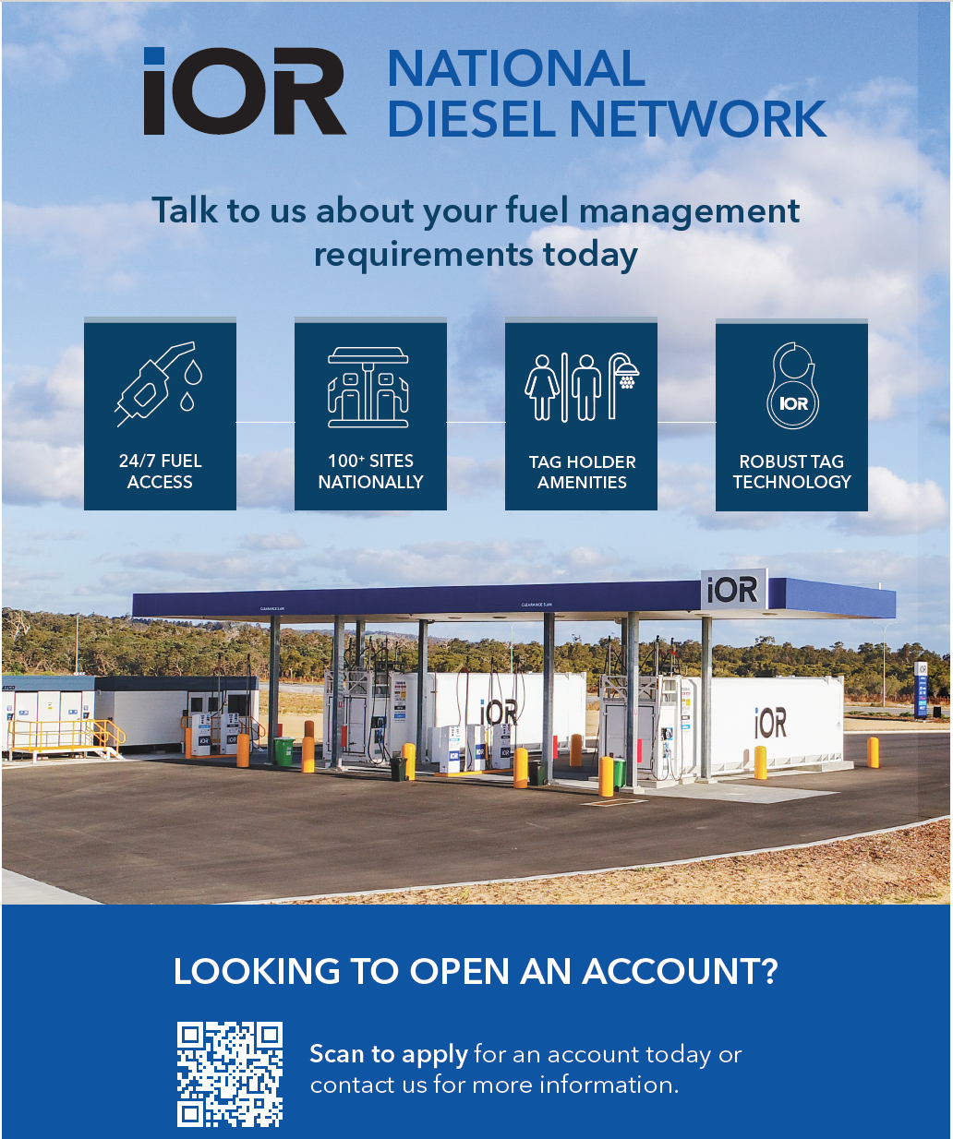

Strong Turnout at the LBRCA Rural Carriers Convention in Coffs Harbour
The Livestock, Bulk and Rural Carriers Association (LBRCA) brought the rural transport industry together in force at its 2026 Rural Carriers Convention, held in Coffs Harbour from 26–28 February, with more than 260 delegates from across Australia attending the highly anticipated event.
The convention once again proved to be one of the most important gatherings for operators involved in livestock, bulk and rural freight, providing a forum for industry leaders, drivers, suppliers, regulators and stakeholders to discuss the challenges and opportunities facing rural transport.
Industry Engagement and Important Conversations
Across the three-day program, delegates participated in a series of panel discussions, presentations and industry forums covering topics such as:
- Productivity and safety in heavy vehicle transport
- The future of Performance Based Standards (PBS) and high productivity vehicles
- Safety Management Systems and upcoming expectations from regulators
- Workforce development and training for regional transport businesses
- Technology and innovation, including the role of AI in transport operations
The convention provided a valuable opportunity for grassroots operators to share real-world experiences, ensuring that policy discussions remain grounded in the operational realities faced by rural carriers every day.

Special Guest Speaker Barnaby Joyce
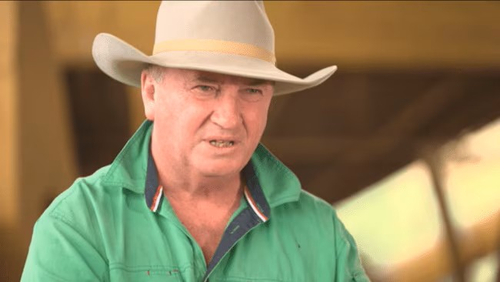
A highlight of the convention was an address by special guest speaker, Federal Member for New England, Barnaby Joyce, who spoke candidly about the growing concerns around diesel supply and energy security.
Mr Joyce warned that global tensions in the Middle East could place pressure on fuel availability in the coming weeks, raising concerns for industries heavily dependent on diesel, including agriculture and freight.
He emphasised that regional Australia relies on diesel to keep food and freight moving, noting that any disruption to supply chains could have significant implications for farmers, transport operators and ultimately the nation’s food security.
His address sparked strong discussion among delegates about the importance of fuel security for rural industries, reinforcing the need for government and industry to work together to protect Australia’s supply chains.
Industry Generosity in the Fight Against MND
While the convention focused heavily on industry issues, it also showcased the strong sense of community within the rural transport sector.
Delegates dug deep into their pockets during the event to support the fight against Motor Neurone Disease (MND), raising an incredible $17,100 through fundraising activities and the industry auction.
The contribution demonstrates the generosity and solidarity of the transport industry, with many operators personally affected by the disease or passionate about supporting the broader community.
A Strong Future for Rural Transport
The LBRCA convention continues to play a critical role in bringing the industry together to share knowledge, strengthen networks and shape the future of rural transport in Australia.
With strong attendance, meaningful discussions and overwhelming support for important causes, the 2026 Coffs Harbour convention once again demonstrated the strength and unity of the rural transport community.
As delegates returned to their businesses across regional Australia, the message was clear: when rural carriers come together, the industry is stronger, safer and better prepared for the challenges ahead.

Exhibition
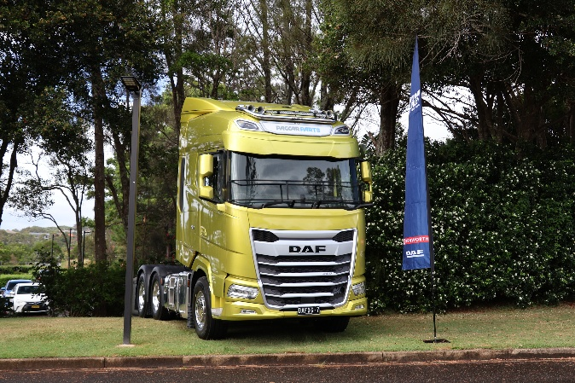
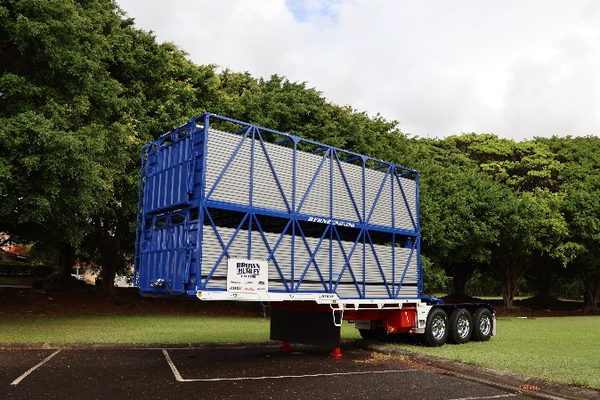
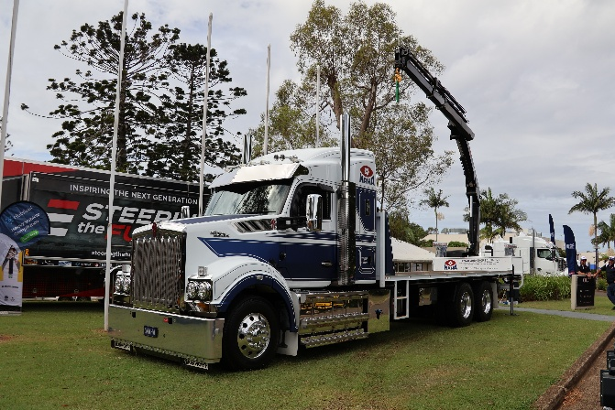
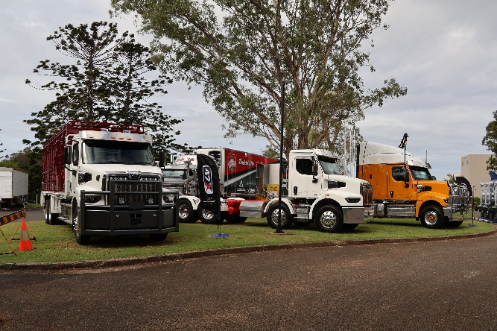
LBRCA Rural Carriers Convention 26-28 February 2026 Coffs Harbour
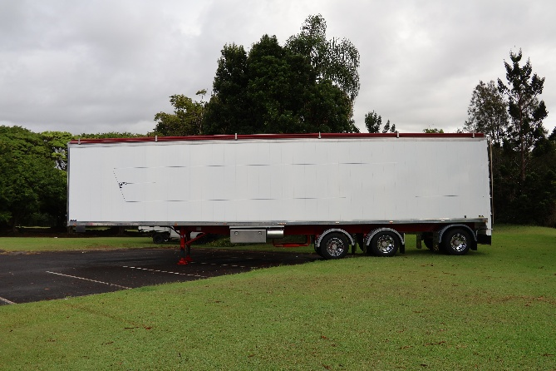
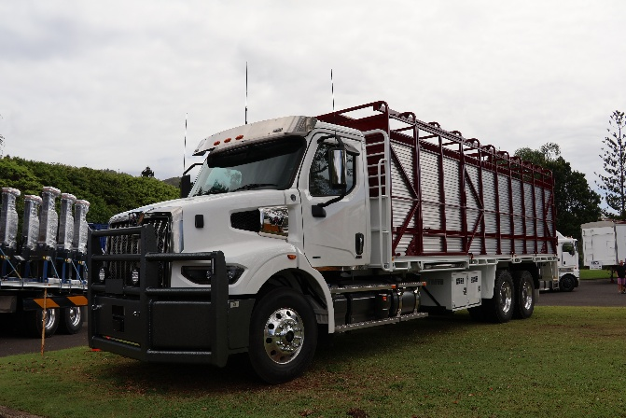
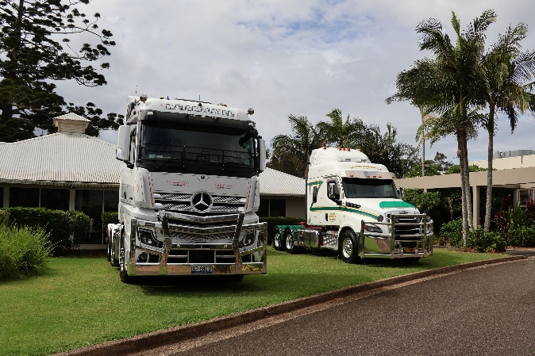
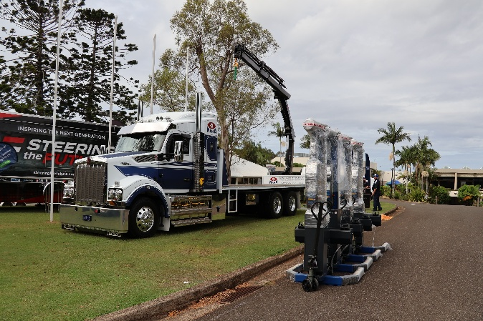

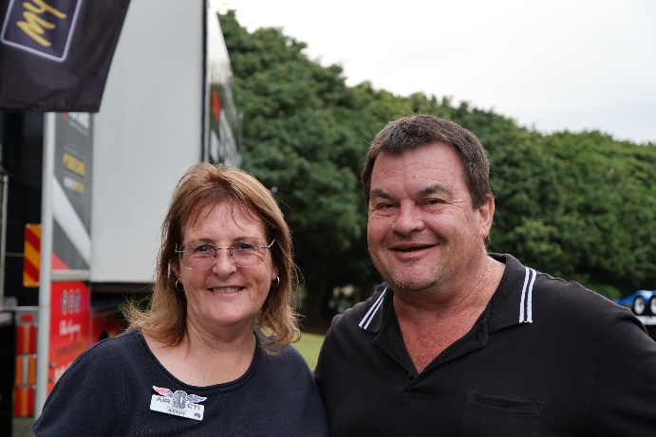
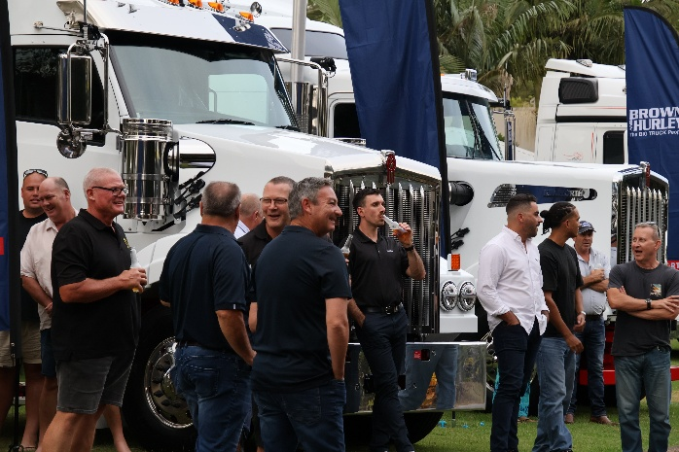
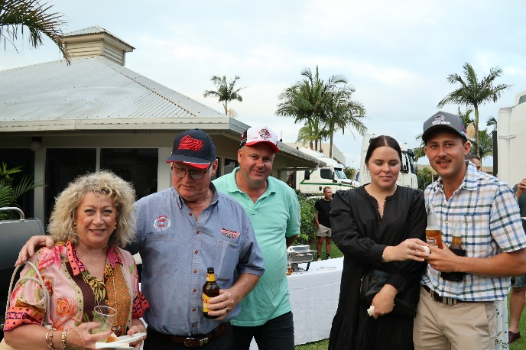
MAHA Australia Thursday Welcome BBQ
LBRCA Rural Carriers Convention 26-28 February 2026 Coffs Harbour
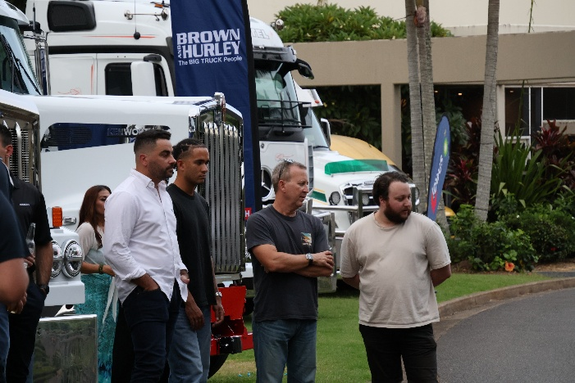
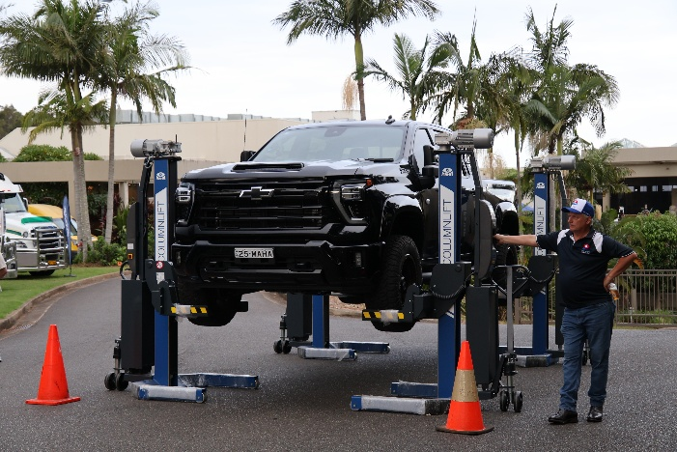
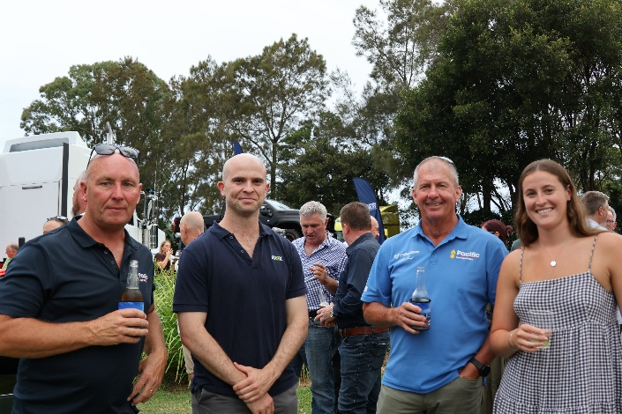
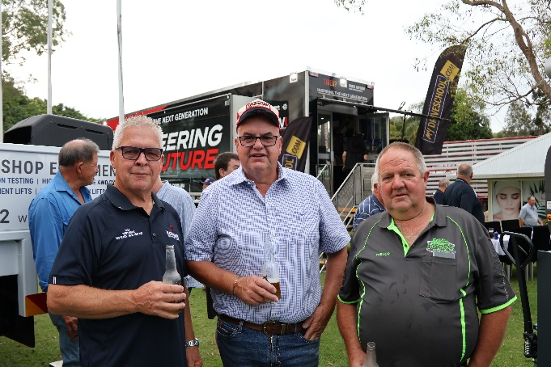
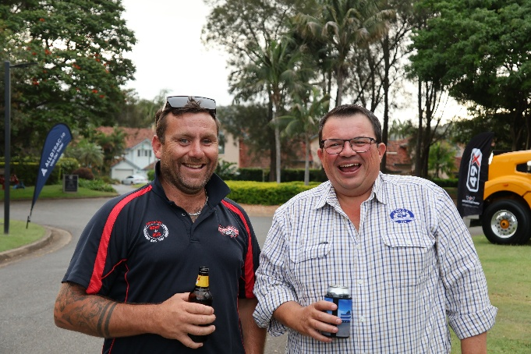

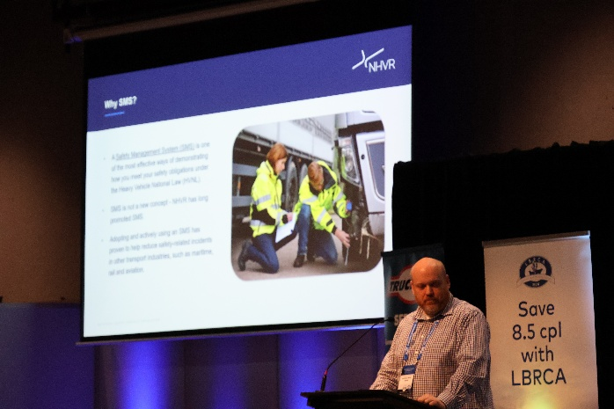
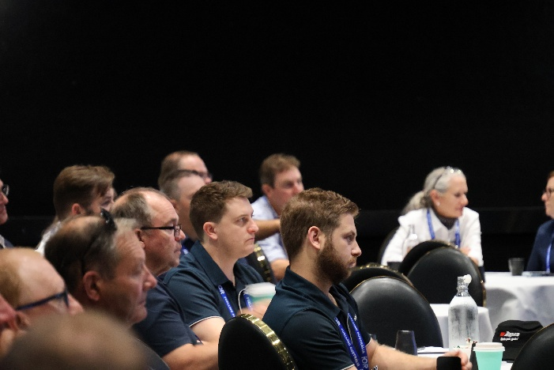
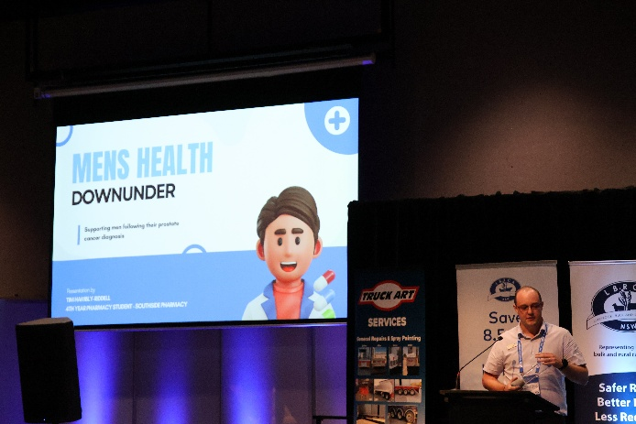
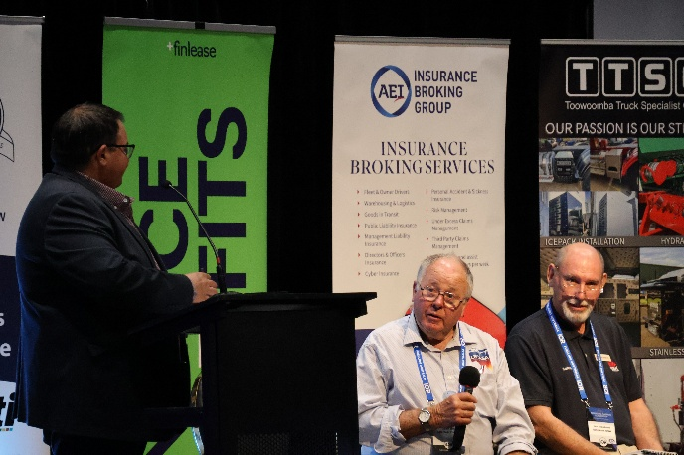

The Program
LBRCA Rural Carriers Convention 26-28 February 2026 Coffs Harbour
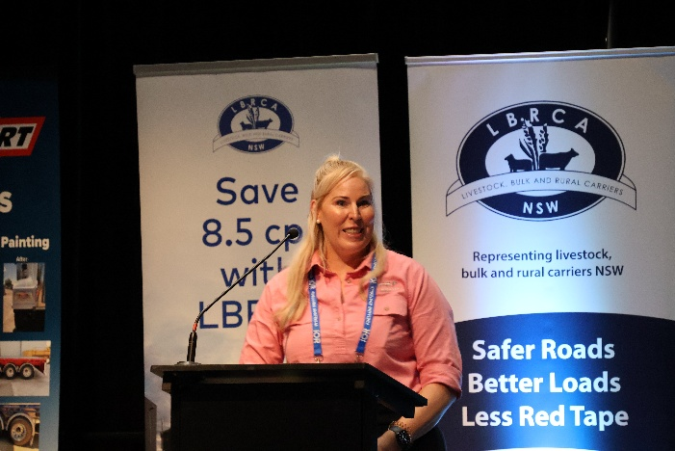
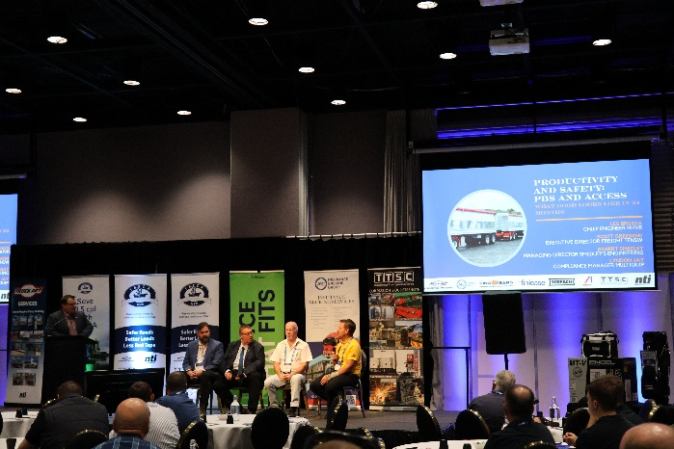
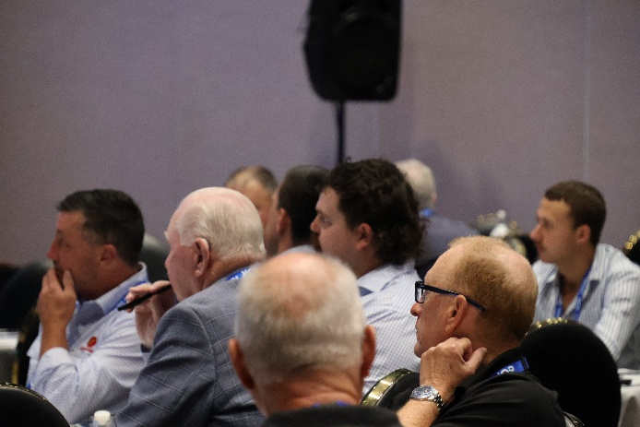

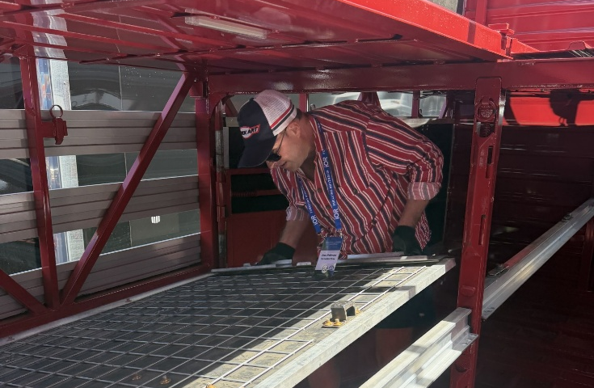
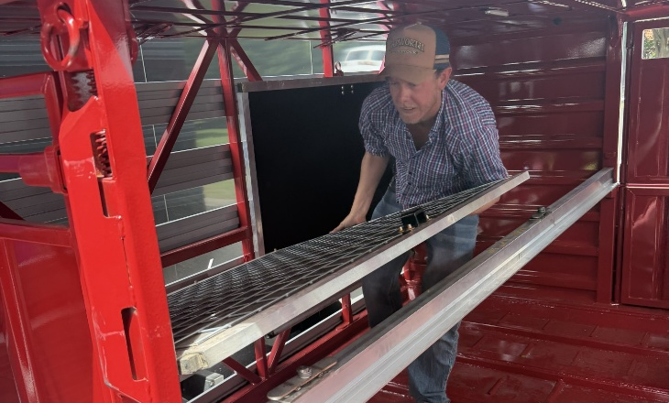
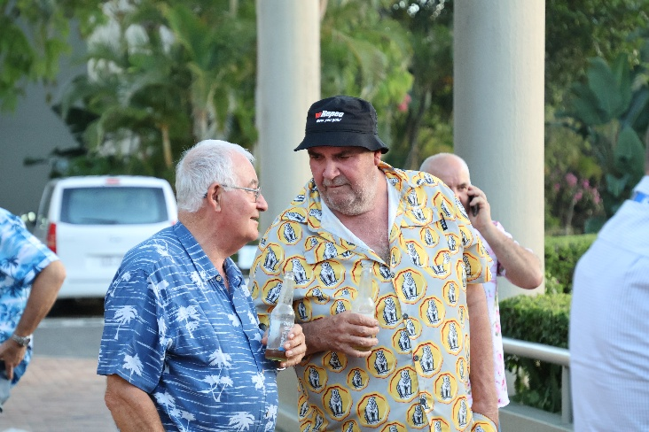
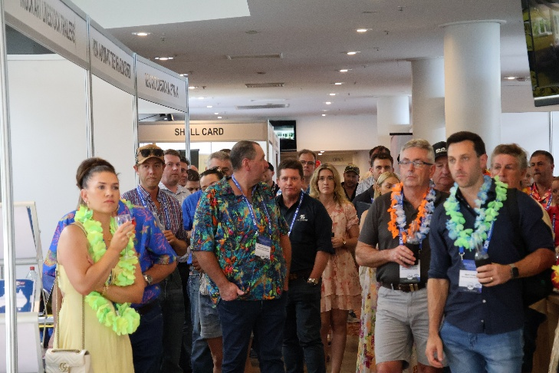
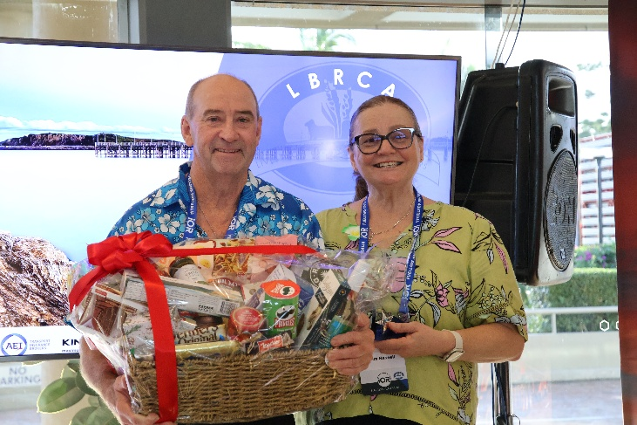
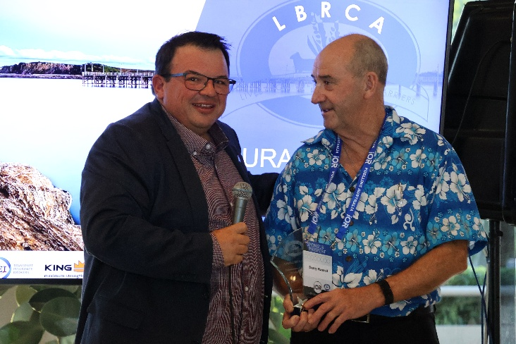
Penske Friday Afternoon Happy Hour
LBRCA Rural Carriers Convention 26-28 February 2026 Coffs Harbour
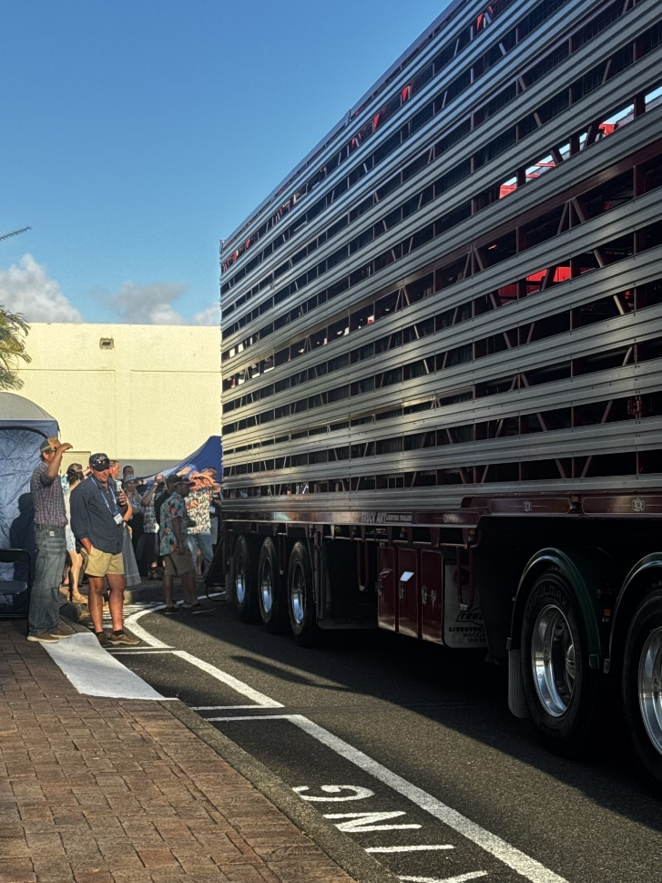
Partners Program
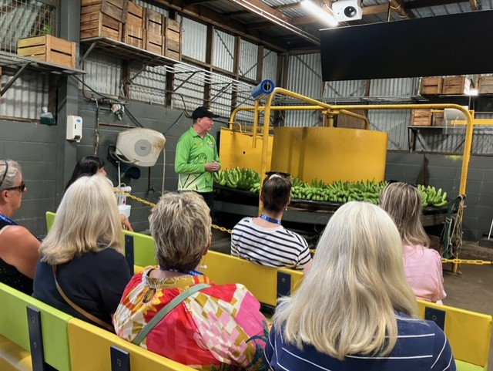
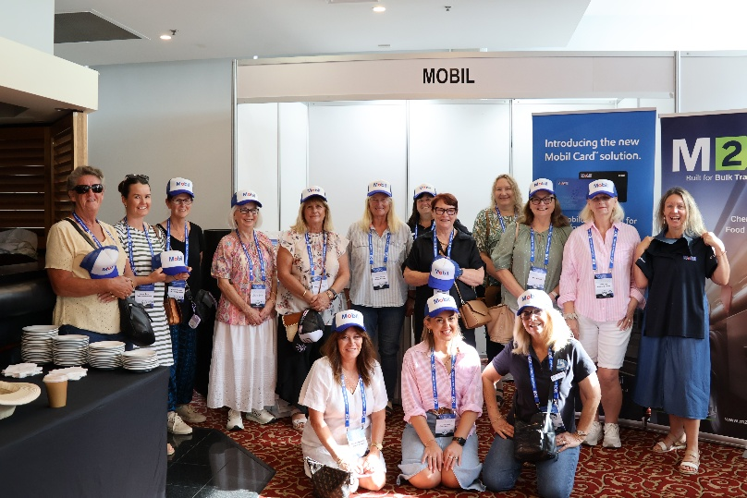
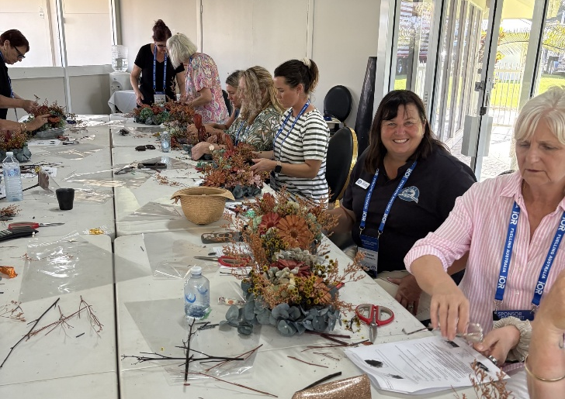
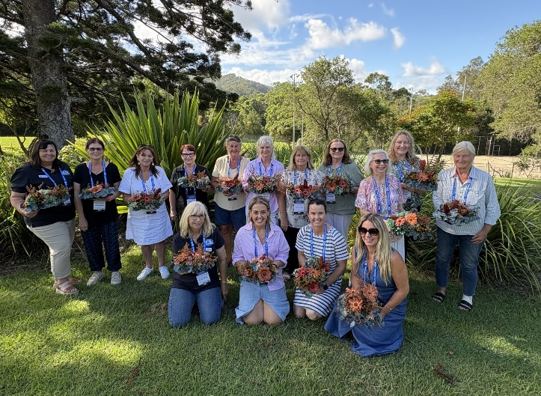
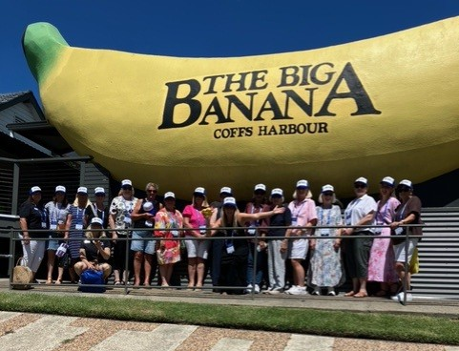
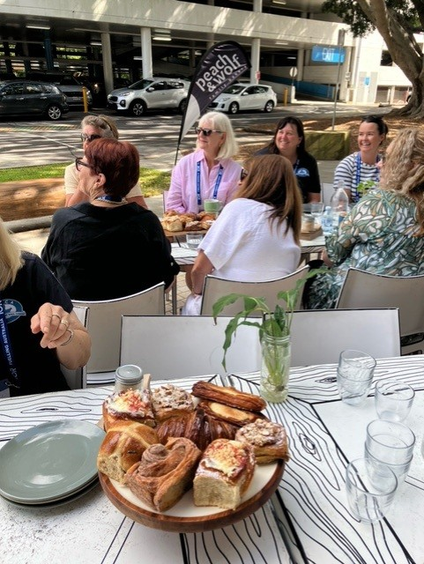
LBRCA Rural Carriers Convention 26-28 February 2026 Coffs Harbour
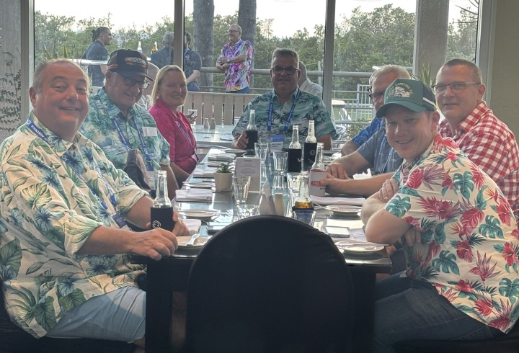
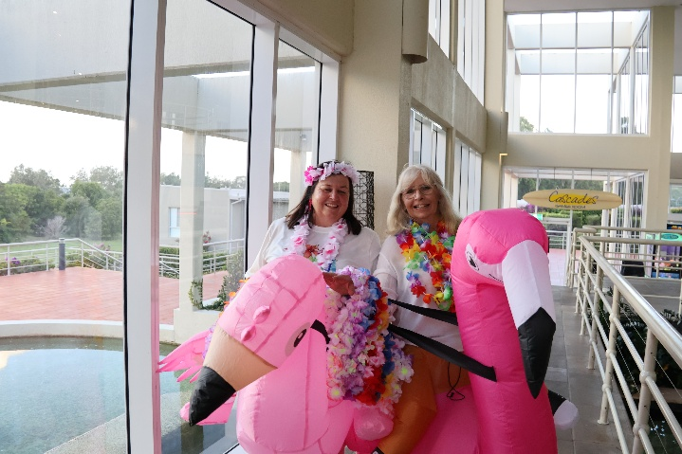
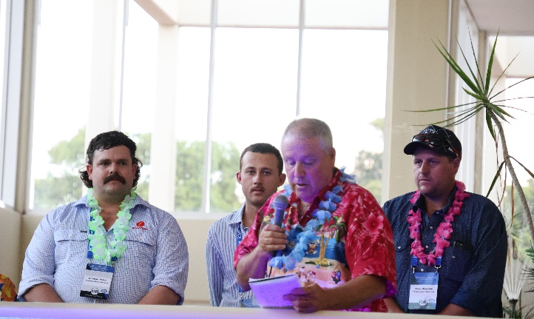

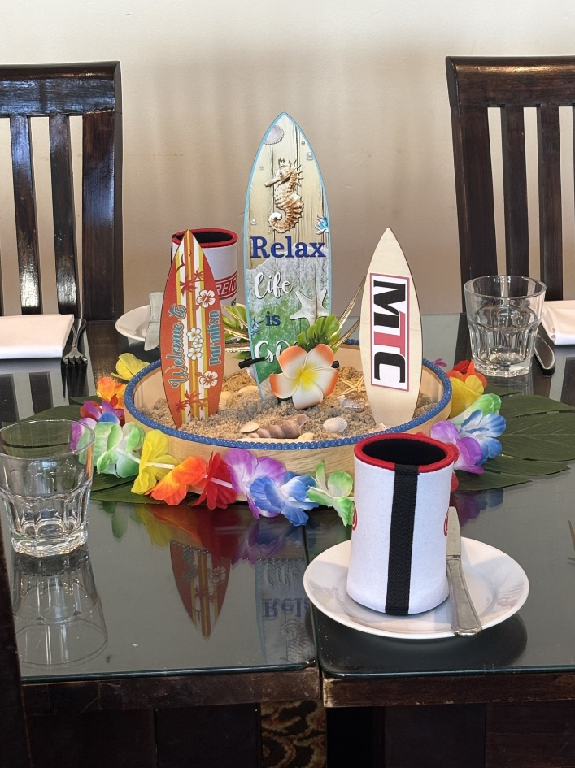
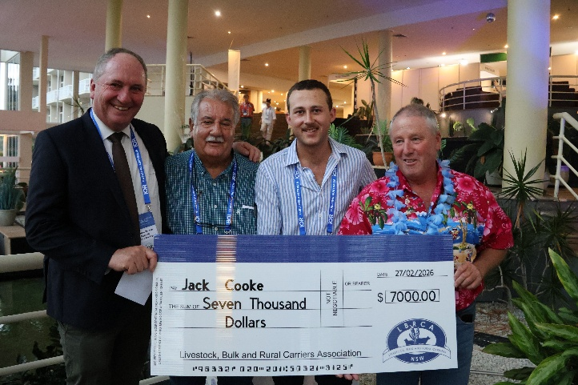
Mavin Truck Centre Friday Night Dinner
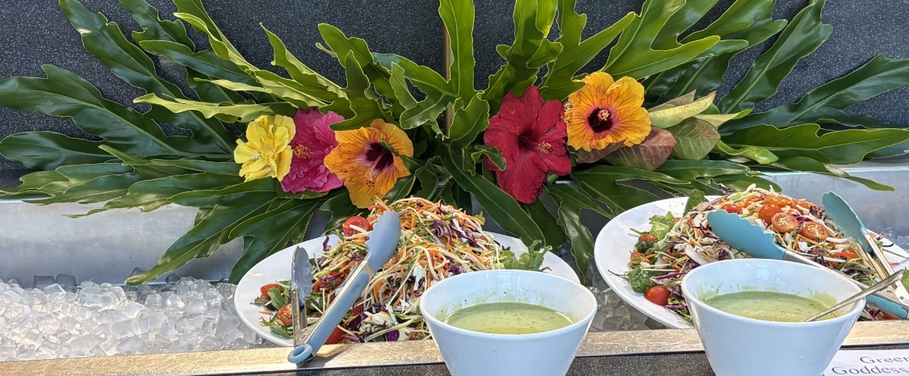
LBRCA Rural Carriers Convention 26-28 February 2026 Coffs Harbour

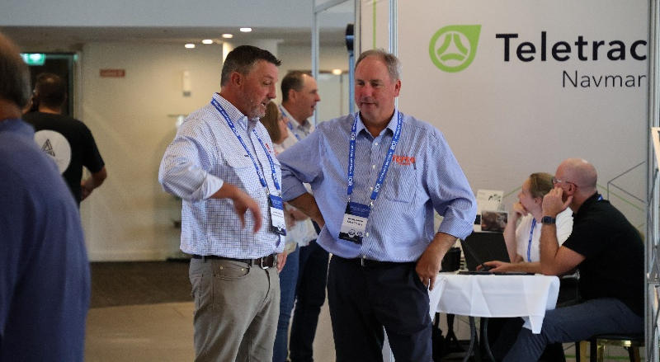
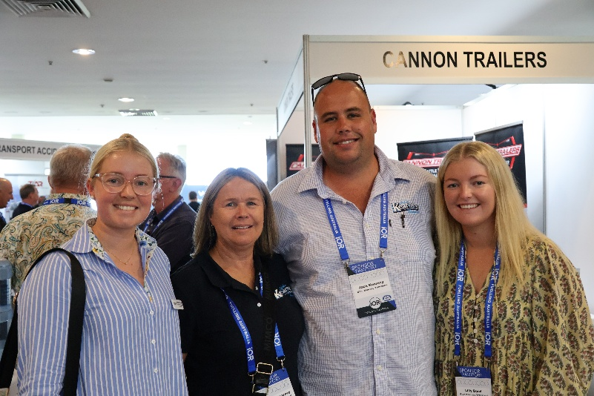
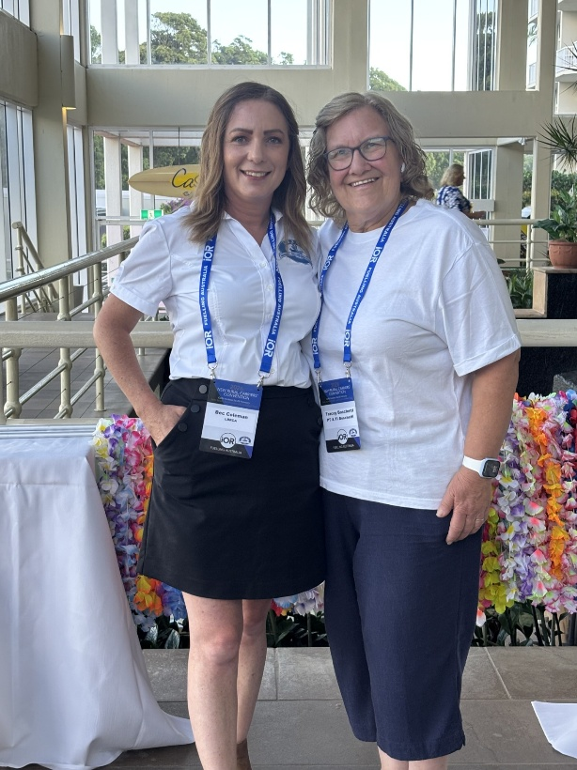
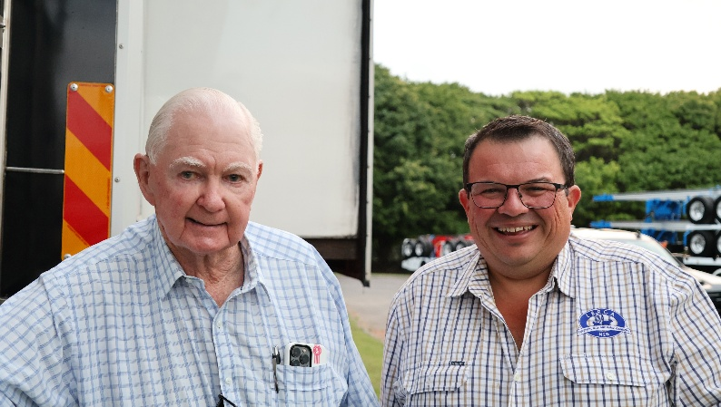
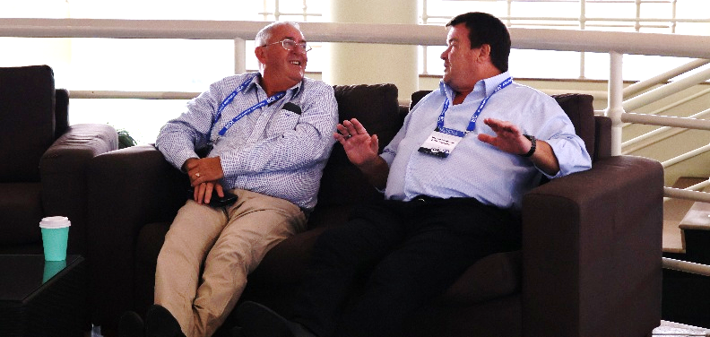
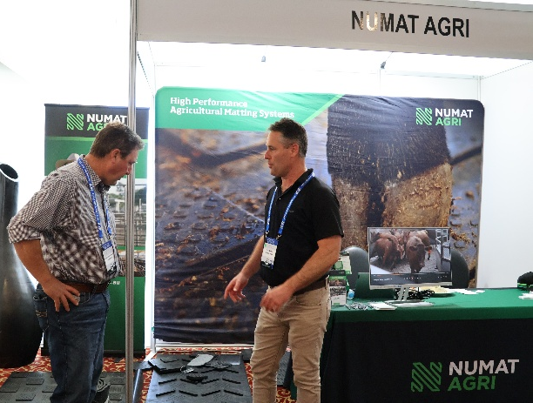
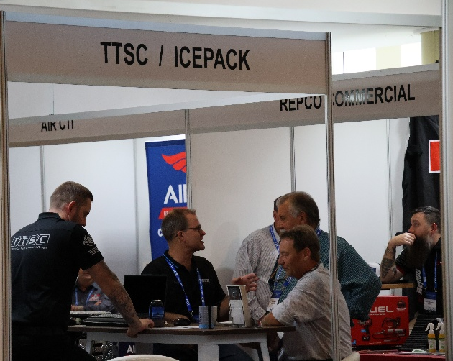
Networking
LBRCA Rural Carriers Convention 26-28 February 2026 Coffs Harbour

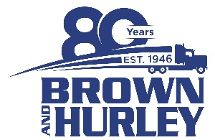
Brown & Hurley Coffs Harbour Gala Dinner and Auction
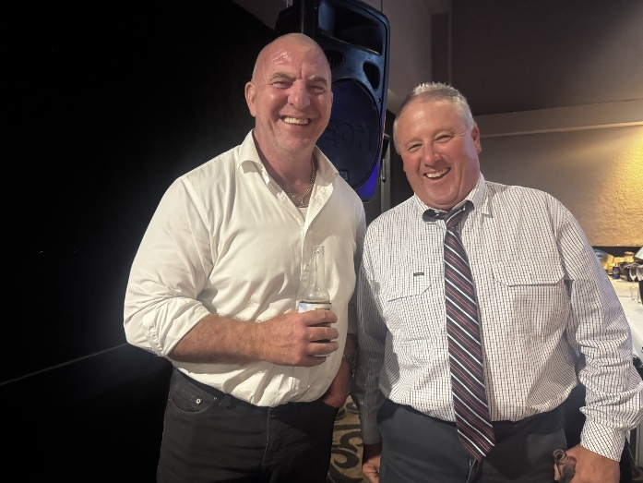
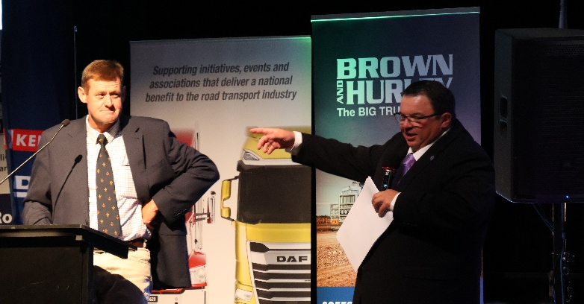
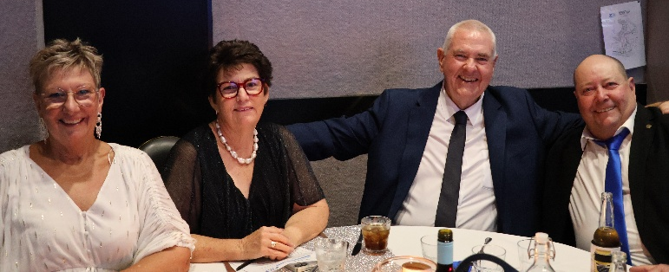
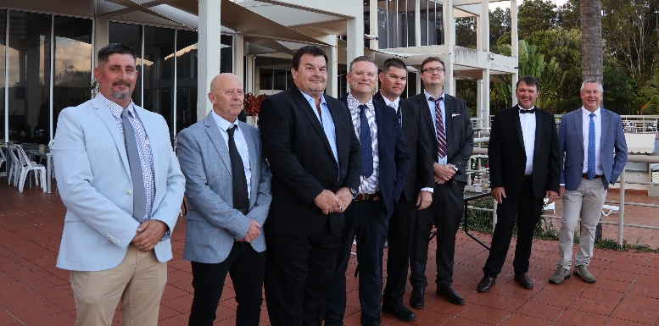
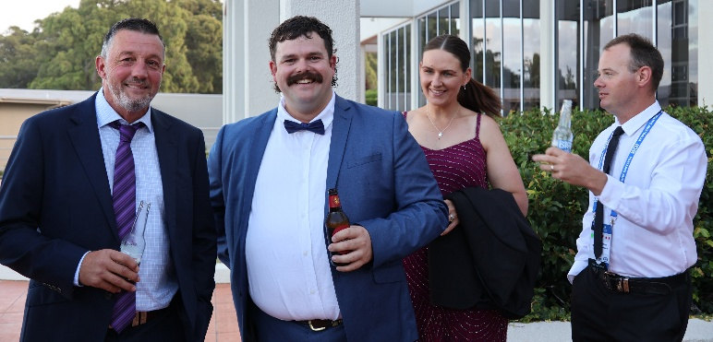
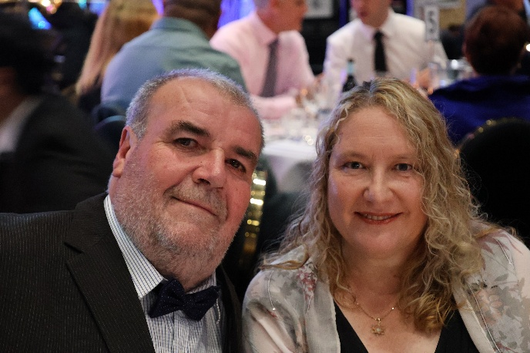
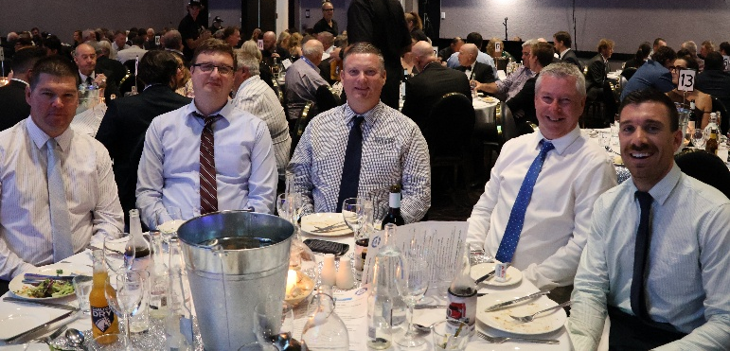
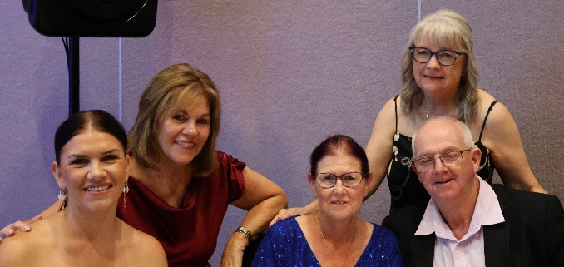
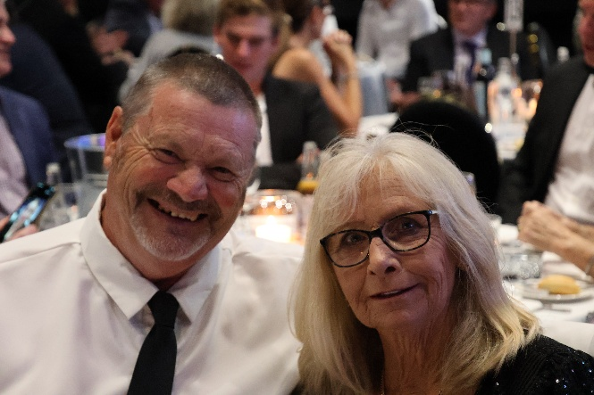
LBRCA Rural Carriers Convention 26-28 February 2026 Coffs Harbour

2026 LBRCA Executive Committee
In recent years, the National Heavy Vehicle Regulator (NHVR) has clearly increased
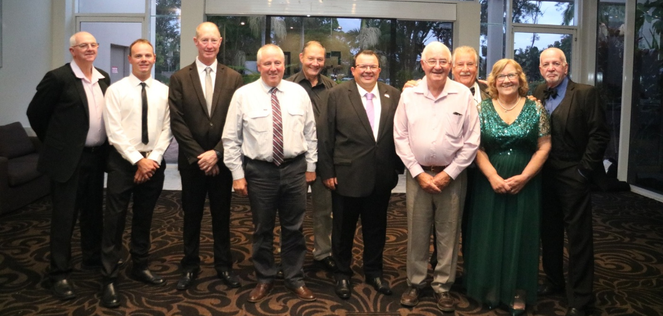

NHVR Master Code
By Belinda Hughes, Hughes Law Pty Ltd
In recent years, the National Heavy Vehicle Regulator (NHVR) has clearly increased its focus on Safety Management Systems (SMS) as a key tool for demonstrating compliance with duties under the Heavy Vehicle National Law (HVNL).
While there is no direct legislative requirement that a business must have a SMS there is a legislated duty to ensure, so far as is reasonably practicable, the safety of

Hubfleet Partners with LBRCA to Deliver Compliance Savings for Members
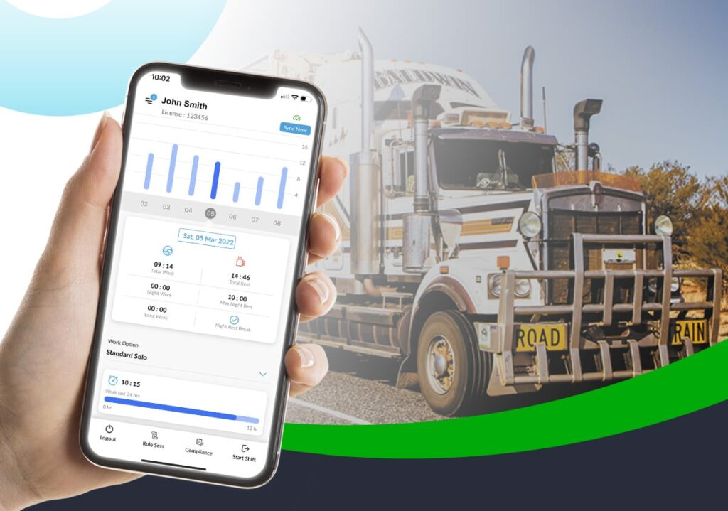

Hubfleet is pleased to announce a new partnership with the Livestock, Bulk and Rural Carriers Association, giving members access to an exclusive 20% discount on their first 12 months’ subscription to Hubfleet’s digital compliance platform.
Hubfleet is one of only 13 NHVR-approved Electronic Work Diary (EWD) providers in Australia, but it offers much more than electronic fatigue recording.
The platform is a complete digital safety management system, helping operators replace paperwork with simple digital tools that keep them audit-ready, compliant, and focused on their core business.
For drivers, Hubfleet’s EWD is a genuine game-changer. Unlike paper logbooks that round work and rest time into 15-minute blocks, Hubfleet records to the exact minute. That accuracy means drivers can legally reclaim up to 40 minutes of driving time each day.
The result is more productive hours on the road, without compromising fatigue safety rules. On top of that, roadside inspections become far less stressful. With Hubfleet, inspectors can instantly view accurate, legible records — eliminating the fear of unknown breaches, messy handwriting, or a misplaced logbook.
For operators, Hubfleet consolidates multiple compliance tasks into one platform. Fatigue management, Maintenance management, schedules, fault reporting, mass management and training records are all captured and stored securely in the cloud. Instead of spending hours chasing missing forms or filing paper records, operators have everything in one place — complete, legible, and audit-ready whenever it’s needed.
Perhaps most importantly, Hubfleet was built with drivers in mind. It’s simple, intuitive design has been developed with real-world feedback, making it easy to learn and adopt. Drivers appreciate a system that works for them rather than against them, while operators gain confidence in the accuracy and reliability of the data. This new partnership reflects the LBRCA’s commitment to providing members with real value — not just in financial savings, but also through tools that support safer, smarter, and more sustainable operations.
To access this exclusive offer, please contact Glyn, email glyn@hubfleet.com.au or phone 02 7908 4053 for your special member link.

New Heavy Vehicle Check Weigh Site at Pine Creek
A new heavy vehicle safety station along the Pacific Highway in NSW has opened, allowing drivers to self-check weights.
The new Pine Creek Heavy Vehicle Safety Station along the popular freight route is officially open, with the National Heavy Vehicle Regulator (NHVR) saying it allows drivers to self-check mass during unstaffed hours.
Members are reminded to follow the signed directions and not park or adjust loads onsite. Self-checking weights outside of staffed hours was first trialled at the Pacific Highway site in April last year, with two other 24/7 sites since being trialled in NSW on the Newell Highway and at Halfway Creek on the Pacific Highway.


Safer Local Roads and Heavy Vehicle Rest Area

Help! We Need Your Support for a New Heavy Vehicle Rest Area in Deniliquin

Edward River Council is preparing a funding application under the Safer Local Roads and Heavy Vehicle Rest Area Programs to support the upgrade of Saleyards Road and to construct a dedicated Heavy Vehicle Rest Area, and they need your help!
To strengthen their application, input from LBRCA members to a short survey is sought. The feedback collected will help the Council demonstrate the need for these important upgrades and ensure the project is designed to meet the needs of industry and the community. You can help by:
- Completing the survey by Thursday, 26 September 2025.
- Distributing the survey link to your customer databases, networks, and industry contacts to help capture as many responses as possible.
Your support in encouraging broad participation will greatly increase the likelihood of securing funding for these improvements. The survey will take less than one minute and all responses will help create a safe and efficient local road network!
The survey is available here - www.surveymonkey.com.au/r/LRWNGGJ

More Good News at Gunnedah Saleyards
LBRCA received news this week that four new shower and toilet ensuites are now open for the benefit of transport operators. Located in the new Administration Building at Gunnedah Regional Saleyards, the new amenities are accessible with an Avdata key only. The old shower and toilet block is still open, however members are encouraged to use the new amenities and give feedback on their design.
There is truck parking off the Kamilaroi Highway behind the carparking area. And if your feeling peckish after your shower, the JK Saleyards Café is open from 5am until after 2pm Monday to Friday and they are usually open on Monday nights for stock delivery. LBRCA extends a BIG thanks to the team at Gunnedah Saleyards for their support in providing fit-for-purpose and thoughtful amenities for the livestock sector.
We’re Heading to Queenstown in October
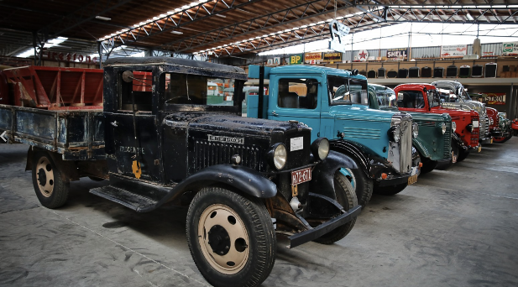
A delegation of 25 members and sponsors are heading to New Zealand’s South Island this October. The tour, proudly supported by Teletrac Navman, will provide valuable networking opportunities, firsthand industry exposure, and cultural experiences, helping participants enhance their business knowledge and foster international connections.

The study component of the tour will include a guided tour of the HWR Richardsons Hydrogen Plant followed by a trip to Bill Richardsons Transport World; a must-see museum housing over 300 classic vehicles. Considered ‘home’ to the mother of all Macks – the Mack AC ‘Bulldog’ truck – it was the truck that inspired Mack’s famous Bulldog logo. This beast of a truck was first introduced to the public at the Boston Truck Show in March 1916, with the US Army ordering 900 to help them during World War 1. Brett Gilmour from Northern Southland Transport will join us in Ayrburn with a suite of livestock and grain trucks for dinner, followed by a tour of a local dairy farm the next morning thanks to our friends at MyTrucking.
The fun part includes a tour and tasting at the Cardrona Whiskey Distillery, followed by local wine tasting and lunch at the impressive Kinross Cellar Door. We have an evening Lake Cruise and Dinner organised, a booking on Queenstown’s famous Gondola followed by dinner at the Stratosfare Restaurant which offers unforgettable panoramic views of Lake Wakatipu.
Fine dining experiences have been carefully curated including dinner at Botswana Butchery where we’ve been told the best cuts of meat on the island are found. A free day to explore Queenstown with options such as skiing, a tour of Milford Sound, jet boating, helicopter tours, quad biking, luge, bungee jumping, skydiving or ziplining can be enjoyed. No one has taken the plunge and booked a bungee jumping experience yet, but as they say, anything can happen with enough encouragement!

LBRCA Showcases Rural Transport at the Canberra Career’s Expo
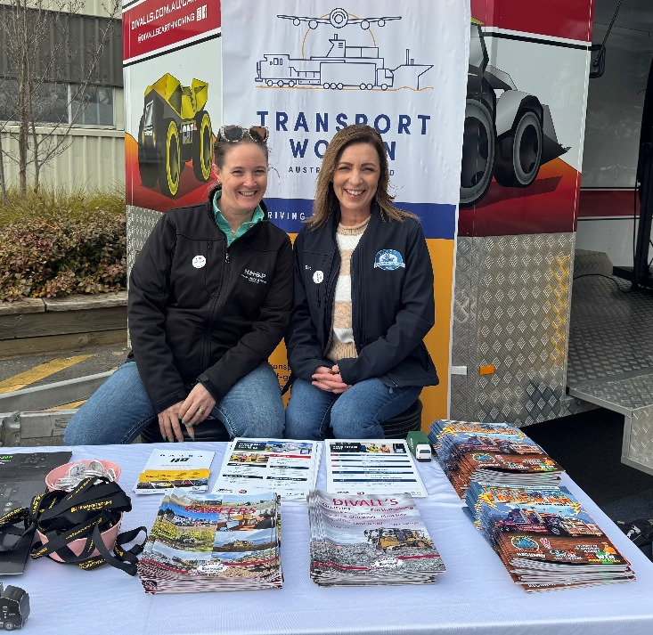
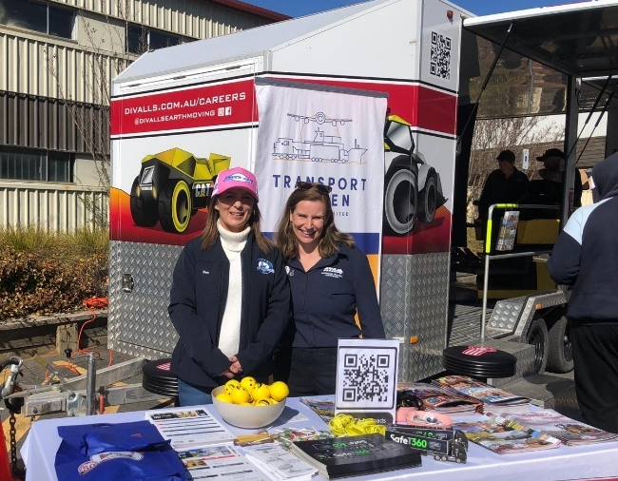
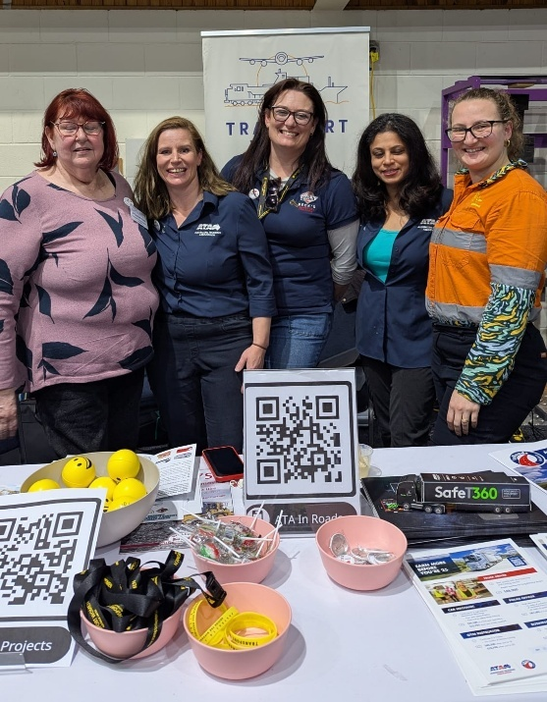
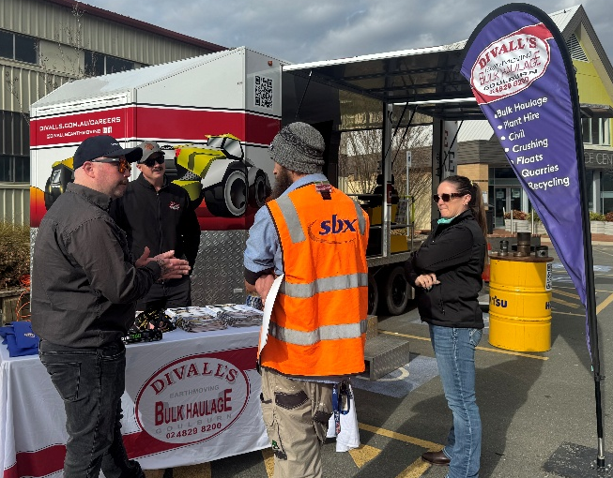
LBRCA’s Bec Coleman was on hand at the Canberra Career’s Expo earlier this month, joining representatives from Transport Women Australia Limited, the Australian Trucking Association, Beck’s Tranport and Training, Holistic Health and Safety Partners and Divall’s Earthmoving and Bulk Haulage to share our passion of trucks with over 9000 students from across the ACT and Southern NSW. We spent a solid two days talking trucks and sharing our passion of trucks and our industry. It was so refreshing to see the younger generation so enthusiastic about trucks and genuinely interested in the career opportunities it can bring.

Are you a Director of a Company?

By Belinda Hughes, Hughes Law Pty Ltd
If an incident occurs involving your company and you are a director, either WorkSafe or the NHVR may ask you some questions to determine if you have exercised your due diligence as a director.
Below is a checklist the NHVR or WorkSafe may ask you to determine if you complied with your obligations as officers.
- What have they done to acquire, and keep up to date, knowledge about the safe conduct of transport activities of your company?
- What have they done to gain an understanding of the nature of the business’ transport activities?
- What have they done to gain an understanding of the nature of the business’ transport activities?
- What have they done to ensure the business has, and uses, appropriate resources to eliminate or minimise those hazards and risks?
- What have they done to ensure the business has, and implements, processes to eliminate or minimise those hazards and risks?
- What have they done or ensure the business has, and implements, processes for receiving, considering, and responding in a timely way to, information about those hazards and risks and any incidents?
- What have they done to ensure the business has, and implements, processes for complying with the business’s safety duties?
- What have they done to verify the resources and processes are being provided, used and implemented?
- What is your budget that you set for safety?
- How do you know the above is adequate?
If you are not sure if you can answer each of these questions, don't be alarmed. Depending on the size of your company will determine how many steps towards each of these you must take.
Reading this article alone is something that you can note towards answer 1.

This advice should be considered as general guidance. Each case may present differences that impact this advice. Liability limited by a scheme approved under Professional Standards Legislation

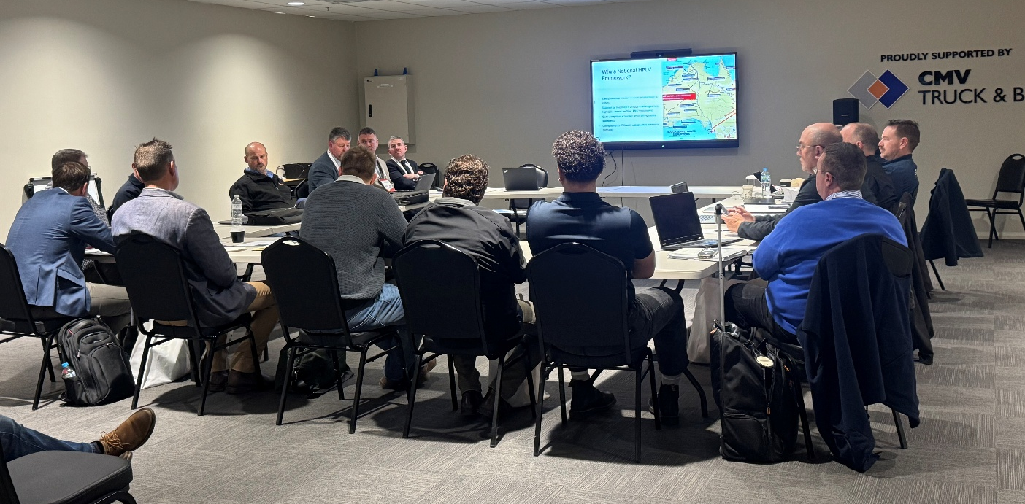
Shepparton Hosts PBS Working Group
The ALRTA PBS Working Group convened in Shepparton to discuss various aspects of livestock transport and the Higher Productivity Livestock Vehicle network (HPLV) earlier this month. Participants included representatives from the transport sector, who engaged in discussions about the development of a pre-approved road network aimed at enhancing the safety and efficiency of livestock transport. Presentations highlighted the importance of rollover stability and compliance with standards for approved access routes, as well as the need for facilities that can accommodate larger vehicles to ensure animal welfare.
LBRCA President Wade Lewis and LBRCA COO Bec Coleman participated with discussions on vehicle design, load management, and the complexities of creating a cohesive network across different states.
Participants also discussed PBS standards related to axle spacing and trailer lengths, emphasizing the need for future-proofing the network to facilitate expansions.
The meeting concluded with discussions on vehicle design, load management, and the complexities of creating a cohesive network across different states. Participants emphasized the need for tailored standards for livestock vehicles and improvements to the permit application process. The conversation underscored the importance of addressing safety protocols and enhancing productivity within the industry, with a call for a review of existing assessments to better support the needs of transport operators.

Have Your Say on Last Mile Access Gaps to Grain Receival Sites in NSW
The National Class 2 Performance Based Standards (High Productivity) Authorisation Notice 2024 (No.1) currently permits 11-axle A doubles to operate at 85.5 tonnes on the NSW PBS 2B network.
In practice, 12-axle A doubles are already operating in NSW under individual PBS permits. Including this combination in the national notice would remove the inefficiency of permit applications and create a more consistent framework. To support the LBRCA in resolving known last-mile access gaps to grain receival and manufacturing sites across the NSW network, we are seeking direct member feedback.
If you access grain and/or manufacturing sites by permit only, please let us know by completing the short LBRCA Member Survey. Your input will help us quantify the extent of current permit-based access and strengthen our case for amending the National Class 2 PBS (High Productivity) Authorisation Notice 2024 to formally include A-doubles—removing the need for inefficient permits.
The survey will take less than one minute – follow the link below:
https://form.typeform.com/to/onHzTuq

LBRCA Participates in State Conferences
LRTAV – Shepparton Vic 8-9 August
The LRTAV conference was held this year in Shepparton over the weekend 8-9 August at the spectacular MOVE Museum. LBRCA’s Bec Coleman participated in the annual event that seen members from across Victoria and abroad discuss various topics front and centre in the rural transporters space now, including Victoria’s innovative High Productivity Livestock Vehicle (HPLV) network.
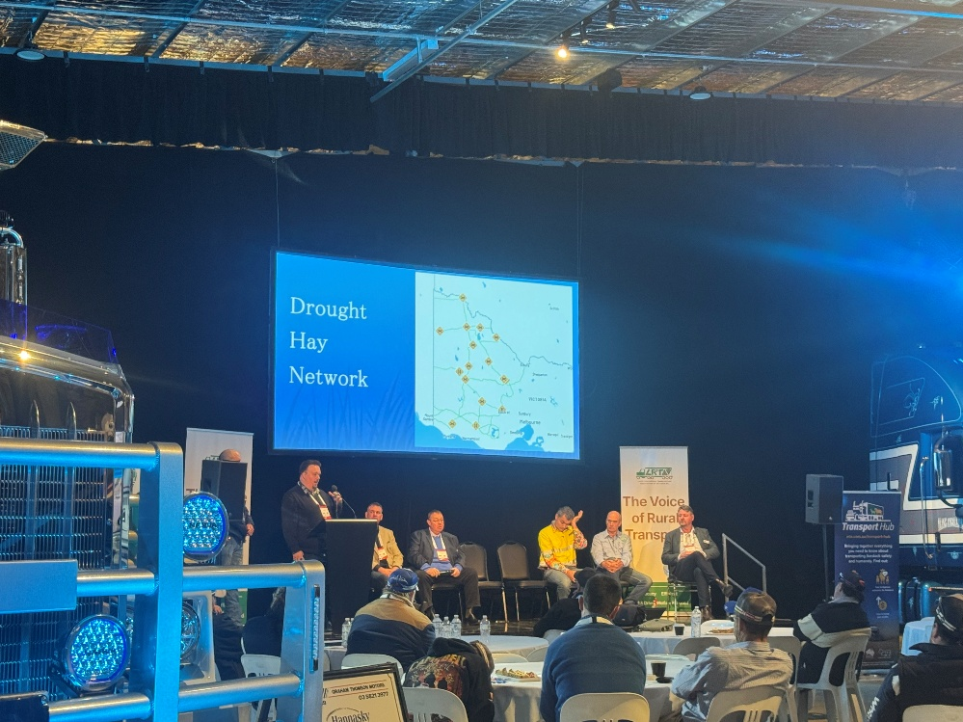
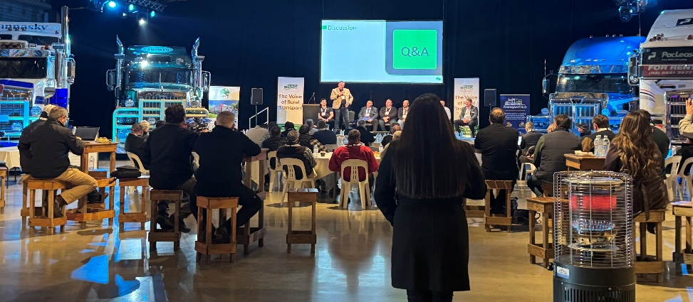
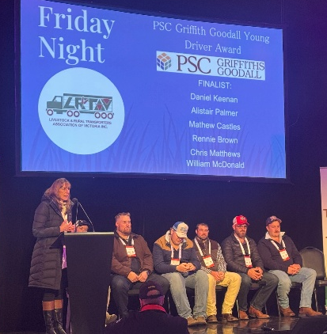
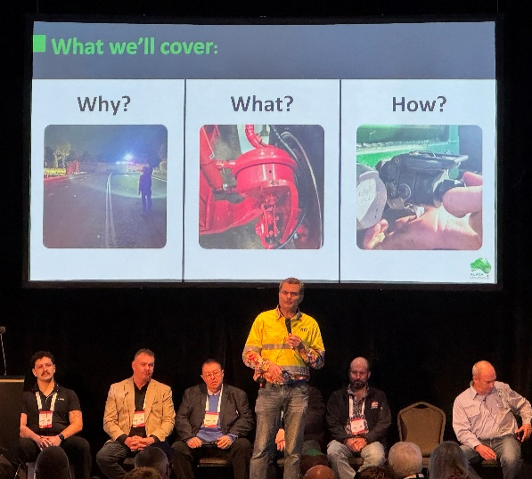
The delegation was treated to various panel sessions including on the recent Drought Hay Network, the Braking Habits project and the importance of functional braking systems that are proven to improve safety as well as a session on the Transport Hub inclusive of initiatives Meat and Livestock Australia are working with the livestock industry to improve. The announcement of the Victorian Young Driver of the Year was a real highlight with an impressive line up of 7 young drivers vying for the accolade of winner, with Rennie Brown taking out the title and Alistair Palmer coming in as runner up. The event concluded with a full house for the Gala Dinner hosted by the one and only lamb man Sam Kekovich. Another great event hosted by the LRTAV led by COO Alina Hawkins and President Russell Borchard.
LRTAWA – Swan Valley WA 22-23 August
The 45th LRTAWA conference was held in the beautiful Swan Valley in Western Australia over the weekend of 22-23 August. President Lewis and Bec joined federation representatives from across the country for the two-day event.
Congratulations to LRTAWA President Benno Sutherland and Executive Officer Jan Cooper and the team on delivering an outstanding program, filled with great people, impressive equipment, and sessions covering key industry issues such as heavy vehicle access, the implications of the live sheep export ban, fatigue management, mental health, financial resilience, and the impacts of HVNL prosecutions on operators.
A highlight of the conference was the awarding of LRTAWA Life Membership to long-serving and highly respected member David Fyfe —a fitting recognition of his dedication and contribution to the industry.
These conferences provide not only an opportunity to progress policy issues of relevance, but the perfect to catch up with friends new and old! Thank you to both LRTAV and LRTAWA for hosting us this month!
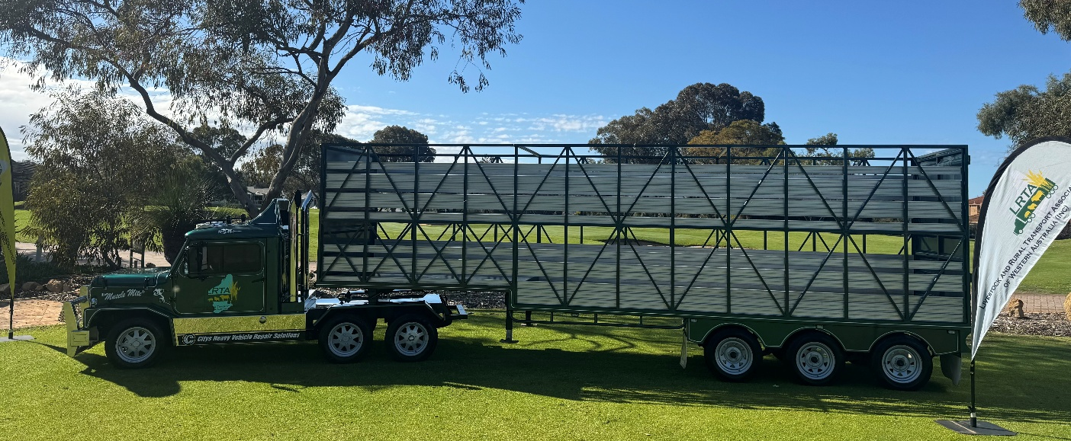
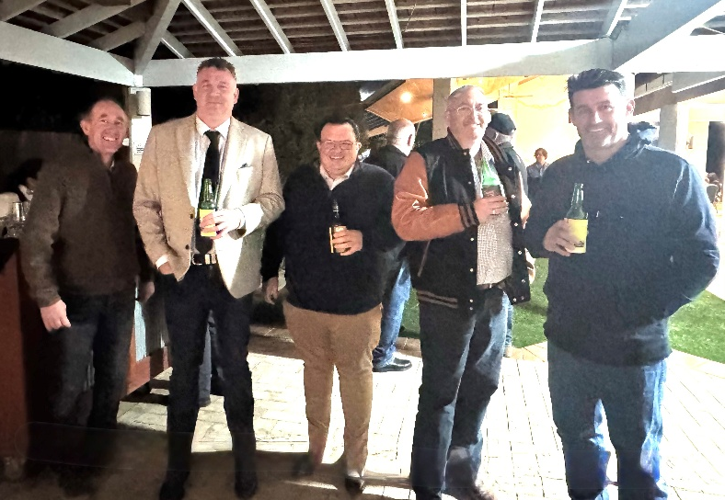
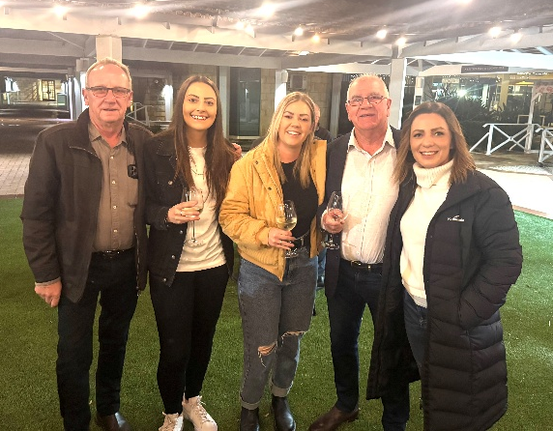
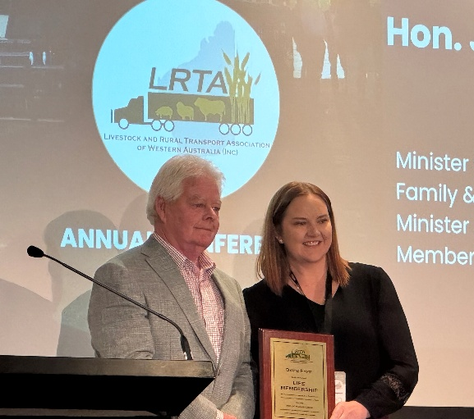


Leadership Change at Transport Women Australia Limited

After nearly eight years as Chair of Transport Women Australia Limited (TWAL), Jacquelene Brotherton has stepped down, leaving behind a legacy of growth and recognition for women across the transport industry.
Brotherton, who will remain on the TWAL Board, said the decision was a natural one.
“I realised it was time to pass the baton, particularly as the organisation prepares for a new conference year,” she said.
During her tenure, Brotherton helped transform TWAL into a truly national organisation. Membership has increased five-fold, sponsor and partner support has expanded, and events such as the annual conference and Brisbane Truck Show breakfast have attracted record numbers. She also championed key initiatives including the Driving the Difference scholarships and Young Gunnette and Dream Maker awards, providing platforms to celebrate and support women in the sector.
Reflecting on her time as Chair, she highlighted the importance of teamwork and inclusivity.
“It’s so important to bring your trusted team along with you. You have to support your community and nurture talent — looking to the past to help guide the future,” she said.
Looking ahead, Brotherton plans to focus on personal projects while continuing to contribute as a TWAL Director.
Stepping into the role of Chair is Coralie Chapman, who acknowledged Brotherton’s impact:
“I can’t thank Jacquelene enough for her guidance and friendship, and for taking TWAL to a whole new level. I have big shoes to fill, and I hope to make her proud.”

LBRCA Member Meeting Schedule: Update your Calendar

The LBRCA has scheduled meetings for the next 9 months and look forward to catching up regularly over this period. Across each month, a range of meetings will be held with the executive only, livestock and bulk sub-committees, as well as meetings for ALL members every 8 weeks. This is your opportunity to hear about progress on key policy areas as well as raise issues and contribute to formation of new policy.
2025 MEETINGS
28-Aug | 5.00pm - 5.30pm | Executive Meeting
10-Sep | 5.00pm - 6.00pm | Members Meeting
17-Sep | 5.00pm - 5.45pm | Executive Meeting (incl. Belinda Hughes)
1-Oct | 5.00pm - 6.00pm | Livestock Sub-Committee Meeting
15-Oct | 5.00pm - 5.30pm | Executive Meeting
29-Oct | 5.00pm - 6.00pm | Bulk Sub-Committee Meeting
12-Nov | 5.00pm - 5.45pm | Executive Meeting (incl. Belinda Hughes)
26-Nov | 5.00pm - 6.00pm | Members Meeting
10-Dec | 5.00pm - 5.30pm | Executive Meeting
17-Dec | 5.00pm - 6.00pm | Members Meeting
2026 MEETINGS
7-Jan | 5.00pm - 5.45pm | Executive Meeting (incl. Belinda Hughes)
21-Jan | 5.00pm - 6.00pm | Livestock Sub-Committee Meeting
4-Feb | 5.00pm - 5.30pm | Executive Meeting
18-Feb | 5.00pm - 6.00pm | Bulk Sub-Committee Meeting
26-Feb | 12.30pm - 5.30pm | TFNSW Quarterly Meeting / Members Meeting (incl. Belinda Hughes)
27-Feb | 8.30am - 5.00pm | LBRCA Annual Conference
11-Mar | 5.00pm - 5.30pm | Executive Meeting
25-Mar | 5.00pm - 6.00pm | Members Meeting
8-Apr | 5.00pm - 5.45pm | Executive Meeting (incl. Belinda Hughes)
22-Apr | 5.00pm - 6.00pm | Livestock Sub-Committee Meeting
6-May | 5.00pm - 5.30pm | Executive Meeting
20-May | 5.00pm - 6.00pm | Bulk Sub-Committee Meeting

Have Your Say: Review of the Roads Act

The NSW Government has released an Options Paper on the Roads Act 1993, kicking off a once-in-a-generation opportunity to modernise the legislation that underpins how our roads are managed and how heavy vehicles gain access. Submissions close 31 October 2025.

This review matters for every livestock, bulk and rural carrier in NSW. The Roads Act sets the rules for who controls our road network, how access is granted, and what responsibilities councils and road authorities hold. With more than 120 local councils acting as road managers, members know all too well the inconsistent, slow and sometimes risk-averse decisions that block efficient access to feedlots, silos, saleyards and processors.

Key Reform Proposals

The Options Paper puts forward three models:

Model 1 – Minor updates: Keeps the current Act with only small changes.

Model 2 – Modernised Act: Updates the law with clearer roles, freight corridor classes, accreditation-based access and digital permitting.

Model 3 – Full rebuild: A completely new framework separating “movement” and “place” functions.

The LBRCA sees the best path forward as Model 2 with targeted features from Model 3 practical, cost-effective, and advantageous to regional freight. This approach would deliver:

Freight corridor classes embedded in law.

Digital permits, accreditation and telematics with clear decision timeframes.

Network-level approvals instead of road-by-road permits.

Effluent and welfare infrastructure provisions tied to funding.

Stronger last-mile access programs to fix local bottlenecks.

LBRCA Submission

LBRCA will be lodging a detailed submission on behalf of members, ensuring the voice of rural carriers is heard. But we need your input to strengthen our case. Tell us:

Where are you facing last-mile access challenges?

How are inconsistent council decisions affecting your business?

What productivity gains could you unlock if access was simpler and more consistent?

This is your chance to shape the future of road access in NSW. Let’s work together to deliver a framework that supports safer, more productive and fairer outcomes for every operator. Please send your feedback to Bec in the Secretariat by 25 October.

Registrations Open Soon for LBRCA’s 2026 NSW Rural Carriers Convention
Circle the date, lock in your accommodation, and get ready—because the 2026 NSW Rural Carriers Convention hosted by the Livestock, Bulk and Rural Carriers Association (LBRCA) is set to be our most dynamic, engaging, and memorable event yet.
Set in the stunning surrounds of Coffs Harbour’s Opal Cove Resort, the 2026 conference offers more than a professional gathering. It’s a celebration of our industry, a forum for ideas, and an opportunity to connect with the people who drive rural transport in NSW forward every day. Whether you're an LBRCA member or attending for the first time, this is the event you won’t want to miss.

Innovate, Integrate, Accelerate:

Where Rural Transport Meets Transformation
LBRCA has shaped a program that strikes the perfect balance between innovation, integration and acceleration. In 2026, expect a fresh approach featuring high-impact, industry-led panel discussions, targeted sessions on key challenges and opportunities, and the popular return of the Livestock Conversion Challenge—plus exciting new additions still to be announced.
And it’s not just about business. This year’s format includes longer, more frequent breaks designed to foster informal conversations, deeper connections, and meaningful engagement in the relaxed setting of Coffs Harbour.
Some of the most valuable connections are made outside the conference room—and this year’s social program is designed with that in mind. From laid-back catchups to formal celebrations, there’s something for everyone:
These events offer the perfect platform to reconnect with peers, forge new partnerships, and build lasting relationships that support your success.
The 2026 NSW Rural Carriers Convention isn’t just another event—it’s a powerful investment in your business, your knowledge, and your network. Come to learn, to share, to be inspired, and to celebrate the strength and resilience of our industry. We can’t wait to welcome you to Coffs Harbour for what promises to be a landmark event.

NSW Government Delivers Fairer Road Recategorization

The Minns Labor Government is introducing a new evidence-based system to ensure NSW roads are categorised, funded and maintained by the right authority.

The New Approach to Road Recategorisation replaces the outdated, ad-hoc process with an ‘always open’ system, allowing councils to apply for changes at any time. A new Self-Assessment Tool and data portal will support councils with clear, consistent criteria for proposals. Consultation with 57 councils and industry groups showed strong support for a system that is fairer, faster and more transparent. The reform will strengthen partnerships between state and local governments, ensuring road categories reflect actual use – such as urban growth areas or freight-heavy routes.

Minister for Roads Jenny Aitchison said the change will deliver “a dynamic, transparent approach” to road management. She highlighted more than $1 billion in road and disaster recovery funding delivered in a single year, adding: “Motorists don’t care who owns the roads – they just want them safe and reliable. This system will help make that happen.”

Major Works Begin on New Marshalls Creek Bridge Replacement

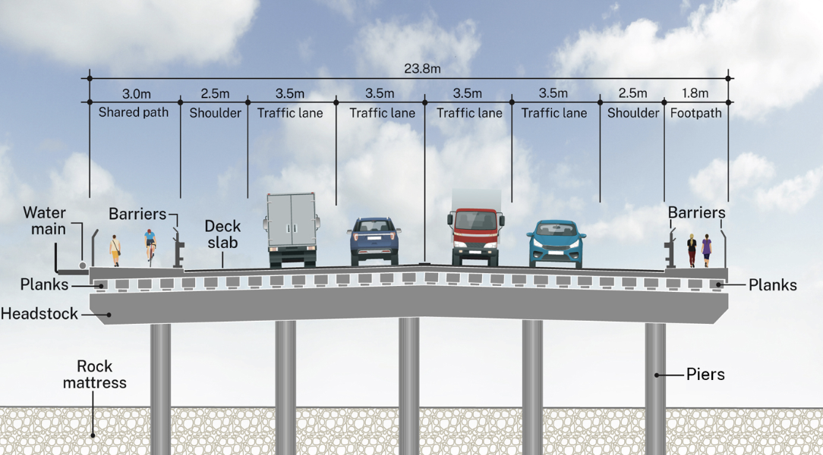

The Minns Labor Government has kicked off construction of the $30 million Marshalls Creek Bridge upgrade in Wagga Wagga, marking a major step toward easing congestion and improving safety for the 20,000 vehicles that use the Sturt Highway each day.

The project will replace the existing two-lane crossing with a wider four-lane bridge, eliminating bottlenecks and delivering smoother east–west connections for local residents, businesses, and freight operators. Pedestrian and cyclist safety will also be improved, with a new shared path on the southern side and a footpath on the northern side of the bridge.

Construction will be staged over two years to keep traffic flowing as much as possible, with temporary pedestrian access provided to maintain links across Marshalls Creek and along Wiradjuri Track.

Minister for Roads Jenny Aitchison said the project will create a “safer, stronger and more efficient” crossing, while Independent Member for Wagga Wagga Dr Joe McGirr described it as “a real win for our community” that will make daily travel quicker and safer.

LBRCA will participate in consultation that is open now and keep members informed of progress.
LBRCA Participates in WorkSafe ACT Transport Industry Forum
LBRCA COO Bec Coleman participated in the WorkSafe ACT Transport Industry forum today in Canberra. A great opportunity to discuss safe and healthy workplaces with the ACT government, NHVR and Healthy Heads in Trucks and Sheds. Over 100 transport representatives discussed what needs to be done to truly support an industry that is critical to Australia’s economic viability.
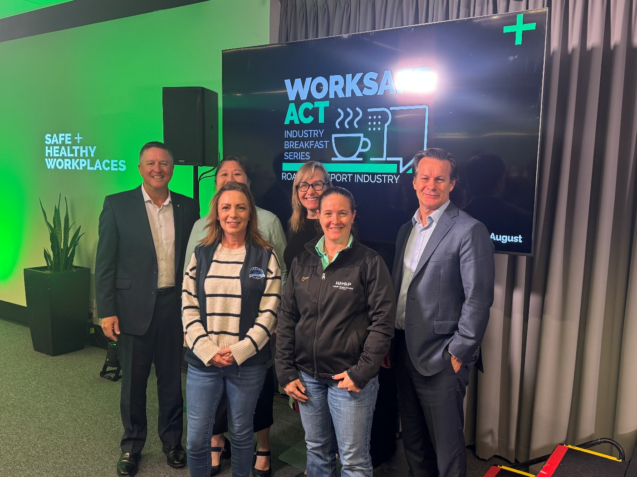
Big thanks to LBRCA member and Healthy Heads in Trucks and Sheds (HHTS) ambassador Ben Maguire, Paul Salvati (NHVR) and Peggy Cheong (Deputy Work Health and Safety Commissioner ACT) who respectively answered many questions from the floor covering everything from fatigue, health and wellbeing, work diaries, HVNL and WH&S, operator licencing, infrastructure constraints, training and licensing and CoR.

Community Consultation Opens on Goonoo Goonoo Road Upgrade
The Albanese and Minns Labor governments have revived the long-stalled $58.4 million upgrade of Goonoo Goonoo Road in Tamworth, with the community now invited to have their say on the next stage.
The project, jointly funded with $46.72 million from the Federal Government and $11.68 million from NSW, will focus first on the northern section between Craigend’s Lane and Calala Lane – the busiest stretch carrying over 20,000 vehicles daily.
Key features include:
- Traffic lights replacing the Calala Lane roundabout
- Dedicated and shared turning lanes to ease congestion
- Safer pedestrian crossings at all approaches
- Widening to four lanes with a central median
- A new eastern footpath from Craigend’s Lane to Calala Lane
Federal Infrastructure Minister Catherine King said the upgrade will “improve safety, support planned growth and strengthen Tamworth’s role as a regional freight hub.” NSW Roads Minister Jenny Aitchison added: “This project was stalled under the previous government, but we are now getting it back on track in partnership with the community.”
Members can view plans and provide feedback at nswroads.work/ggroad.

Members Haul at Country Truck Shows
Weethalle Truck Show
LBRCA Young Driver of the Year 25’, Timmy Mitton, joined truck enthusiasts incl LBRCA members Kurt Duffy, Clayton Thomas, Jeremy Horne, MD Trucking and FarmFreight in Weethalle a couple of weeks back for the town’s annual show.
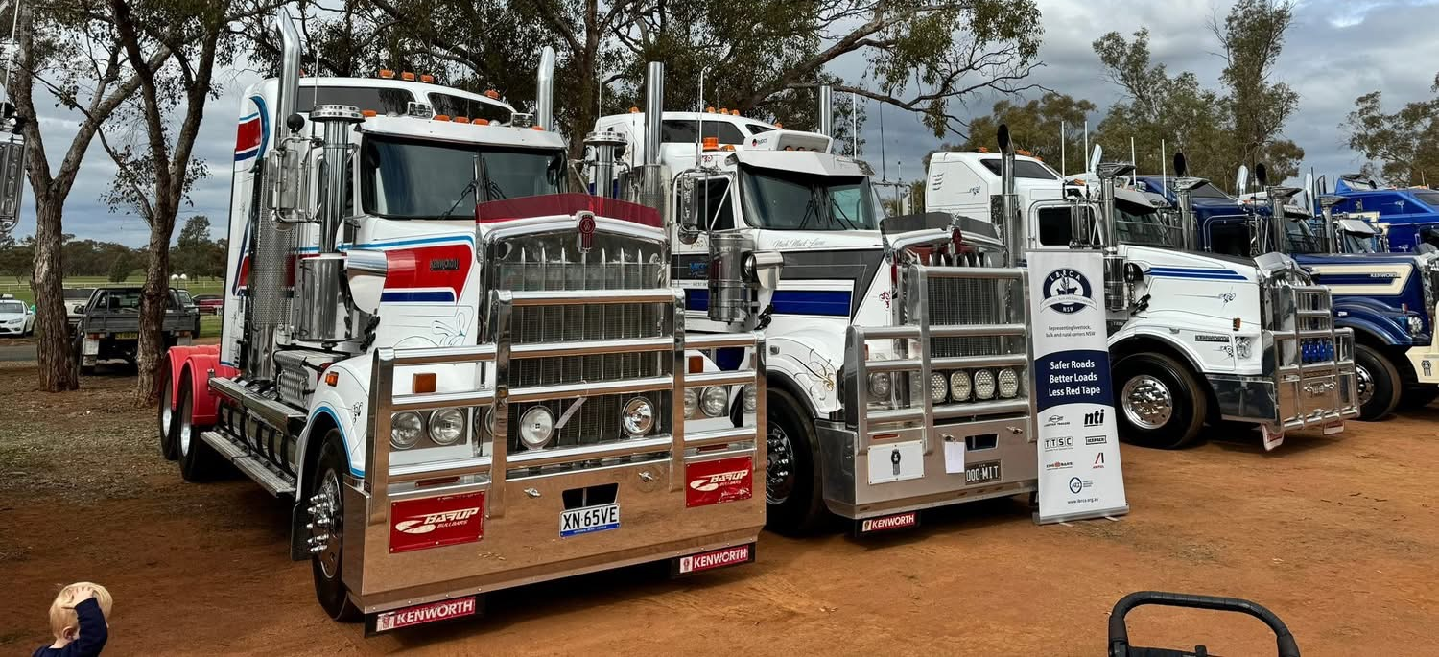
Trangie Truck Show
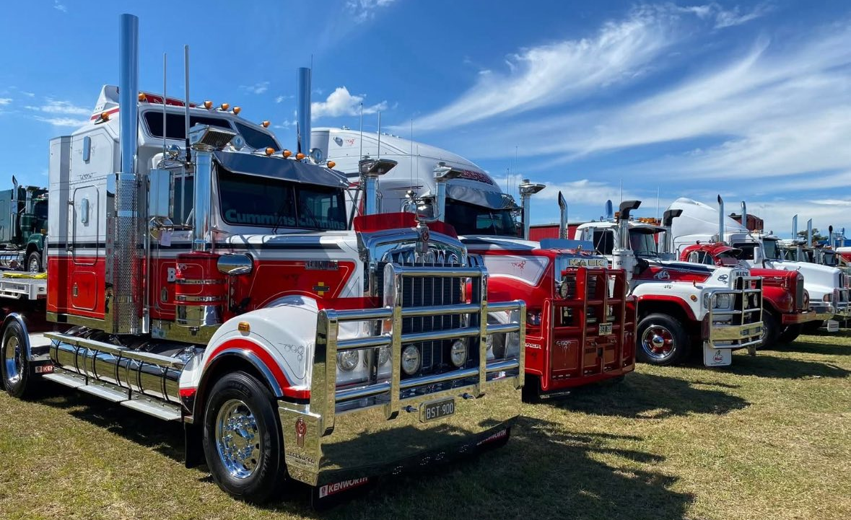
Congratulations to Chris Betts on being awarded ‘Truck of the Show’ at the Trangie Truck Show held last weekend.
New 80 km/h Speed Limit on Rugby and Narrawa Roads
From 25 August 2025, the speed limit between Boorowa and Narrawa will be reduced from 100 km/h to 80 km/h following a safety review by Transport for NSW.
The 43km section was identified as a route of concern after crash rates were found to be significantly higher than expected for a rural regional road. The review, supported by NSW Police and Hilltops Council, confirmed the road environment did not meet the standard for a 100 km/h zone.
Electronic signs and community notices will advise motorists of the change. Drivers are reminded to follow all signage and drive to conditions.

Operation Falcon Highlights Safety of PBS Vehicles
The NHVR’s Operation Falcon (28 April–3 May 2025) has confirmed the strong safety and productivity record of Performance-Based Standards (PBS) vehicles in NSW.
Of 367 PBS vehicles inspected, the non-compliance rate was just 11%, compared to 22% for the 1,928 other heavy vehicles checked. PBS combinations also achieved 100% load restraint compliance.
NHVR Acting Director Alen O’Hara said the results prove PBS vehicles are safer by design, moving more freight with fewer truck movements. “PBS vehicles are involved in 46% fewer major crashes per kilometre than conventional heavy vehicles,” he said.
The operation also included 122 driver interactions to improve awareness of PBS permit and network conditions, with a focus on helping operators meet obligations.

NHVR Draft Master Code – Risk and Activity Framework
This summary provides a clear overview of the revised NHVR Draft Master Code (2025).
It captures the key risk areas, emerging hazards, and the underlying foundation activities that all Chain of Responsibility (CoR) parties must integrate into their safety management systems. The purpose of this framework is to help organisations understand their obligations, map risks to specific activities, and conduct practical gap analyses to strengthen compliance.
Risk Area Aligned Activities
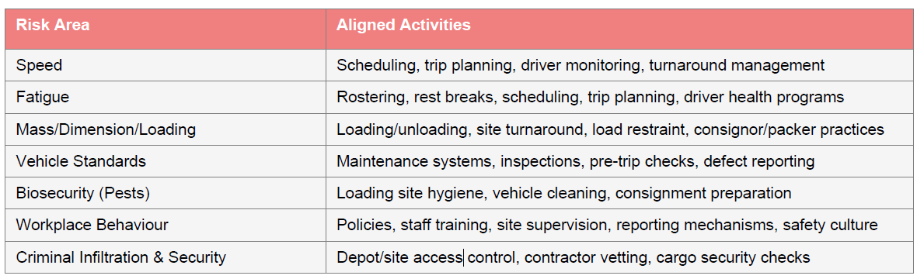Foundation Activities
The revised Master Code emphasises the importance of foundation activities that underpin every risk control measure. These activities establish the systems, culture, and governance that ensure risks are not just identified but are systematically managed across the supply chain. The foundation activities include:
Safety Culture & Executive Due Diligence: Building a strong safety-first culture, with directors and executives demonstrating active oversight, regular reporting, and commitment to Chain of Responsibility obligations.
Competency & Training: Ensuring all staff, contractors, and managers are adequately trained in both general safety principles and specific activity-based risks such as scheduling, loading, and vehicle maintenance.
Information Sharing: Establishing reliable systems for the timely exchange of safety-related information between consignors, operators, loaders, and drivers, ensuring hazards are communicated across the chain.
Contractor & Third-Party Oversight: Implementing robust processes to vet, monitor, and manage contractors and subcontractors, including written contracts, audits, and evidence of compliance with safety standards.
NHVR Draft Master Code – Interactive Checklist
This checklist is designed to help organisations benchmark their current systems against the draft Master Code. Each activity should be reviewed, documented, and verified for compliance. Use this tool to identify gaps and prioritise corrective actions.
Activity Risk Area Compliant?
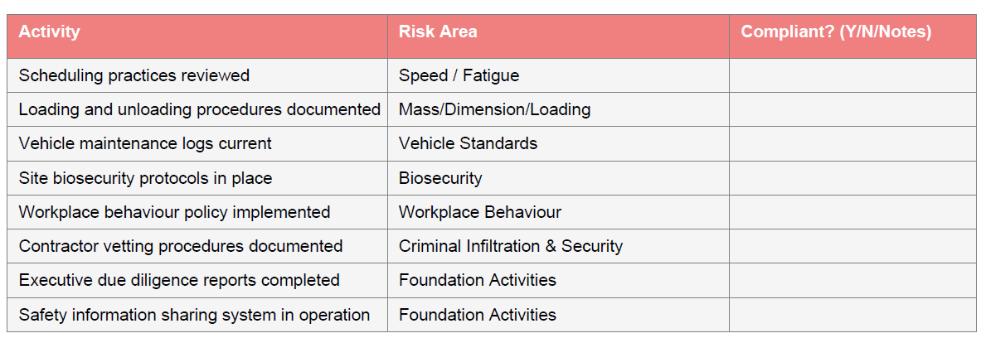

Transport for NSW OSOM Pilot Requirements Updated
Transport for NSW have made some changes to the pilot and escort requirements for class 1 cranes, special purpose vehicles and load carrying vehicles in NSW in an effort to standardise these requirements for vehicles with similar dimensions and on road behaviour.
These changes relate only to pilot and escort requirements. There have been no changes to other access conditions, including travel time requirements. This means that existing night or day travel restrictions are unchanged – only the pilot requirements when travelling at the time applicable to you as outlined in the Operators Guide.
More information can be found on the Transport for NSW website

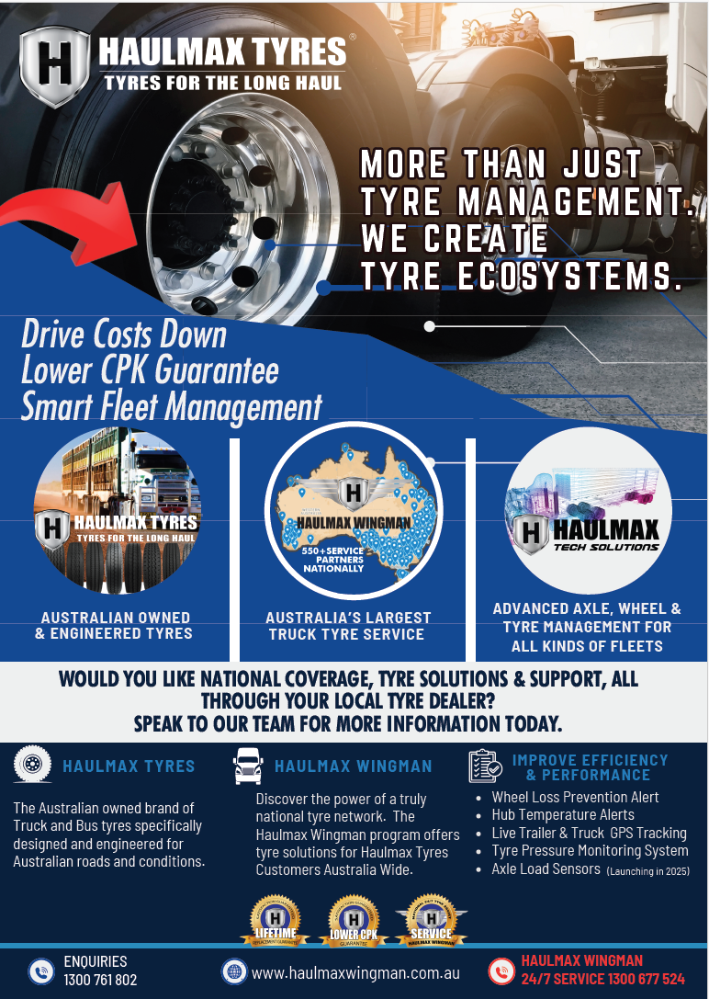

Enhancing Heavy Vehicle Safety: New Resources Now Available in HVRAP
LBRCA continues to strengthen safety across the Australian road freight industry with the release of new Heavy Vehicle Rollover Awareness Program (HVRAP) tools and resources designed to help reduce heavy vehicle rollovers and crashes—ultimately preventing loss of life and serious injury.
To further support drivers and operators, LBRCA has introduced new learning modules in HVRAP specifically tailored for timber and logging transport, covering:
- East Coast Hardwood
- Pine
- Bluegum
- In-field chipping
- Sawmill operations
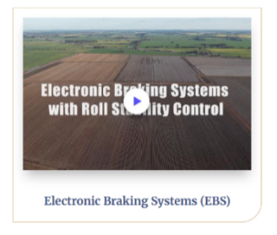
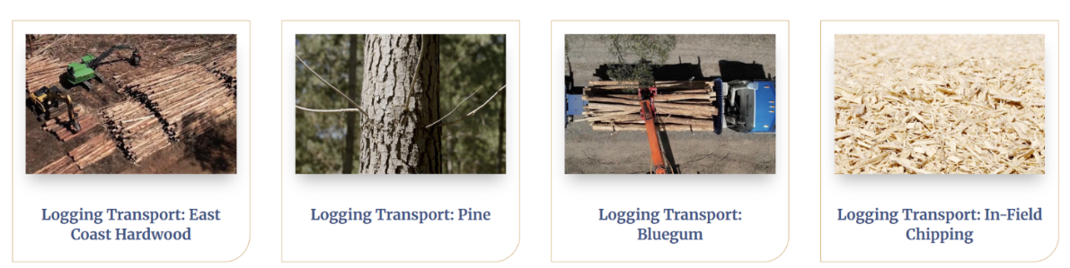
In addition, new modules are now available focusing on Electronic Braking Systems (EBS), Electronic Stability Control (ESC), and Bushfire Salvage Haulage Operations, ensuring industry members have access to essential safety knowledge in critical areas.

To highlight practical risk management strategies, LBRCA has published three new industry case studies showcasing how members—including Betts Livestock Transport, Brian Smith Timber Transport, and Riordan Grain—are proactively mitigating the risk of heavy vehicle rollovers within their operations.
These latest initiatives underscore LBRCA’s unwavering commitment to advancing road safety for heavy vehicle operators across Australia. Be sure to explore these new resources and continue prioritising safety in your operations!

www.hvrap.au
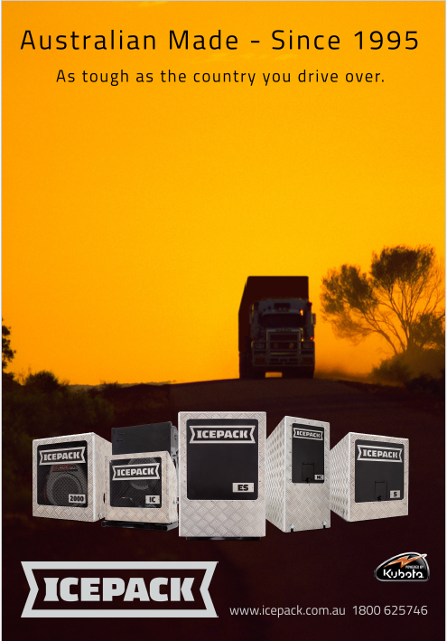
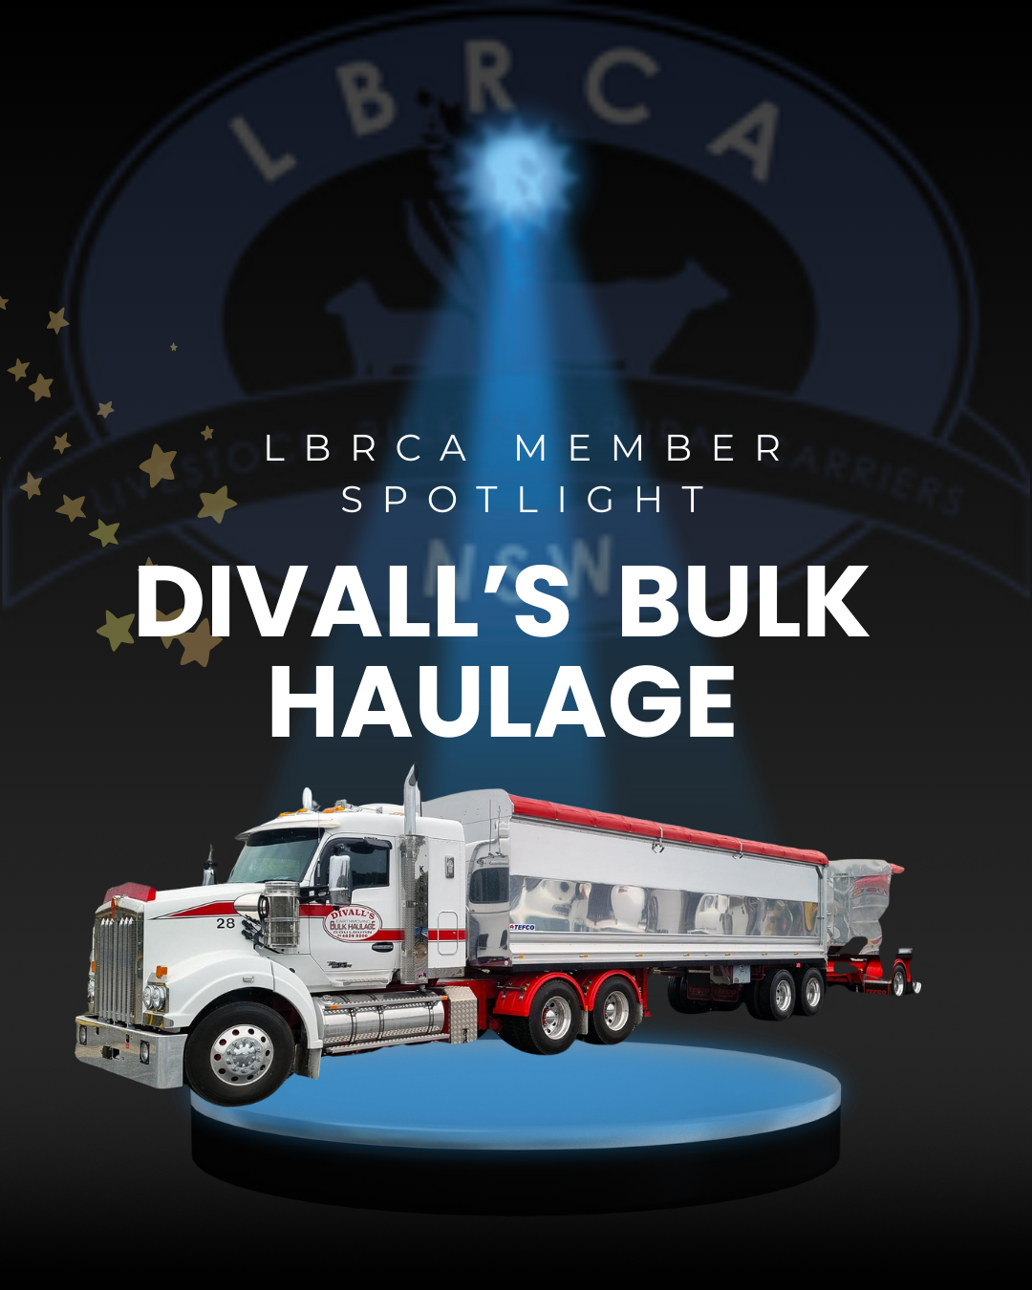

CoRLink Animal Welfare Accreditation
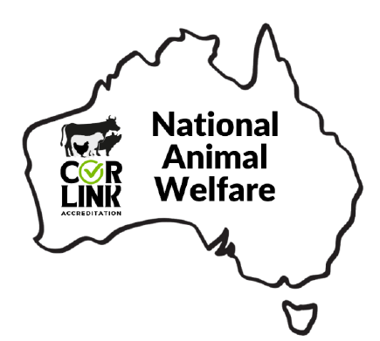
The CoRLink Accreditation National Animal Welfare Module has been developed industry to provide an industry business management framework consistent with legislation and enforcement across Australia with regard to animal welfare, and provide guidance for all persons involved in, and responsible for livestock handling, preparation, and transport.
﻿The development of the National Animal Welfare Module Business Standards is based on scientific knowledge, recommended industry practice, and wider community expectations with relation to livestock and animal welfare.
The Business Standards apply to all those responsible for the care and management of livestock that are transported, including drivers, transport companies, owners, agents and livestock handlers at farming enterprises, depots, saleyards, feedlots and livestock-processing plants.
The chain of responsibility for livestock welfare in transport begins with the owner or their agent and extends to the final receiver of the livestock.

BECOME CORLINK ACCREDITATED
Become a part of CoRLink and take the first step towards a safer, more professional future in the heavy vehicle industry. Together, we can make a difference on the road.

If you would like to become a CoRLink Accredited Operator
visit www.corlink.com.au.

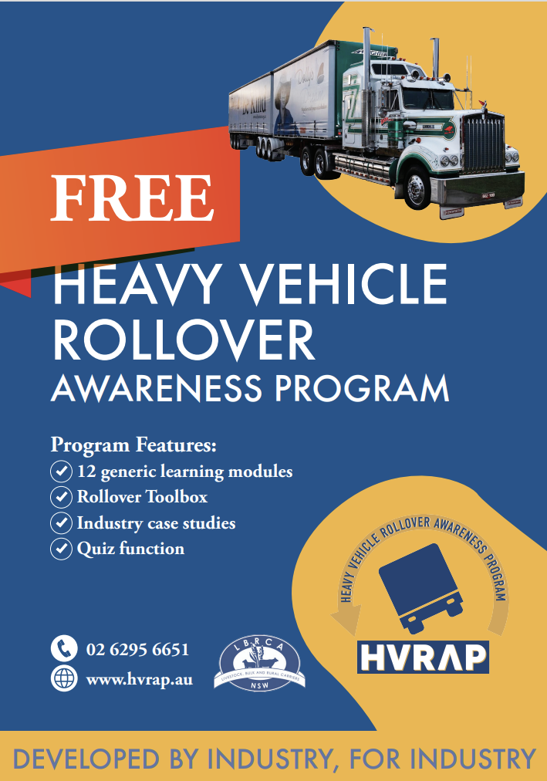

Advertise in The Rural Carrier

About the Magazine
The Rural Carrier Magazine is a monthly publication produced by the Livestock, Bulk and Rural Carriers Association (LBRCA). Delivered digitally to an estimated 600 members, industry stakeholders and suppliers via email and social media, with limited printed copies distributed, the magazine provides essential news and information tailored to support our members and the rural transport industry.
About the LBRCA
The LBRCA is a strong community of livestock, bulk, and rural carriers who transport Australia's vital agricultural products across regional and rural New South Wales. Our mission is to build a more productive, efficient, and safer industry for the future. We offer members advocacy, support services, exclusive benefits, and vital networking opportunities.

Advertising Rates
Full Page Advertisement:
- 1 Insertion: $500 per insertion
- 6 Insertions: $400 per insertion
- 12 Insertions: $300 per insertion
Other advertising options available on request (POA).

Editorial Submissions
We welcome editorial submissions relevant to our members. Preference will be given to Blue Ribbon sponsors, advertisers, and conference exhibitors.

Contact
For bookings or editorial submissions, please contact:
matt@lbrca.org.au | 02 6130 1528
