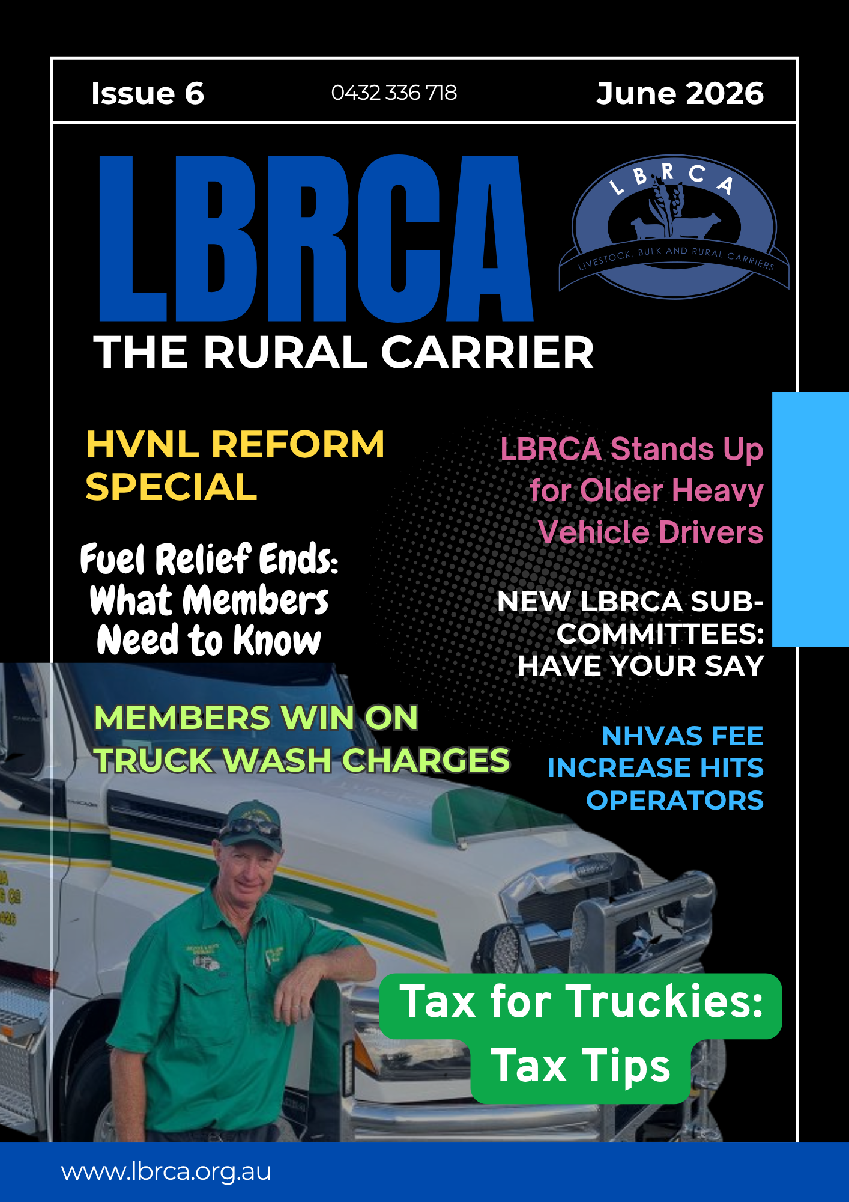
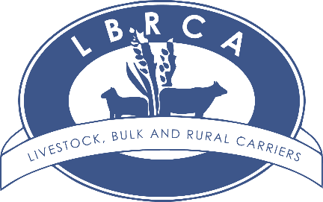
Contents

Save the Date: LBRCA Member Meeting – Tamworth Page 4
President’s Update Page 5
Major HVNL Reforms Confirmed: What Members Need to Know Page 10
LBRCA Joins the Australian Trucking Association Page 19
Vale David Paddison Page 21
Fairer Licence Rules for Experienced Heavy Vehicle Drivers Page 24
NHVAS Accreditation Fees Rise Page 30
Updated Access for Great Western Highway Detour Route Page 32
NHVR Regional Toolbox Talks NSW Page 33
Victorian Bridge Funding Cuts Page 34
NSW Cattle Tick Consultative Committee Nomination Page 36
Contribute to the PBS and HPFV Access Sub-Committee Page 37
Contribute to the Driver and Animal Welfare Sub-Committee Page 39
The Defence That Is Winning Permit Offence Cases Page 40
More Green Reflector Rest Sites in the Upper Hunter Page 42
Meet Torin Young – Ampol Partnership and Association Manager Page 42
Mitchell Highway Speed Limit Reduced Page 45
Bilpin Truck Parking Bay Reopens on Bells Line of Road Page 46
Berrigan and Finley Truck Wash Fee Increase Page 47
LBRCA Welcomes New Members Page 49
Have Your Say: Review of Assessing Fitness to Drive Standards Page 50
Your Compliance. Sorted. – Introducing ComplyAssist Page 52
NHVR Updates Notices Ahead of HVNL Reforms Page 56
Tax for Truckies: Tax Tips Page 58
Fuel Relief Ending 1 July: What Members Need to Know Page 66

Cover Image: LBRCA executive member Stephen ‘Wilba’ Haslem of Walcha Carrying Co based in Walcha, NSW
Welcome to Issue 6 of the Rural Carrier


This edition comes at an important time for livestock, bulk and rural carriers, with major regulatory reform, rising operating pressures and ongoing infrastructure challenges continuing to shape the environment in which our members work every day.

A key focus of this issue is the upcoming HVNL reforms, which represent the most significant changes to the national heavy vehicle framework in more than a decade. These reforms will affect many operators across our sector. LBRCA is working to ensure members are informed early, understand what is changing and have access to practical guidance as the transition approaches.

This issue also highlights the strength of member-led advocacy. LBRCA has continued to stand up for fairer licence testing pathways for experienced heavy vehicle drivers, particularly older MC drivers who may be at risk of losing both MC and HC entitlements following an unsuccessful assessment. Experienced drivers are vital to our industry, and LBRCA will continue to push for a system that supports safety while treating drivers fairly and recognising different licence classes and competencies.

Members will also read about LBRCA’s successful advocacy on the proposed Berrigan and Finley truck wash fee increase. Truck wash facilities are essential infrastructure for livestock carriers, local agriculture and regional biosecurity.

We are also pleased to invite members to contribute to two important new LBRCA sub-committees: the PBS and HPFV Access Sub-Committee, and the Driver and Animal Welfare Sub-Committee. These groups will give members a stronger voice on issues that directly affect day-to-day operations, safety, productivity and animal welfare outcomes.

As always, many of the issues featured in this magazine have come directly from members. Your feedback, examples and local knowledge help LBRCA identify problems early and take practical, evidence-based concerns directly to government, regulators and decision-makers.

Thank you for your ongoing support of LBRCA and for the work you do every day to keep livestock, grain, rural commodities and essential freight moving across regional NSW and beyond.


Bec Coleman
LBRCA Chief Operating Officer
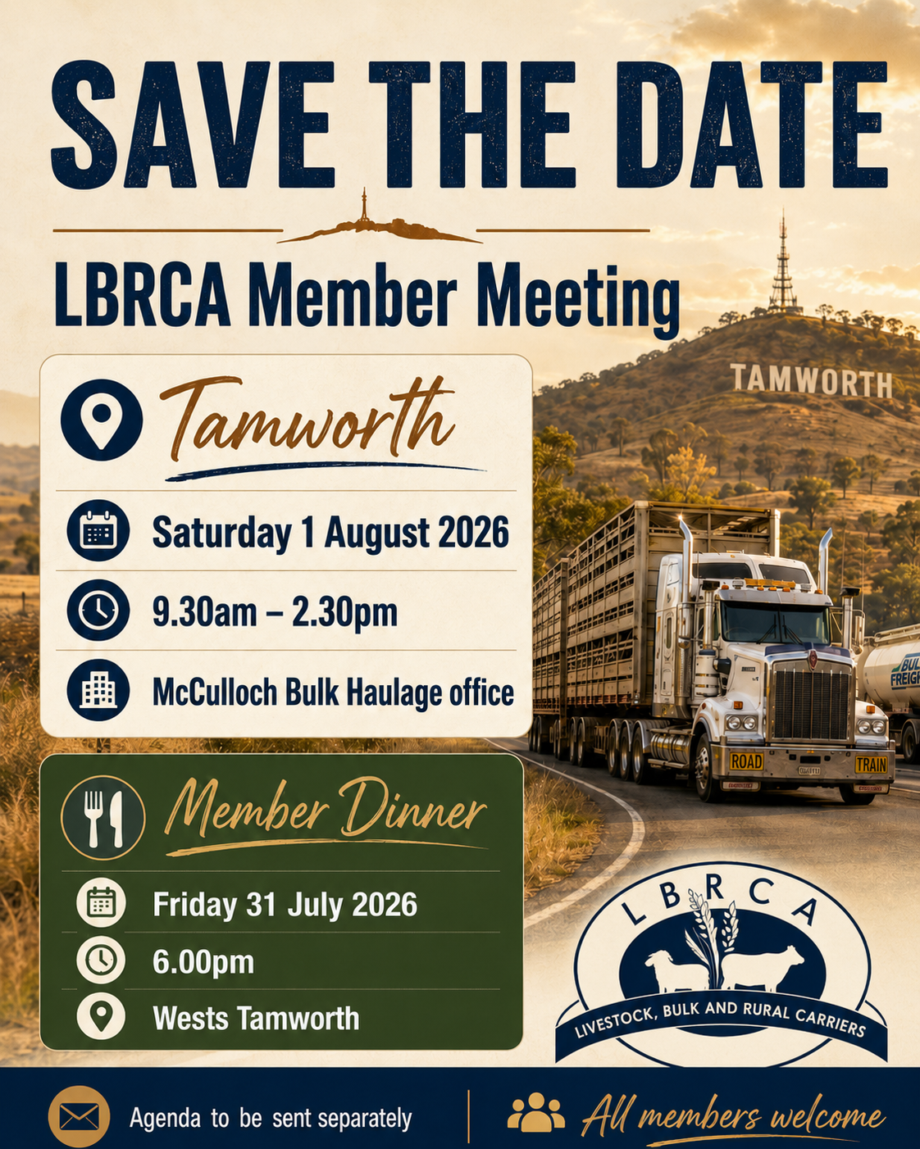

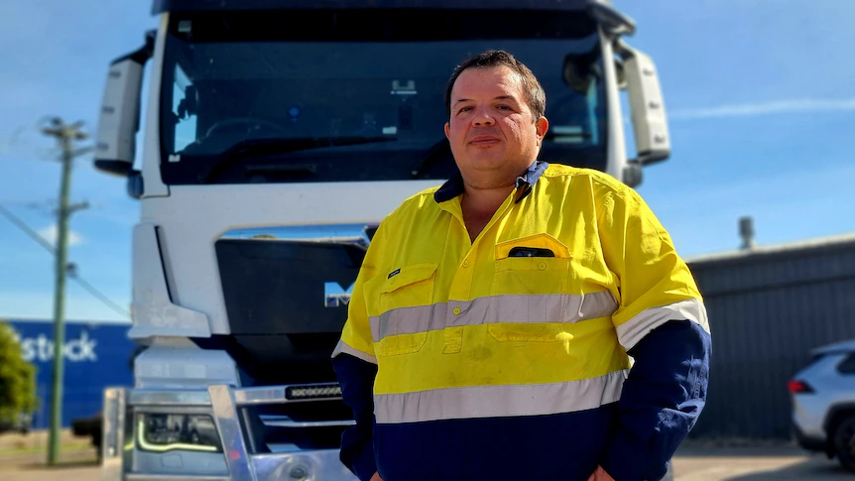
President’s Update – Grassroots Advocacy Remains at the Heart of LBRCA

By Wade Lewis, LBRCA President
Dear Members,
One of the greatest strengths of the LBRCA has always been our connection to the people on the ground.
LBRCA was built by grassroots operators — family businesses, drivers, livestock carriers, bulk carriers and rural freight operators who understand the realities of regional transport because they live them every day. That grassroots connection remains our greatest asset, and it is why member-driven advocacy continues to be a major focus for LBRCA.
Good advocacy does not start in boardrooms. It starts in depots, saleyards, truck washes, feedlots, grain sites, paddocks, workshops and on the roadside. It starts with members telling us what is working, what is not working, and where government decisions are creating real-world impacts for transport businesses.
Over the past three months, LBRCA has continued to focus on practical advocacy that reflects the needs of our members and delivers outcomes for the livestock, bulk and rural transport sectors.
Primary Producer Registration Concession Reform
A major focus has been LBRCA’s work on reform of the Primary Producer Registration Concession in NSW.
LBRCA has been advocating for a fairer and more practical approach that recognises the essential role of agricultural transport operators who support primary production. Many livestock, grain and rural bulk carriers provide services that are critical to farming businesses, regional supply chains and food production.
Our position is that the current concession framework does not properly reflect the way modern agricultural transport operates. LBRCA has called for the creation of an “Eligible Agricultural Transport Operator” category to better recognise operators carrying livestock, grain and other rural commodities.
This reform would help ensure transport businesses supporting agriculture are not unfairly excluded simply because they carry goods for fee or reward. LBRCA will continue to push for a model that is fair, practical and aligned with the needs of regional NSW.
Heavy Vehicle National Law Reform
The amended Heavy Vehicle National Law will commence on 1 August 2026, and LBRCA has been actively engaging on what these changes mean for our sector.
A key change is the replacement of the National Heavy Vehicle Accreditation Scheme with the new Heavy Vehicle Accreditation scheme, including General Safety Accreditation and Alternative Compliance Accreditation.
LBRCA has been working to understand the practical impact of these reforms for livestock and bulk operators, particularly in relation to mass, maintenance, fatigue, accreditation transition arrangements and the new “unfit to drive” duty.
Our focus is to ensure members are informed early, understand their obligations, and have a strong industry voice as the new framework is implemented.
Older Driver Licensing Reform
LBRCA has also continued to advocate for fairer licence rules for experienced heavy vehicle drivers.
In NSW, drivers aged over 70 who are required to undertake a Multi Combination licence re-test can risk losing both their MC and HC entitlements if they are unsuccessful — even where they may still be capable of safely operating a Heavy Combination vehicle.
LBRCA believes this is unfair and disproportionate.
We are calling for a more practical approach that allows drivers to retain their HC licence where they remain competent and medically fit to operate at that level.
Experienced drivers are a critical part of our industry. The licensing system should support safety, but it should also treat drivers fairly and recognise different vehicle classes and competencies.
Access, Infrastructure and Last Mile Issues
Access remains one of the most important issues for our members.
Over the past three months, LBRCA has continued to raise concerns and work through issues relating to last mile access, high productivity vehicle routes, local road approvals, truck wash facilities, rest areas, bridges and regional freight corridors.
This has included advocacy on key freight routes, engagement with government on livestock and grain access, and continued work on practical infrastructure issues that affect operators every day.
LBRCA has also been active in responding to issues such as the Great Western Highway detour arrangements, the Mitchell Highway speed limit reduction, Golden Highway upgrades, and regional bridge funding concerns.
These matters may appear local in nature, but they have broader consequences for industry productivity, safety and supply chain efficiency.
This is why grassroots feedback from members is so important — it helps us identify issues early and take them directly to decision-makers.
Truck Wash Advocacy
LBRCA has continued to advocate for fair and reasonable truck wash charges, including at the Finley and Berrigan truck wash facilities.
LBRCA has raised concerns about significant fee increases, the need for proper consultation and the importance of cost recovery being based on evidence.
We were pleased to successfully advocate against the proposed increase at Berrigan Shire Council, and we will continue to support members where essential infrastructure is at risk of becoming unaffordable or impractical.
Operational Updates and Representation
LBRCA has also taken important steps to strengthen our internal capability.
A key development has been the engagement of a General Manager of Policy and Advocacy. This role will help expand LBRCA’s capacity to respond to policy reform, prepare submissions, engage with government, support members and drive advocacy priorities.
As the policy environment becomes more complex, it is important that LBRCA has the right resources in place to represent members effectively. This appointment is an investment in stronger advocacy and better support for our industry.
LBRCA has also continued to build relationships across government, regulators and industry bodies, including the NHVR, Transport for NSW, NSW Government representatives, local councils, the Australian Trucking Association, state-based associations and other national transport stakeholders.
Following our members’ decision to strengthen LBRCA’s independent advocacy voice, we have continued to ensure livestock, bulk and rural carriers are represented in the right forums.
National representation matters, but it must always be informed by grassroots industry feedback.
PBS, High Productivity Vehicles and Safety Reform
Performance Based Standards and high productivity vehicle access remain key areas of focus.
LBRCA has established a PBS Sub-Committee to provide members with a more direct voice on PBS issues, access barriers and reform opportunities.
PBS vehicles can deliver major productivity, safety and efficiency benefits, but only if access arrangements are practical, consistent and fit for purpose.
LBRCA will continue to support industry-led solutions that are practical, affordable and designed with operators in mind.
Why Grassroots Advocacy Matters
The past three months have shown exactly why grassroots advocacy is so important.
When members speak up, LBRCA can act. When operators provide examples, we can take real evidence to government. When local issues are raised early, we can identify broader policy failures and push for change.
Whether it is a truck wash charge, an access restriction, a licensing issue, a fuel cost concern or a major law reform, the strongest advocacy comes from combining member experience with a clear and professional industry voice.
That is what LBRCA does best.
We are not here to simply comment from the sidelines. We are here to represent the people who keep livestock, grain, rural commodities and essential freight moving across NSW and beyond.
That’s why I am pleased that members now have strengthened representation at the national level through our membership of the ATA.
On behalf of the Committee, I thank every member who has taken the time to raise an issue, provide feedback, attend a meeting, contribute to a submission or support another operator. Your input shapes our priorities and strengthens our advocacy.
LBRCA will continue to stand up for practical reform, fair treatment and better outcomes for rural carriers. Grassroots advocacy is not just part of our history — it is the way we will continue to deliver for members into the future.

Wade Lewis
President
Major HVNL Reforms Confirmed: What Members Need to Know
HVNL REFORM SPECIAL 0
LBRCA is providing members with an important update on the most significant reform to the Heavy Vehicle National Law (HVNL) in more than a decade.
These changes will affect heavy vehicle operators across key areas including accreditation, safety management systems, Chain of Responsibility (CoR) obligations, and the responsibilities of business owners, directors and senior managers.
LBRCA has been closely monitoring, preparing for and advising on these reforms since the HVNL review commenced. We are updating members now to ensure you are informed well ahead of commencement and have time to understand what the changes may mean for your business.
The National Transport Commission (NTC) commenced a comprehensive review of the HVNL in 2019, with the aim of modernising a framework that was considered overly prescriptive and outdated.
The Heavy Vehicle National Law Amendment Bill 2025 passed Queensland Parliament on 18 November 2025. The NHVR has since confirmed that the amended law will commence on 1 August 2026.
Supporting instruments for the new framework have also now been released by the NHVR and NTC, including the Safety Management System Standard, the Ministerial Guidelines for Heavy Vehicle Accreditation, the National Audit Standard, and the Ministerial Standard for Alternative Compliance Hours.
While the commencement date has been confirmed, some provisions remain subject to ongoing Ministerial approval and finalisation. LBRCA will continue to monitor this closely and update members as further detail is confirmed.
The reformed HVNL will apply in New South Wales, Victoria, Queensland, South Australia, Tasmania and the Australian Capital Territory. It will not apply in Western Australia or the Northern Territory.
These reforms are significant, but we are working to ensure members understand their obligations, are prepared for the transition, and have clear, practical guidance every step of the way.
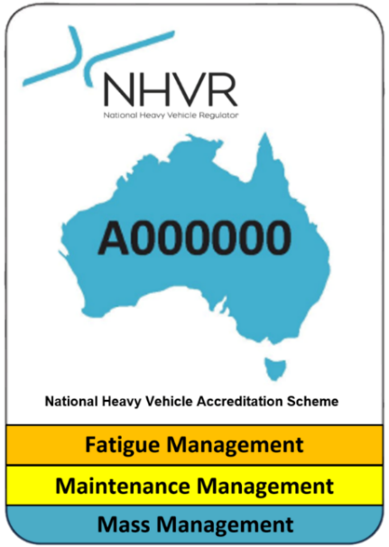
Heavy Vehicle Accreditation (HVA) Scheme
HVNL REFORM SPECIAL
One of the most significant changes under the reformed Heavy Vehicle National Law is the replacement of the National Heavy Vehicle Accreditation Scheme (NHVAS) with a new Heavy Vehicle Accreditation (HVA) Scheme.
For many members, NHVAS has been part of day-to-day compliance for many years, particularly through Mass Management, Maintenance Management, Basic Fatigue Management and Advanced Fatigue Management.
Under the new framework, this module-based approach will be replaced with a whole-of-business accreditation model.
The new HVA Scheme will have two key pathways.
- General Safety Accreditation
General Safety Accreditation (GSA) will become the new baseline accreditation pathway available to heavy vehicle operators.
Instead of being accredited against separate modules, operators will need to demonstrate that they have a functioning Safety Management System that applies across their business.
This includes how the business manages maintenance, mass, fatigue, driver fitness, training, risk, incident management and record keeping.
GSA is intended to provide a more complete picture of how an operator manages safety across their transport activities.
- Alternative Compliance Accreditation
Alternative Compliance Accreditation (ACA) will be the advanced pathway under the new scheme. ACA will replace the current BFM and AFM pathways.
ACA will not be mandatory. It will be an option for operators who have the systems, processes and evidence in place to support higher levels of flexibility.

What happens to your current NHVAS accreditation?
HVNL REFORM SPECIAL
Members should be aware that existing NHVAS accreditation will not suddenly disappear on 1 August 2026.
Your current NHVAS accreditation will remain valid until its current expiry date. Operators will have up to three years from 1 August 2026 to transition across to the new HVA Scheme.
From 1 August 2026, NHVAS will no longer accept new applicants. Any operator seeking accreditation for the first time after that date will need to apply under the new HVA framework.
During the transition period, both NHVAS and HVA will operate in parallel.
Safety Management Systems will become central
A major change under the new accreditation model is the requirement for accredited operators to have a documented and auditable Safety Management System, commonly referred to as an SMS.
This is not intended to be a policy folder that sits on a shelf. It must be a practical system that is used in the day-to-day operation of the business.
The SMS Standard is built around five key areas:
- Leadership and commitment – showing that owners, directors and managers are actively committed to safety.
- Risk management – identifying, assessing and controlling risks within the operation.
- People – managing driver fitness, training, supervision and competency.
- Assurance and improvement – using internal audits, incident reporting and continuous improvement.
- Safety systems – maintaining procedures, records and controls for maintenance, mass, fatigue and other safety matters.
Importantly, the SMS must be proportionate to the size and risk profile of the business.
A small family operation or owner-driver will not be expected to have the same level of documentation as a large multi-depot fleet.
However, every accredited operator will need to show that they have a system that works in practice.
HVNL REFORM SPECIAL
This shift is also relevant for operators who are not currently accredited under NHVAS, as the broader HVNL reforms place greater emphasis on safety systems and Chain of Responsibility obligations across the heavy vehicle supply chain.
Audits will focus on whether your system actually works
The audit process is also changing. Under the new National Audit Standard, auditors will assess whether your Safety Management System is:
- Present – the system exists and is documented.
- Suitable – the system is appropriate for your business and the risks you manage.
- Operating – the system is being used by your drivers, staff and management.
- Effective – the system is achieving the safety outcomes it is designed to deliver.
This is often referred to as the PSOE approach: Present, Suitable, Operating and Effective.
In simple terms, audits will move away from checking whether paperwork exists and will focus more heavily on whether the business can demonstrate that its safety system is working in real life.
Operators will also be expected to conduct internal audits and maintain evidence between formal audit periods.
New “unfit to drive” duty
The reforms also introduce a new express duty relating to drivers who are unfit to drive. This duty is separate from the existing fatigue obligations and extends beyond simply counting work and rest hours. A driver may be unfit to drive due to:
- illness or injury;
- mental health or emotional distress;
- the effects of medication, alcohol or other substances; or
- any other factor that affects their ability to safely operate a heavy vehicle.
This obligation also flows through the Chain of Responsibility. Operators, schedulers, employers and others in the supply chain must take reasonable steps to ensure a driver does not operate a heavy vehicle while unfit to do so.
HVNL REFORM SPECIAL
This means businesses will need to review their fit-to-drive procedures and ensure drivers, managers and schedulers understand their responsibilities.
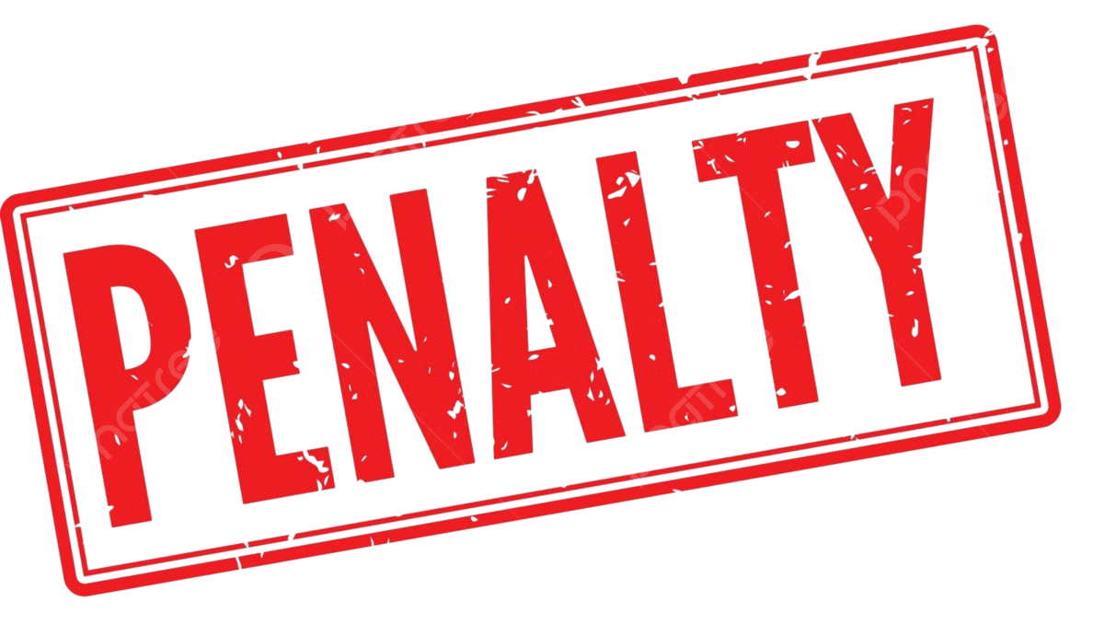
Changes to penalties under Chain of Responsibility
More than 70 penalties are being revised under the reformed HVNL.
The changes are not all one-way. Some penalties for minor administrative or technical breaches will be reduced. However, penalties for safety-critical failures will increase.
For directors, executives and business owners, Chain of Responsibility obligations remain significant.
These obligations cannot simply be delegated to someone else. Businesses will need to show that safety is actively managed through real systems, practical controls and evidence of ongoing compliance.
Mass and dimension changes
The mass and dimension changes commencing with the amended HVNL on 1 August 2026 are mainly in the Mass, Dimension and Loading Regulation. In practical terms, these changes are:
- GML increases to align with current CML
The major mass change is that General Mass Limits (GML) will increase to match what is currently available under Concessional Mass Limits (CML).
The amendments increase maximum mass under GML to current CML levels, with buses excluded from the increased GML. In practical terms:
Current position | New position
GML applies as the general baseline
Operators need CML accreditation to access CML | Current CML-level mass becomes part of GML
CML and 1 tonne tri-axle mass transfer allowance exist as separate concepts
HVNL REFORM SPECIAL
In summary, GML will increase by 1 tonne for a heavy vehicle with a current GML maximum mass of 55 tonnes or less, and by 2 tonnes for a heavy vehicle with a current GML maximum mass of more than 55 tonnes.
- Axle group mass limits increase for some axle types
Some axle group limits are increased to reflect current CML-style limits. Examples include:
Axle group | New limit
Tandem axle group with single tyres less than 375 mm | 11.5 t
Tandem axle group with single tyres at least 375 mm but less than 450 mm | 13.8 t
Tandem axle group with single tyres at least 450 mm | 14.5 t
Tandem axle group with dual tyres on both axles, specified category | 17.0 t
Tri-axle group on vehicle fitted with specified single/dual tyre combinations | 15.5 t
Tri-axle group on vehicle other than a pig trailer with specified single/dual tyre combinations | 21.0 t
Quad-axle group with single tyres less than 375 mm | 15.5 t
Quad-axle group with single tyres at least 375 mm or dual tyres | 21.0 t
- Road trains gain access to Euro VI mass concessions
Road trains were previously excluded from some Euro VI mass concessions. The amendments remove that exclusion so road trains can access Euro VI concessions, including a 0.5 tonne increase in relevant axle spacing calculations for Euro VI road trains.
There is also a new 21 tonne cap for a Euro VI vehicle fitted with a tri-axle drive group.
- Tag trailer mass requirements are amended
HVNL REFORM SPECIAL 0
The amendments change the maximum mass requirements for tag trailers. The new wording provides that, in a combination, the mass on the axle group or single axle of a tag trailer must not be more than 30% greater than the sum of the mass on all axles of the towing vehicle.
It also sets a minimum mass requirement for the steer axle or twin steer axle group of the towing vehicle.
- Length increases from 19 metres to 20 metres for some combinations
The main dimension change is an increase in the length limit for vehicles currently limited to 19 metres, increasing to 20 metres. This applies across relevant provisions for Class 2 heavy vehicles, restricted access vehicles and safer freight combinations.
However, this is not a blanket increase for every vehicle combination. For members, the key practical point is that this is mainly relevant to combinations such as certain prime mover and semitrailer and truck and trailer combinations, not B-doubles or road trains.
- Conditions for 19–20 metre combinations
For a heavy trailer used in a combination that is longer than 19 metres but not more than 20 metres, the trailer must have a braking system that complies with ADR 38/05 or later and is powered by the towing vehicle.
There are also trailer dimensional requirements, including:
Requirement | Change
Semitrailer front articulation point to rear of trailer | May be up to 14.5 m when towed by a prime mover
S-dimension controls | Subject to wheelbase-based limits
Semitrailer with S-dimension over 9.5 m | Must have side underrun protection complying with ADR 106/00 or later
Rear overhang for certain 19–20 m combinations | May be up to the lesser of 4 m or 60% of S-dimension

What is not changing on 1 August 2026
HVNL REFORM SPECIAL
The proposed general 4.6 metre height increase is not part of the 1 August 2026 commencement package. That remains a future reform issue.
Also, the length increase does not include B-doubles at this stage.
For livestock and bulk operators, that means the immediate win is mainly around the GML/CML alignment and the simplification of some mass pathways, rather than a broad new height or B-double length entitlement.
What this means for your business
For operators, the key actions will be to:
- understand when your current NHVAS accreditation expires;
- prepare for transition to the new HVA Scheme within the permitted timeframe;
- develop or update your Safety Management System;
- ensure your system reflects how your business actually operates;
- conduct internal checks and maintain evidence;
- review fit-to-drive procedures;
- train drivers, schedulers, supervisors and managers on the new obligations.
For directors and senior managers, the reforms reinforce the importance of active oversight.
Chain of Responsibility duties apply across the heavy vehicle supply chain and cannot be delegated away.
Under the new framework, an effective Safety Management System will become a critical tool for demonstrating that your business is taking reasonable steps to manage safety.
Summary of key dates and changes
Item | Detail
Commencement of amended HVNL | 1 August 2026
NHVAS closed to new applicants | 1 August 2026
Existing NHVAS accreditation | Remains valid until current expiry date
Transition window to HVA | Up to three years from 1 August 2026
New accreditation structure | General Safety Accreditation and Alternative Compliance Accreditation
SMS requirement | Mandatory for accredited operators
Audit approach | Present, Suitable, Operating and Effective
Immediate action required | No immediate action, but operators should begin preparing
HVNL REFORM SPECIAL
LBRCA will support members through the transition
LBRCA understands that reform of this scale can feel overwhelming. However, members should not panic.
These changes will not all happen overnight, and existing NHVAS accreditation will remain valid until its current expiry date.
The most important thing members can do now is stay informed and begin thinking about how their current systems, records and procedures align with the new framework.
In the coming weeks, LBRCA will also provide further information about support tools and resources being developed to assist operators with the transition to the new HVA Scheme, including practical Safety Management System support aligned to the SMS Standard, the National Audit Standard and the new GSA and ACA frameworks.
Our message to members is simple: these reforms are significant, but you will not be navigating them alone.

LBRCA Joins the ATA
LBRCA is pleased to advise members that we have officially joined the Australian Trucking Association (ATA), strengthening our ability to represent livestock, bulk and rural carriers at a national level.
The ATA is the united national voice for the Australian trucking industry. Through its member associations, the ATA represents more than 60,000 trucking businesses and 200,000 people across the sector.
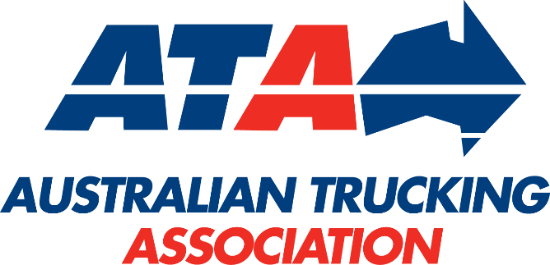
LBRCA joins the ATA alongside the National Road Freighters Association (NRFA), further broadening the ATA’s representation of the industry.
LBRCA President Wade Lewis said becoming an ATA member creates an important new pathway for LBRCA members to help shape national transport policy and ensure the needs of rural carriers are heard in key regulatory and policy discussions.
“LBRCA’s membership of the ATA strengthens our ability to represent our members on the national stage,” Mr Lewis said.
“It gives livestock, bulk and rural carriers a stronger collective voice and opens the door to greater collaboration with other industry associations, improved access to national policy expertise, and more coordinated advocacy on the practical issues affecting operators every day.
“Our members operate across some of the most critical and challenging parts of the freight task. They support agriculture, livestock production, regional communities and essential supply chains. It is vital that their experience and priorities are represented in national conversations about road transport reform, safety, productivity and access.”
LBRCA looks forward to working constructively with the ATA and its member associations to advocate for practical, fair and effective policy outcomes for our industry.
This is a positive step for LBRCA and for our members, ensuring livestock, bulk and rural carriers have a stronger voice in the national transport agenda.
Vale David Paddison
It is with great sadness that LBRCA acknowledges the passing of David Paddison, a highly respected industry figure, valued friend and staunch supporter of the Association.
David dedicated an extraordinary 45 years of service to Cummins and the road transport industry. He began his career as a mechanic with Blackwood Hodge before transitioning to Cummins following its acquisition of the business. Through his commitment, technical knowledge and strong leadership, David progressed to Service Manager and then Branch Manager of Cummins’ Tamworth branch, before taking on the role of On-Highway Business Manager.
It was in this role that David supported LBRCA members for decades. He was a reliable and trusted point of contact who understood the demands faced by rural transport operators.
Nothing was ever too much trouble for David. Whether a member needed technical advice, assistance with an urgent issue or simply someone who would listen and help find a solution, David could always be counted on.
David attended every LBRCA conference from the early 2000s, demonstrating his enduring commitment to the Association and its members. His experience, practical knowledge and genuine understanding of the transport industry made him a trusted voice and a familiar, friendly presence at LBRCA events.
Beyond his considerable professional achievements, David will be remembered for the relationships he built and the respect he earned across the industry. His willingness to help others, his dependability and his unwavering support of LBRCA and its members leave a lasting legacy.
On behalf of the LBRCA committee, staff and members, we extend our deepest sympathies to David’s family, friends and colleagues at Cummins.
David’s contribution to our Association and the broader road transport industry will not be forgotten.
He will be greatly missed.

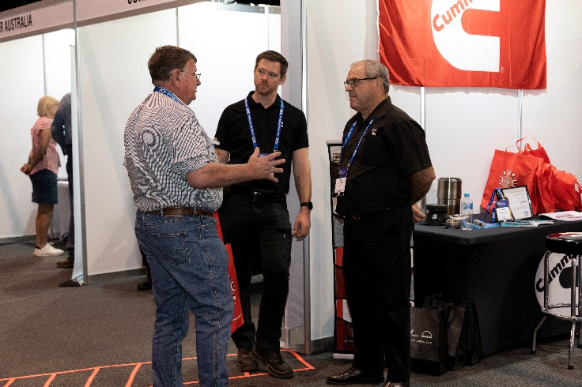
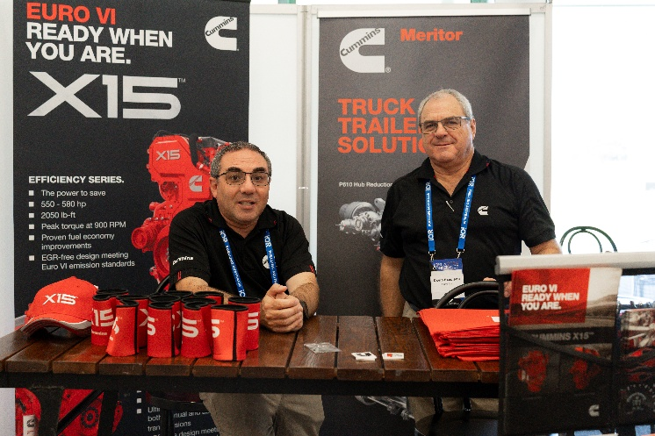
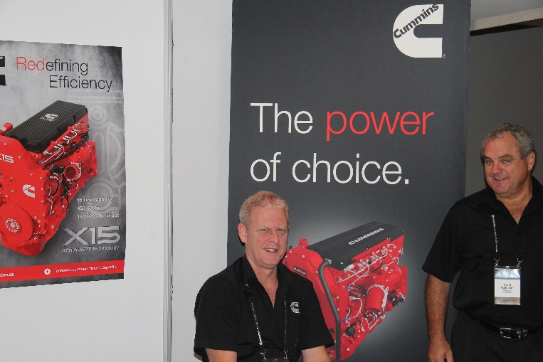
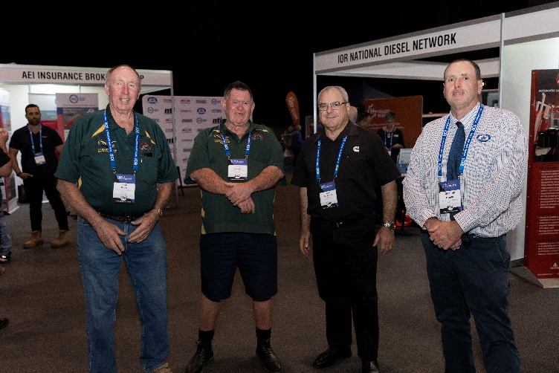
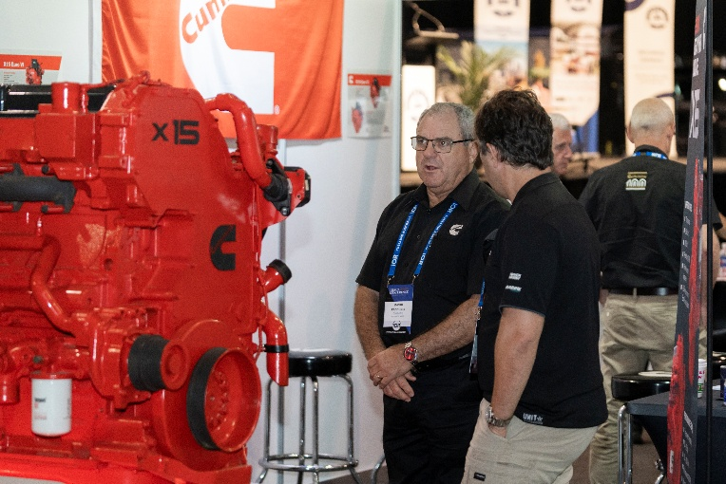
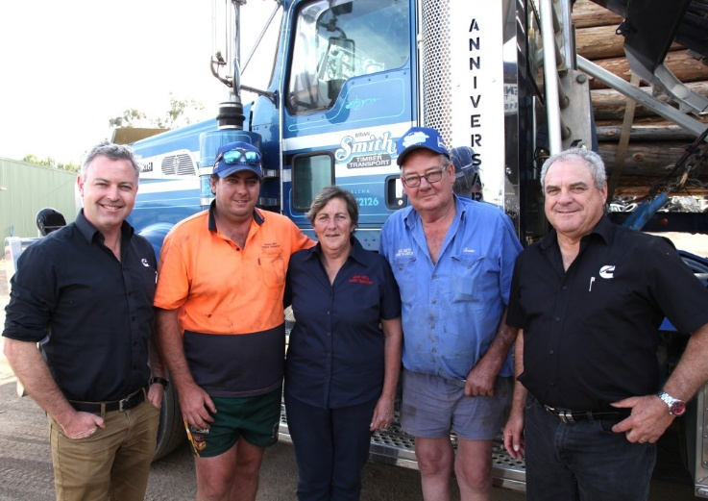
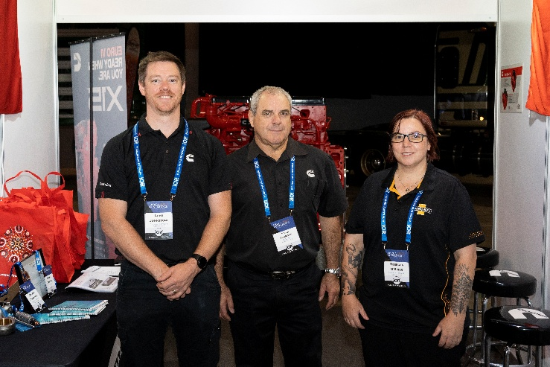


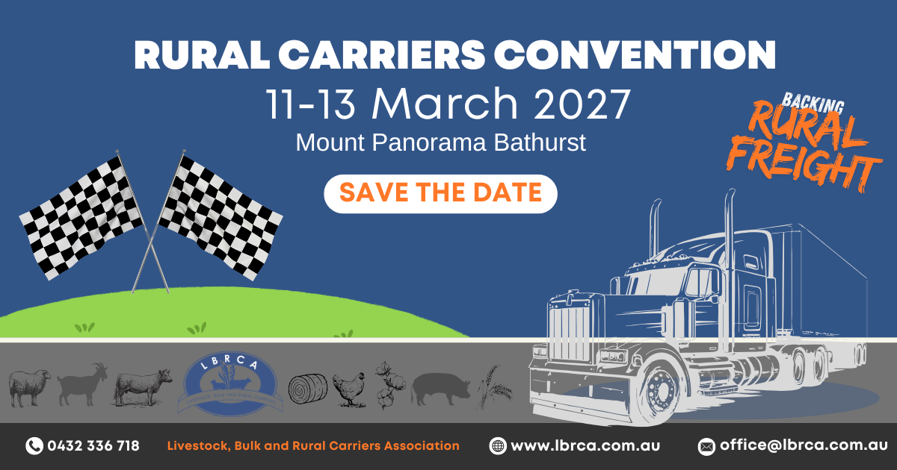
Save the Date: 2027 Rural Carriers Convention | Mount Panorama, NSW
Save the date for the 2027 Rural Carriers Convention, to be held at the iconic Mount Panorama precinct in Bathurst from 11–13 March 2027.
With the theme Backing Rural Freight, the 2027 Convention will bring members, industry partners, government, regulators and key stakeholders together to discuss the real issues facing the rural and regional transport industry.
The Convention will be held across some of Bathurst’s most well-known venues, including the National Motor Racing Museum, Rydges, The Pit Complex and The Goldfields Resort — all located within the Mount Panorama precinct.
Members can look forward to a packed program, including the Thursday welcome party, Friday and Saturday happy hours, Friday dinner and entertainment, Saturday gala dinner and auction, Livestock Conversion Challenge, Young Driver of the Year, two days of conference sessions, partners program, giveaways and much more.
The 2027 Convention promises to be another major gathering for rural carriers, celebrating our industry while focusing on the challenges and opportunities ahead. More details, including registration and sponsorship opportunities, will be released soon.
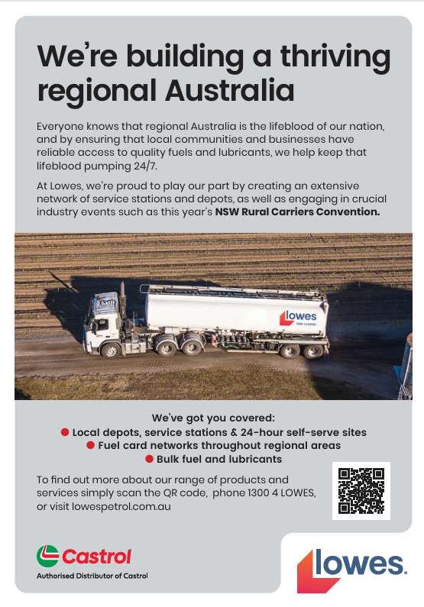
LBRCA Calls for Fairer Licence Rules for Experience Heavy Vehicle Drivers
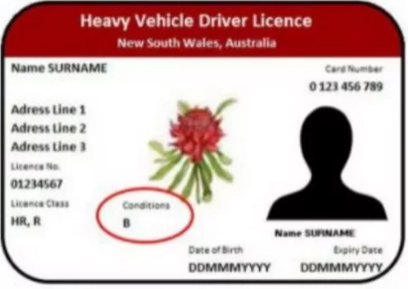
The LBRCA is calling on the NSW Government to urgently review licensing practices that can result in drivers aged over 70 years losing both their Multi Combination licence and Heavy Combination licence following an unsuccessful MC re-test.
LBRCA supports strong medical and competency standards for all heavy vehicle drivers. Road safety must remain the priority.
However, the current approach is unfair, disproportionate and places experienced drivers in a position where attempting to retain their MC licence can put their HC licence at risk.
The current problem
In NSW, heavy vehicle drivers are generally required to undertake annual medical and driving assessments from:
- 70 years of age for an MC licence; and
- 80 years of age for an HC licence.
In practice, drivers aged over 70 years who are required to undertake an MC re-test are often assessed in an HC vehicle, rather than an MC combination.
This creates a significant problem.
If a driver is unsuccessful in that assessment, they may effectively be treated as having failed both their MC and HC competency, resulting in the loss of both licence entitlements.
This can occur even where the driver is medically fit, has a strong safety record and may still be capable of safely operating an HC vehicle.
The issue is not that drivers should retain a higher licence class where they no longer meet the required standard.
The issue is that an unsuccessful assessment for the purpose of retaining an MC licence can also result in the driver losing their HC licence, even though the assessment process does not properly distinguish between the two licence entitlements.
The inconsistency
There is also an inconsistency in how the current rules operate.
A driver aged over 70 years who voluntarily surrenders their MC licence may retain their HC licence. However, a driver of the same age who attempts to retain their MC licence by undertaking the required re-test may risk losing both their MC and HC entitlements.
This creates a strong disincentive for experienced drivers to attempt an MC re-test.
In practical terms, a driver who does the right thing and submits to assessment may be placed in a worse position than a driver who voluntarily gives up their MC licence before being tested.
That outcome is neither fair nor safety focused.
What is LBRCA asking to be changed?
LBRCA is asking the NSW Government to adopt a fairer, more consistent and capability-based approach.
Specifically, LBRCA recommends that:
- MC and HC licence entitlements be assessed and treated separately.
An unsuccessful MC re-test should ordinarily result in the loss of the MC entitlement only, unless there is clear evidence that the driver is also unsafe to operate an HC vehicle.
- Drivers undertaking an MC re-test should not automatically lose their HC licence where the assessment has been conducted in an HC vehicle.
The purpose of the assessment must be clearly identified, and the consequences of an unsuccessful assessment must be proportionate to the licence class being assessed.
- Where concerns are identified about a driver’s HC competency, the driver should be given the opportunity to undertake a separate HC-only assessment before the HC licence is suspended or cancelled.
This assessment should be specifically designed to determine whether the driver is capable of safely operating an HC vehicle.
- Drivers should be clearly advised before undertaking an MC re-test if their HC licence may also be affected.
Drivers should not unknowingly place their HC entitlement at risk when their intention is to be assessed for their MC licence.
- Transport for NSW should review its testing and decision-making procedures to ensure licence outcomes are based on the driver’s demonstrated capability for each relevant licence class.
HC and MC licences involve different operating requirements
An MC licence permits a driver to operate more complex vehicle combinations, including B-doubles and road trains. These vehicles involve different operating environments, turning requirements, coupling arrangements, swept paths, route access considerations and vehicle management skills.
An HC licence, while still requiring a high level of skill and responsibility, generally involves a prime mover towing a single semi-trailer.
A driver may no longer meet the full standard required to operate an MC combination but may remain entirely competent and safe when operating an HC vehicle.
The licensing system should recognise this distinction.
An unsuccessful MC assessment should not automatically be treated as proof that a driver is unsafe across all heavy vehicle licence classes.
Drivers should be assessed on capability, not age alone
LBRCA recognises that medical fitness and driving competency are essential to road safety. Where a driver is no longer safe to operate a heavy vehicle, appropriate action must be taken.
However, decisions about a person’s licence should be based on their demonstrated ability to safely operate the relevant vehicle class — not assumptions based solely on age or the outcome of an assessment connected to a higher licence class.
Many drivers aged over 70 years remain highly skilled, medically fit and safe operators. They bring decades of experience to the transport industry and are often among the most careful and knowledgeable drivers on the road.
Where a genuine safety concern exists, it should be addressed through an assessment relevant to the licence class the driver is seeking to retain.
Automatic loss of the HC licence is disproportionate
Removing both MC and HC licence entitlements following an unsuccessful MC re-test can have serious consequences for drivers, families, employers and regional communities. It can:
- unnecessarily end or restrict a driver’s employment;
- discourage experienced drivers from attempting to retain their MC licence;
- remove capable HC drivers from the industry;
- create unnecessary administrative reviews and appeals;
- reduce workforce availability in regional areas; and
- impose additional pressure on livestock, bulk and rural transport businesses.
A more proportionate response is to remove the MC entitlement where the driver does not meet the required MC standard, while allowing the HC licence to remain in place unless there is clear evidence that the driver does not meet the HC safety standard.
Regional operators need experienced drivers
The livestock, bulk and rural transport sectors continue to experience significant driver shortages, particularly in regional NSW.
Experienced drivers are especially important during seasonal freight peaks such as harvest, livestock movements, drought response, emergency freight tasks and peak agricultural periods.
Many older drivers may no longer wish to operate larger MC combinations but remain willing and capable of undertaking work in HC vehicles.
Automatically removing their HC entitlement reduces the available workforce without delivering a clearly demonstrated road safety benefit.
LBRCA’s position
LBRCA President Wade Lewis said the proposed change is about achieving the right balance between safety, fairness and workforce sustainability.
“Failing an MC re-test should not automatically mean that an experienced driver is incapable of safely operating an HC vehicle,” Mr Lewis said.
“Older drivers are often tested for their MC entitlement in an HC vehicle. If they are unsuccessful, they can effectively lose both licence classes. That is a serious outcome, and it needs to be reviewed.
“HC and MC are different licence entitlements, and the consequences of an assessment should reflect the licence class being assessed.
“A driver should only lose their HC licence where there is clear evidence that they do not meet the safety standard for operating an HC vehicle.”
LBRCA is calling on the NSW Government and Transport for NSW to review current assessment practices and introduce a fairer process that protects road safety while ensuring experienced heavy vehicle drivers are treated consistently and proportionately.
The outcome LBRCA is seeking is simple: if a driver does not meet the MC standard, they should lose the MC entitlement. They should not automatically lose their HC licence unless they have been properly assessed against the HC standard and found not competent to safely operate an HC vehicle.

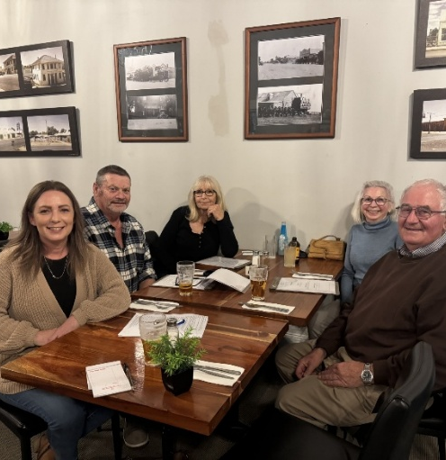
Member Catch Up
Finley Country Club
LBRCA COO Bec Coleman caught up with Finley and Berrigan members Craig and Suzie Congram and Kelvin and Marilyn Baxter this week to discuss local access issues and ongoing infrastructure challenges impacting operators in the region.
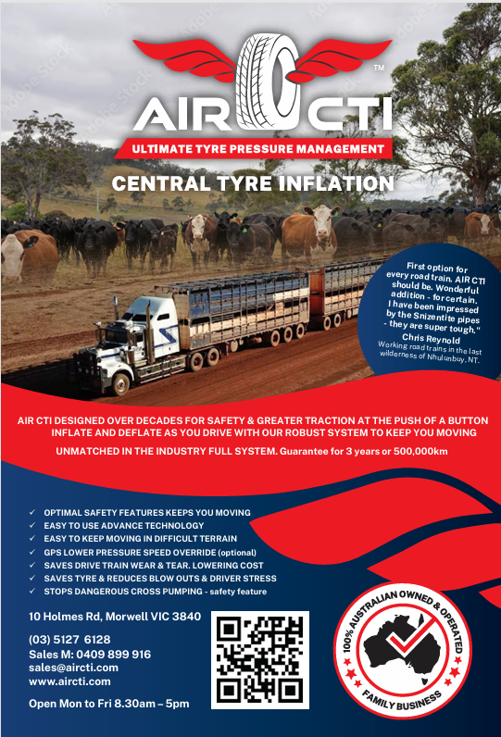

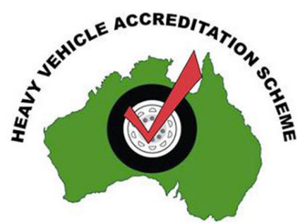
NHVAS Accreditation Fees Rise
NHVAS accreditation fees will increase on Wednesday, 1 July 2026 in line with CPI.
NHVAS fees are reviewed each year and this year's review will see an increase in all four module fees, plus an increase in the nominated vehicle fee.
NHVAS fee structure

Establish, maintain or add accreditation modules/s | Current fee | Fee from 1 July
Mass | $110 | $113
Maintenance | $110 | $113
Basic Fatigue Management (BFM) | $110 | $113
Advanced Fatigue Management (AFM) | $167 | $172
Vehicles to be added or remain in accreditation module/s
Mass management | $40 per vehicle | $41 per vehicle
Maintenance management | $40 per vehicle | $41 per vehicle

Important: The new Heavy Vehicle National Law (HVNL) and Heavy Vehicle Accreditation (HVA) takes effect on 1 August 2026. From 1 August 2026, the NHVR will no longer have the authority to grant or maintain NHVAS accreditation.

Updated Access Arrangements for Great Western Highway Detour Route

LBRCA is continuing to monitor access arrangements for heavy vehicle operators affected by the ongoing closure of the Great Western Highway at Victoria Pass.
Transport for NSW has confirmed that the Great Western Highway at Victoria Pass remains closed to all traffic in both directions while urgent road repairs are undertaken. The closure continues to place significant pressure on the surrounding road network, particularly the detour route through Main Street, Mort Street, Chifley Road and Darling Causeway.
Recent advice from Transport for NSW and the NHVR has now clarified the permit arrangements for restricted access vehicles using the detour route.
What has changed?
The key change is that affected permits will no longer be cancelled outright where a vehicle cannot continue to access the detour route.
Instead, permits will be amended to remove the Great Western Highway detour roads, while preserving the remainder of the permit where applicable.
Which vehicles can continue to use the detour?
The detour along Main Street, Mort Street, Chifley Road and Darling Causeway remains suitable for:
- general access vehicles;
- Performance Based Standards vehicles up to 20 metres long that meet the required performance criteria; and
- Class 2 Vehicle Carriers with a laden length up to 21.4 metres.
PBS vehicles seeking continued access must be able to demonstrate that the vehicle meets:
- Level 1 Low Speed Swept Path requirements; and
- a minimum startability performance of 13.2 per cent for eastbound travel.
Operators with PBS Level 2 vehicles up to 20 metres long must provide documented evidence to support continued access to the detour route.
What happens if evidence is not provided?
If the required PBS evidence is not provided, the permit will be amended to remove access to the detour route. This means the affected vehicle will no longer be authorised to use Main Street, Mort Street, Chifley Road and Darling Causeway as part of the Great Western Highway detour.
Class 1 OSOM and SPV vehicles
Transport for NSW has also clarified arrangements for Class 1 Oversize Overmass and Special Purpose Vehicles.
Class 1 permits that previously included the detour route will be amended to remove the detour roads, rather than being cancelled altogether.
Access for Class 1 vehicles may still be considered where the vehicle’s origin or destination is located within the detour route. These movements will be assessed on a case-by-case basis and may be subject to additional conditions.
What this means for members
Members operating PBS vehicles, OSOM vehicles or Special Purpose Vehicles should check their current permits and confirm whether the Great Western Highway detour route is included.
Operators should also ensure they have the necessary PBS performance evidence available if they are seeking continued access to the detour route.
LBRCA encourages members to:
- review current permits;
- check whether their vehicle is approved to use the detour route;
- provide any required PBS evidence as soon as possible;
- monitor updates from Transport for NSW, Live Traffic NSW and the NHVR; and
- contact the NHVR if a permit amendment is required.
LBRCA will continue to advocate for practical access outcomes that support freight movements, livestock transport, regional supply chains and operators affected by the ongoing Great Western Highway closure.

NHVR Regional Toolbox Talks

The NHVR is holding 12 specialised sessions called Regional Toolbox Talks designed for rural transport operators, farmers, harvest contractors and more, locked in well ahead of grain harvest so everyone has time to prepare.
These sessions will cover topics including Chain of Responsibility, Access, Load Restraint and the requirements around moving agricultural machinery – which have seen some recent changes, particularly around the movement of comb trailers.
We encourage you to attend these sessions to learn, network and ask questions so that industry is best placed to tackle the grain harvest season head on.
Attendance is free. You can register for free at https://www.trybooking.com/au/event/1561517
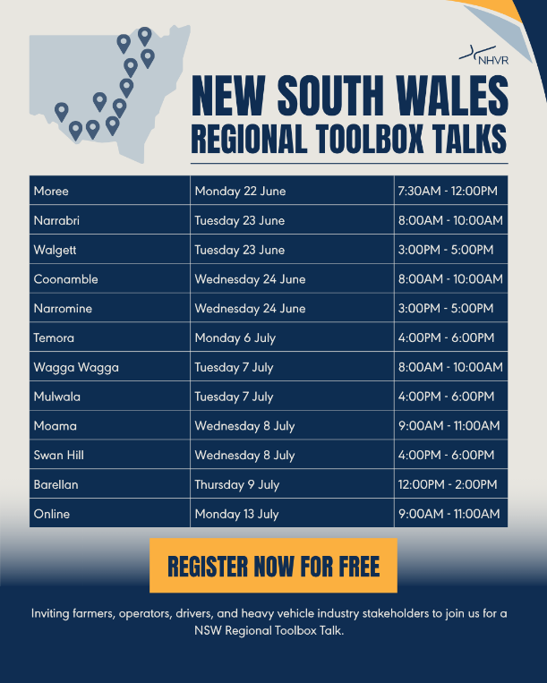
- Moree: June 22
- Narrabri: June 23
- Walgett: June 23
- Coonamble: June 24
- Narromine: June 24
- Temora: July 6
- Wagga Wagga: July 6
- Mulwala: July 6
- Moama: July 7
- Swan Hill: July 7
- Barellan: July 8
Please register at least one week before the event you plan to join for catering purposes.
If you are unable to attend these sessions, you can join the NHVR for an online session on July 13th. Register for the webinar at https://www.trybooking.com/au/event/1561517 and the session details will be sent to you
Please contact Bethany Magill – NHVR Stakeholder Engagement Officer for Inland NSW at bethany.magill@nhvr.gov.au with any questions.

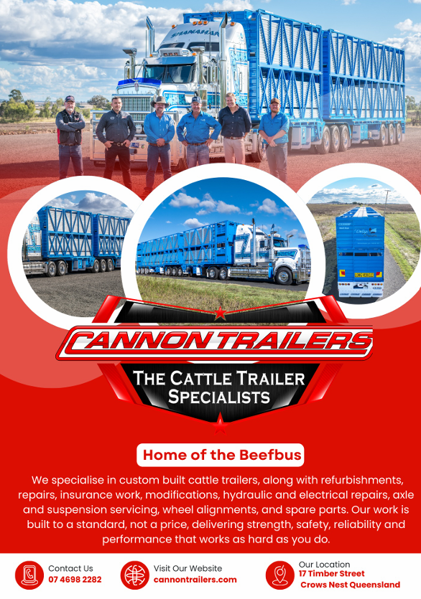

Victorian Bridge Funding Cuts Raise Serious Concerns for Rural Freight


The LBRCA has written to the Victorian Government following the release of budget performance measures showing a significant reduction in regional bridge strengthening and replacement works for the 2026-27 financial year.
According to the Victorian Government's budget papers, the target for regional bridge strengthening and replacement projects will fall from 22 bridges in 2025-26 to just seven bridges in 2026-27.
While governments are facing increasing budget pressures, LBRCA is concerned that reducing investment in freight-critical infrastructure will have long-term consequences for regional industries, supply chain efficiency and road safety.
For livestock, bulk and rural carriers, bridges are not simply pieces of infrastructure—they are critical links in the supply chain.
Every time a bridge is restricted, downgraded or unable to accommodate modern freight vehicles, operators face increased costs through detours, reduced payloads, additional truck movements and longer travel times.
Many members will be familiar with the frustration of navigating bridge restrictions that force freight onto less efficient routes or prevent access by High Productivity Freight Vehicles (HPFVs). These restrictions not only reduce productivity but can also create fatigue management challenges and increase road safety risks.
The funding cuts are particularly concerning given the significant investment operators have made in Performance Based Standards (PBS) vehicles and other productivity initiatives. There is little benefit in encouraging the uptake of safer and more productive freight vehicles if the supporting infrastructure cannot accommodate them.
The issue extends beyond Victoria. Across Australia, regional bridge infrastructure is ageing, and many assets are approaching or exceeding their intended design life.
The Australian Local Government Association's National State of the Assets Report identified billions of dollars’ worth of bridge assets in poor condition or lacking sufficient freight capacity.
LBRCA believes investment in regional freight infrastructure should be viewed as an investment in economic productivity.
Every tonne of livestock, grain, fertiliser, feed and agricultural inputs transported across Australia relies on safe and efficient roads and bridges.
What Has LBRCA Done?
Following the announcement, LBRCA:
- Issued a public media statement highlighting the impacts of reduced bridge investment on rural freight operators and regional communities;
- Wrote directly to Victorian Premier Jacinta Allan and Roads Minister Ros Spence expressing concern about the reduction in bridge strengthening and replacement works;
- Called on the Victorian Government to reconsider the scale of the reductions and maintain investment in freight-critical infrastructure;
- Requested the development of a long-term regional freight bridge upgrade program focused on productivity, resilience and future freight demand;
- Advocated for greater collaboration between government, local councils and industry to identify and prioritise critical freight bottlenecks; and
- Reinforced the importance of ensuring bridge infrastructure can support current and future access by PBS and High Productivity Freight Vehicles.
LBRCA will continue to monitor this issue closely and advocate for increased investment in regional freight infrastructure.
Reliable roads and bridges are essential to maintaining the efficiency, safety and competitiveness of Australia's livestock, bulk and rural transport industries.
Members who are experiencing bridge-related freight constraints, load restrictions or access challenges are encouraged to contact the LBRCA office so these issues can be incorporated into our ongoing advocacy efforts.

LBRCA Nominates Jenneke Matthewson for NSW Cattle Tick Consulative Committee
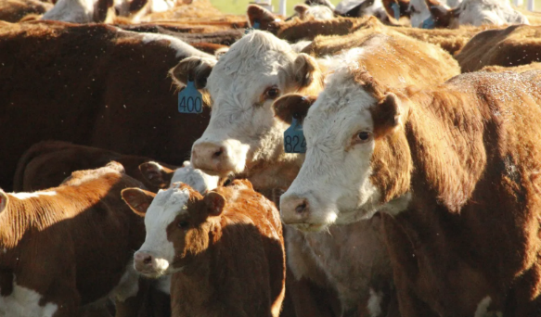
The LBRCA is pleased to announce that we have nominated long-standing member Jenneke Matthewson of BeefTrans to represent the Association on the NSW Cattle Tick Consultative Committee (CTCC).
The CTCC plays an important role in providing advice and industry input on cattle tick management, biosecurity policy and the practical impacts of cattle tick regulation on producers, transport operators and the broader livestock supply chain.
Jenneke and her husband John operate BeefTrans, a highly respected livestock transport business, while also maintaining their own cattle production enterprise. Their unique perspective as both livestock carriers and cattle producers provides valuable insight into the practical challenges faced by industry when managing cattle tick risks and complying with movement requirements.
With extensive experience across livestock production, animal welfare, biosecurity and cattle transport, Jenneke understands the significant impact that cattle tick management can have on producers, transport operators, saleyards and processors.
LBRCA believes it is essential that the practical experiences of transport operators are represented in discussions relating to cattle tick policy and management. Livestock carriers play a critical role in maintaining biosecurity while ensuring the efficient movement of livestock across regional and interstate supply chains.
Should her nomination be successful, Jenneke will provide a strong voice for LBRCA members and work to ensure that future cattle tick management strategies consider the practical, economic and operational impacts on rural transport businesses.
LBRCA thanks Jenneke for her willingness to represent the Association and contribute her expertise to this important industry committee. We look forward to keeping members informed of developments relating to cattle tick management and biosecurity policy across NSW.
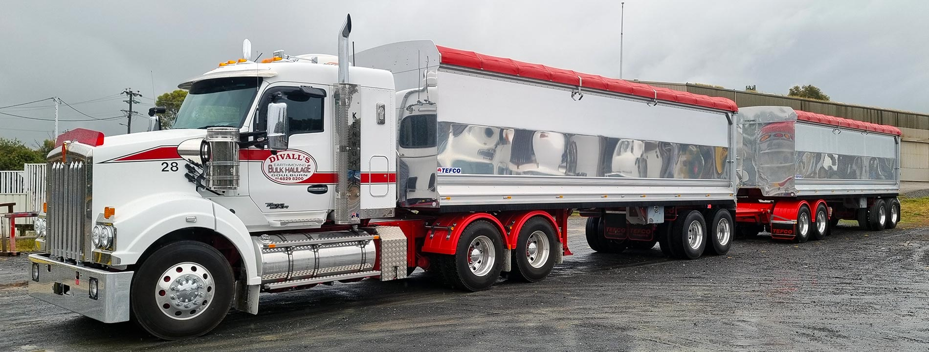
Contribute to the LBRCA PBS and HPFV Access Sub-Committee

The LBRCA is pleased to announce the establishment of a new Performance Based Standards (PBS) and High Productivity Freight Vehicle (HPFV) Sub-Committee to help drive practical improvements in heavy vehicle productivity, access and safety across the livestock, bulk and rural transport sectors.
PBS vehicles continue to play an increasingly important role in improving freight efficiency, reducing transport costs, enhancing animal welfare outcomes and supporting regional productivity.
However, many operators continue to face significant challenges relating to route approvals, first and last mile access, infrastructure constraints, permit delays and inconsistencies between jurisdictions and road managers.
To ensure the voice of rural transport operators is heard, the LBRCA Board has approved the formation of a dedicated PBS and HPFV Sub-Committee that will provide advice and recommendations to the Association on PBS and HPFV related policy, advocacy and operational matters.
The committee will focus on a range of key issues including:
- Improving first and last mile access for PBS and HPFV vehicles;
- Expanding access to saleyards, feedlots, grain receival sites and processing facilities;
- Addressing infrastructure constraints including bridge and road limitations;
- Supporting nationally consistent PBS policies and access frameworks;
- Identifying opportunities for High Productivity Freight Vehicle (HPFV) access;
- Working with government, the NHVR and road managers to remove unnecessary barriers to productivity; and
- Developing evidence-based policy positions that support both safety and efficiency outcomes.
The committee will operate in an advisory capacity to the LBRCA Executive and will include representatives from across the livestock, bulk and rural freight sectors.
Expressions of Interest
LBRCA is now calling for expressions of interest from members who would like to join the PBS and HPFV Sub-Committee.
We are particularly seeking members who:
- Operate PBS-approved and/or HPFV vehicles;
- Have experience with heavy vehicle access and route approvals;
- Are involved in livestock, grain, rural bulk or agricultural freight transport;
- Have an interest in improving productivity and access outcomes across regional Australia; or
- Are willing to contribute practical operational knowledge to support industry advocacy.
Participation will involve quarterly meetings (online where possible), reviewing policy proposals and providing practical industry feedback on emerging PBS and HPFV issues.
This is an excellent opportunity for members to directly influence LBRCA's advocacy agenda and help deliver meaningful improvements for the broader heavy vehicle industry.
Together, we can help ensure PBS and HPFV continues to deliver safer, more productive and more efficient freight outcomes for regional Australia.

Members interested in joining the PBS Sub-Committee are encouraged to contact the LBRCA office by emailing office@lbrca.org.au or contacting COO Bec Coleman to discuss their interest.

Contribute to the LBRCA Driver and Animal Welfare Sub-Committee

The LBRCA is pleased to announce the establishment of a new Driver and Animal Welfare Sub-Committee, reinforcing our commitment to supporting both the people and livestock that underpin Australia's rural transport industry.

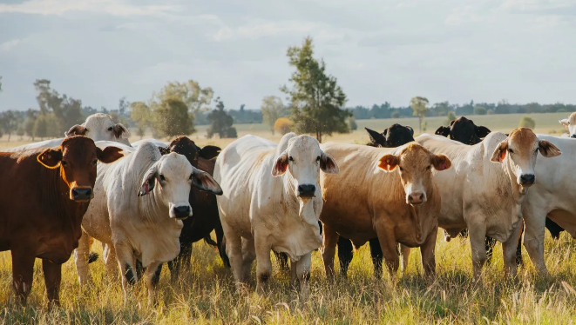
Driver welfare and animal welfare are two of the most important issues facing the livestock transport sector. Safe drivers, fit-for-purpose infrastructure, practical regulations and strong animal welfare outcomes are critical to maintaining community confidence, industry sustainability and the long-term success of our sector.

The new Sub-Committee has been established to provide a dedicated forum for members to identify challenges, develop practical solutions and help shape LBRCA's advocacy and policy priorities in these important areas.

The committee will focus on a broad range of issues including Driver health, wellbeing and mental health, access to rest areas, amenities and driver facilities, animal welfare regulations and standards, livestock loading, unloading and transport practices, saleyard, feedlot and processing facility infrastructure, emergency animal welfare responses during natural disasters and transport disruptions, industry education and community awareness; and emerging animal welfare and driver welfare policy developments.

The committee will work closely with industry stakeholders, government agencies, regulators, animal welfare organisations and transport operators to ensure the voices of livestock and rural carriers are represented in discussions that affect the industry.

Expressions of Interest Now Open

LBRCA is now seeking expressions of interest from members who would like to join the Driver and Animal Welfare Sub-Committee.

The committee will meet periodically throughout the year, primarily via online meetings, with opportunities to contribute to submissions, policy development and advocacy projects.

Members interested in joining the Driver and Animal Welfare Sub-Committee are encouraged to contact the LBRCA Secretariat or email office@lbrca.org.au to express their interest.
Reasonable Excuse: The defence that is winning permit offence cases

By Belinda Hughes, Hughes Law Pty Ltd
A number of cases have recently come before the courts where I have acted for companies charged with a "permit" offence under the Heavy Vehicle National Law.
These matters generally arise where a vehicle is detected breaching the rules and, because the company is the registered operator, it is prosecuted on the basis that it permitted the offending conduct.
The majority of these matters have been successfully defended by establishing either that the company had a reasonable excuse or that there was simply no evidence of permission.
So, what is a reasonable excuse?
The law does not demand perfection. It recognises that things can and do go wrong, and that not every breach warrants a criminal sanction.
While reasonable excuse is commonly raised as a defence in criminal matters, under the HVNL it also appears as an element of certain offences. In those cases, the prosecution must prove that the conduct occurred "without a reasonable excuse".
Where and how can it apply?
Take an overwidth offence as an example.
Where a company is charged with a permit offence, the NHVR may need to establish that:
- The company positively permitted another person to drive the vehicle, or had constructive knowledge of the conduct;
- The company failed to ensure compliance with the applicable dimension requirements; and
- The company did so without a reasonable excuse.
There is limited case law dealing with reasonable excuse in this context, but there are a number of factors that may be relevant when a court is determining whether a reasonable excuse exists.
These may include:
- Whether the company conducts regular audits to ensure loads comply with company policies, procedures, HVNL loading requirements, loading performance standards and the Master Code;
- The level of control or influence the company has over the driver or the load;
- Whether drivers and relevant workers receive training in loading and load restraint policies and procedures;
- Whether drivers are made aware of the load they are expected to carry so they can identify when a load differs from what was intended and take appropriate action;
- Whether the company regularly reviews its loading and restraint procedures to ensure the safest and most appropriate methods are being used.
There is no fixed rule as to what a court will accept as a reasonable excuse. The assessment is always made in light of the particular circumstances of the case.
We have achieved positive outcomes where companies had limited control or influence over the transport activity but were able to demonstrate robust systems, policies and procedures.
We have also had success where company directors gave evidence about the steps taken to ensure compliance. In some cases, the court accepted that those measures amounted to a reasonable excuse, resulting in the company being excused from liability under the Act.
For operators facing a permit offence, the focus should not only be on what went wrong, but on what systems were in place before the breach occurred.A breach does not automatically mean a conviction. If a company can demonstrate that it had appropriate systems in place and took reasonable steps to ensure compliance, there may be a defence available.
If you or someone you know wants more information or needs help or advice, call 0422 388 370 or 13004HUGHES or email info@hugheslaw.com.au.

Liability Limited by a scheme approved under Professional Standards Legislation.

More Green Reflector Rest Sites Delivered for Heavy Vehicle Drivers in the Upper Hunter

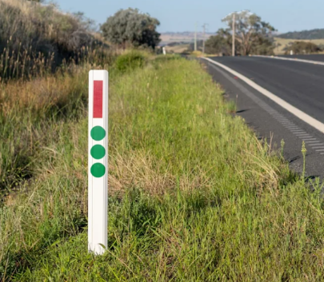
Heavy vehicle drivers travelling through the Upper Hunter now have greater access to informal rest stopping locations, following the installation of 10 new green reflector sites along key freight corridors.

The NSW Government has announced that new green reflector markers have been installed on sections of the Golden Highway and New England Highway to help truck drivers more easily identify suitable places to stop and rest.

The green reflectors are installed on roadside guideposts in the approach to informal heavy vehicle rest areas. They provide a simple visual cue to drivers that a safe place to pull over is nearby, which is particularly helpful when travelling at night or in poor visibility. The latest sites are located at:

Golden Highway, 6 kilometres east of Denman

Golden Highway, 4 kilometres east of Mount Thorley

Golden Highway, 10 kilometres east of Warkworth

New England Highway, 6 kilometres west of Ardglen

New England Highway at Liddell

New England Highway, 14 kilometres west of Liddell

New England Highway, 18 kilometres west of Liddell

New England Highway, 4 kilometres east of Muswellbrook

New England Highway, 3 kilometres north of Wingen

New England Highway, 1 kilometre south of Murulla

LBRCA welcomes practical initiatives that support driver fatigue management and improve safety for heavy vehicle operators. Access to safe and suitable rest areas remains a critical issue for livestock, bulk and rural carriers, particularly across regional freight routes where drivers often travel long distances and operate outside major centres.

For operators, the green reflector program provides a simple but effective way to improve awareness of rest opportunities and support safer journeys across NSW’s regional road network.

Meet Torin Young – Ampol Partnership and Association Manager

I joined Ampol in 2018 and have worked across a few different areas including, customer service, Gift card sales, B2B with a focus on Onsite Refuelling, and now AmpolCard solution sales.
For the past two years, I’ve been the Partnership and Association Manager, looking after our industry partnerships, including our relationship with the Livestock, Bulk and Rural Carriers Association (LBRCA).
I’m the main point of contact for LBRCA and love getting to know the people behind the business. Building strong relationships and helping customers find the right solutions is what I enjoy most especially supporting those in rural and regional NSW.
Before Ampol, I worked as a carpenter but knew it wasn’t something I could do long term. I’ve always been a problem solver, so moving into a more customer focused role, helping customers solve challenges made sense.
Outside of work, you’ll usually find me on the golf course, away in the caravan with friends and family, or cheering on North Melbourne in the AFL. What I enjoy most is connecting with people and knowing the work I do makes a real difference.
YOUR MEMBER BENEFIT
LBRCA members receive an exclusive off the pump price discount of up to 8.5 cents per litre (cpl) through AmpolCard at the time of purchase.

Apply at http://www.ampolcard.com.au with promo code LBRCA.
Contact: customerappsupport@ampol.com.au or call 1800 240 398.

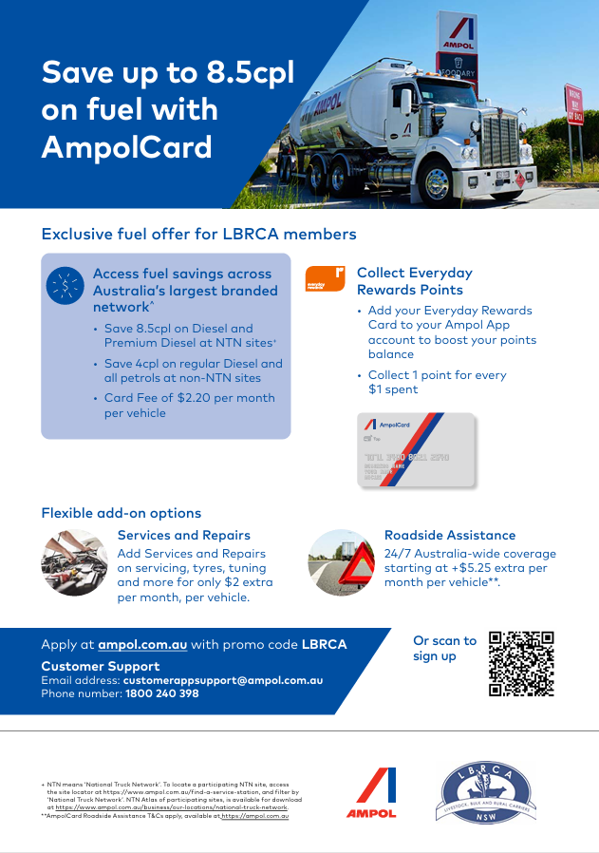

Mitchell Highway speed limit reduced between Dubbo and Wellington

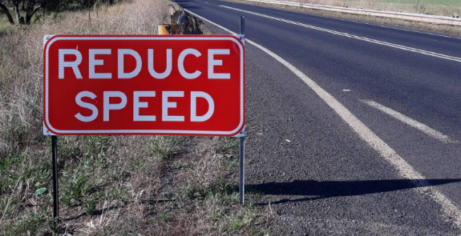
LBRCA members travelling on the Mitchell Highway between Dubbo and Wellington are advised that the speed limit on two sections of the highway will be reduced from 110 km/h to 100 km/h from Monday 22 June 2026.

Transport for NSW has confirmed the change follows a speed zone review of the highway between Dubbo, Geurie and Wellington, undertaken in response to safety concerns raised by road users and following the introduction of an updated speed zoning standard for NSW.

Transport for NSW Executive Director Damien Pfeiffer said the review considered a range of factors including crash history, road environment, access points, road usage, traffic mix and traffic volumes.

While the road environment is generally flat with good clearways, the reviewed sections are undivided and do not have physical separation between opposing lanes of traffic.

Transport for NSW reported that, over the most recent five years of complete data, there were 38 crashes within the 110 km/h sections of the highway, resulting in 38 people being injured and five fatalities.

The following changes will apply from Monday 22 June:

The speed limit will be reduced from 110 km/h to 100 km/h on a 14.1 kilometre section of the Mitchell Highway from just north of Saxa Road in Wellington to just south of The Old Road in Geurie.

The speed limit will be reduced from 110 km/h to 100 km/h on a 20.7 kilometre section from just north of Old Dubbo Road in Geurie to just south of South Buninyong Road in Dubbo.

The existing 50 km/h speed limit through Geurie will remain unchanged.

Transport for NSW has advised that the change will have no impact on heavy vehicles already operating under a 100 km/h speed limit.

Bilpin truck parking bay reopens on Bells Line of Road

LBRCA members travelling on Bells Line of Road are advised that the heavy vehicle-only parking bay near Bilpin has reopened, providing an additional rest option for drivers using the route.
The eastbound parking bay, located about seven kilometres east of Bilpin, reopened on Friday 5 June 2026 after Transport for NSW provided $45,000 to Hawkesbury City Council to prepare the site for reopening and support ongoing maintenance.
Its reopening follows calls from the freight industry for additional rest opportunities, particularly while the ongoing closure of Victoria Pass continues to place extra pressure on drivers and freight movements across the Blue Mountains.
The parking bay is for heavy vehicles only and has capacity for up to four heavy vehicles at a time. Rubbish bins are available on-site, however there are currently no toilets or seating.
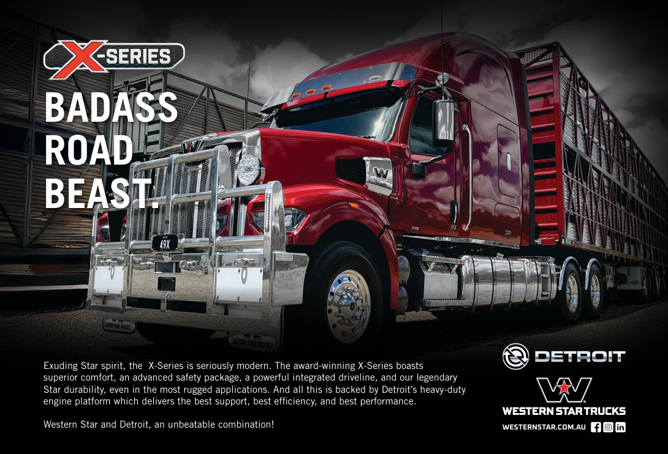
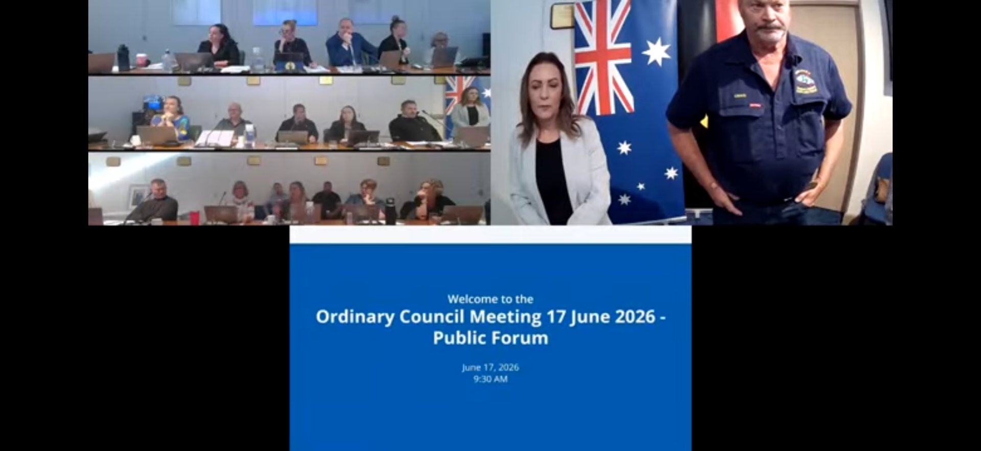
LBRCA Successfully Advocates Against Berrigan and Finley Truck Wash Fee Increase

LBRCA has successfully advocated on behalf of members to stop a proposed increase to truck wash charges at the Berrigan and Finley truck wash facilities.
Berrigan Shire Council had proposed increasing the truck wash charge from the current Avdata-listed rate of $1.36 per minute to $1.60 per minute as part of its draft 2026–2027 fees and charges.
LBRCA strongly opposed the increase, raising concerns about the lack of industry consultation, the significant cost impact on livestock transport operators, and the need for Council to undertake proper analysis of the actual cost-recovery requirements for both sites.
On Wednesday 17 June, LBRCA presented its case at a Public Forum held at the Berrigan Shire Council offices. LBRCA Chief Operating Officer Bec Coleman was joined by local operators Kelvin Baxter and Craig Congram, who spoke directly to Councillors about the practical impact the proposed increase would have on livestock carriers, local producers and the broader agricultural freight task.
LBRCA argued that truck wash facilities are not optional conveniences for livestock carriers. They are essential agricultural and freight infrastructure that support animal welfare, biosecurity, chain of responsibility obligations, workplace health and safety requirements, and processor hygiene expectations.
LBRCA also made clear that the proposed $1.60 per minute charge was for unfiltered water and was significantly higher than comparable unfiltered truck wash facilities across the Riverina region. LBRCA called on Council not to proceed with the increase and instead undertake a proper review of the true cost-recovery requirements for the facilities before setting any future charge.
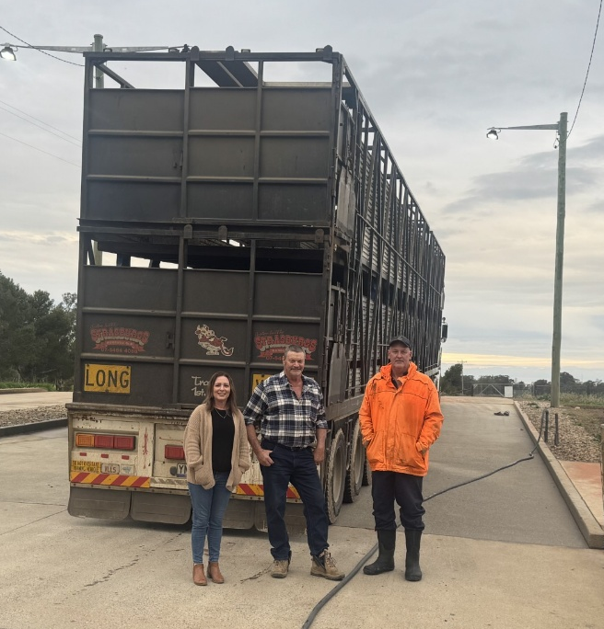
Following LBRCA’s presentation and advocacy, Berrigan Shire Council resolved not to proceed with the proposed increase from $1.36 to $1.60 per minute.
This is a strong and practical outcome for members.
LBRCA thanks Berrigan Shire Councillors for listening to industry concerns and recognising the need for a fairer, evidence-based approach to truck wash charges.
We also acknowledge the important contribution of Kelvin Baxter and Craig Congram, whose local knowledge and industry experience helped reinforce the real-world impact of the proposed fee increase.
LBRCA will continue to advocate for truck wash charges that are fair, transparent, proportionate and based on genuine cost recovery.
Truck wash facilities play a critical role in supporting livestock transport, agriculture, biosecurity, animal welfare and regional productivity.
Ensuring these facilities remain affordable and accessible is essential for the operators and communities that rely on them.

LBRCA welcomes new members
The LBRCA is pleased to welcome a number of new members who have joined the Association over the past four weeks. We extend a warm welcome to each of the new members listed below and thank them for choosing to be part of the LBRCA community.
Our members are at the heart of everything we do, and we look forward to supporting every regional transport business representing your interests, and working together to strengthen the livestock, bulk and rural transport sector.
Welcome aboard – we’re glad to have the following new members with us.
Brooks Haulage and Cattle Co | Moree, NSW
Jacob Livestock Transport | Scone, NSW
JKC Carrying Co | Scone, NSW
Kearney Logistics | Cobram, VIC
M Davis & S Davis | Scone, NSW
Mort & Co Transport | Pittsworth, QLD
Nodtrans Heavy Haulage | Teresa Park, NSW
Paul Hayter Livestock Transport | Goulburn, NSW
Phill & Fi Worldon Contracting | Gundagai, NSW
Prendergast Livestock | Alfredton, VIC
RW & KA Fitzgerald | Berremangra, NSW
Shazton Haulage | Mindaribba, NSW
Ward Livestock Transport | Cattle Creek, NSW

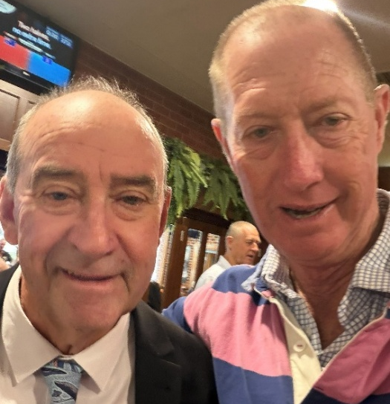
Member Catch Up
Tamworth
LBRCA Executive Member Stephen “Wilba” Haslem enjoyed catching up with Darryl ‘Dusty’ Russell in Tamworth last week. Dusty was awarded LBRCA’s Outstanding Contribution to Industry award at our 2026 Annual Conference held in Coffs Harbour in February this year.
Have Your Say: Review of Assessing Fitness to Drive Standards
LBRCA is encouraging members to provide feedback on the National Transport Commission’s (NTC) review of the Assessin g Fitness to Drive Standards.
The NTC has commenced the 2026–2028 review of the Standards, which are used to support medical and licensing decisions for drivers across Australia.
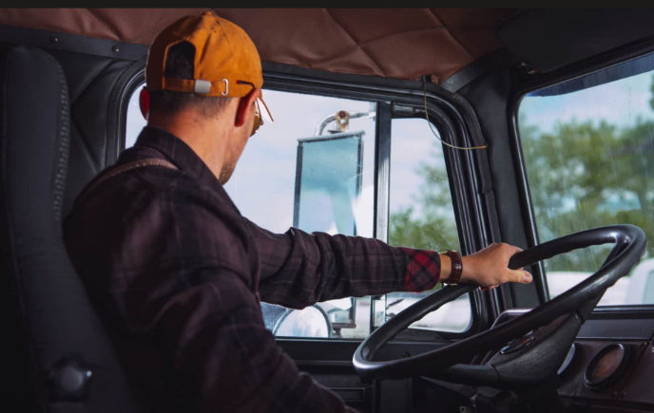
LBRCA understands the importance of maintaining strong safety standards on our roads.
However, it is equally important that the Standards remain practical, fair and workable for experienced heavy vehicle drivers and operators, particularly in regional, rural and remote areas where access to medical services can be limited and where the loss of a licence can have significant impacts on businesses, families and supply chains.
The NTC is currently seeking feedback on:
- issues relevant to the review, including opportunities for improvement;
- implementation challenges;
- emerging evidence; and
- areas requiring further investigation.
LBRCA is seeking input from members to help inform our response to the review. We are particularly interested in hearing from members about any practical issues they have experienced with fitness to drive assessments, medical review processes, licence conditions, delays, inconsistencies between jurisdictions, or challenges faced by older drivers and rural operators.
Members are encouraged to send their feedback to LBRCA as soon as possible so it can be considered as part of our submission.
Members can also make their own submission directly to the NTC via its website before Friday, 17 July 2026.
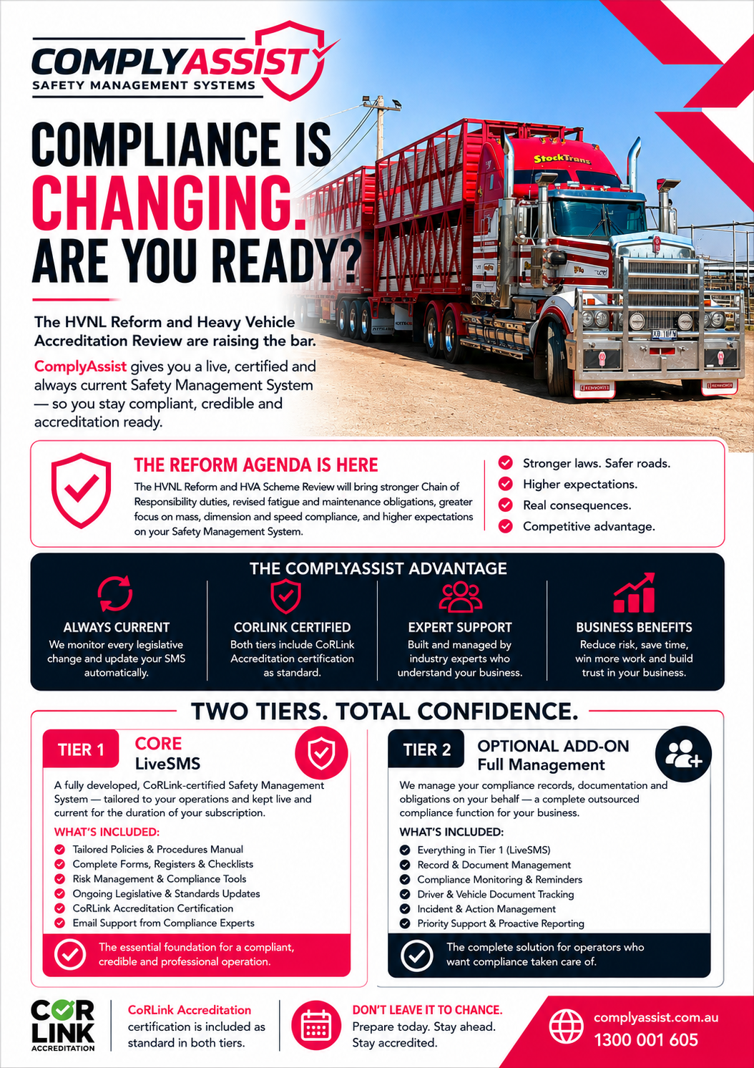

Your Compliance. Sorted. – Introducing ComplyAssist for Livestock and Bulk Rural Carriers
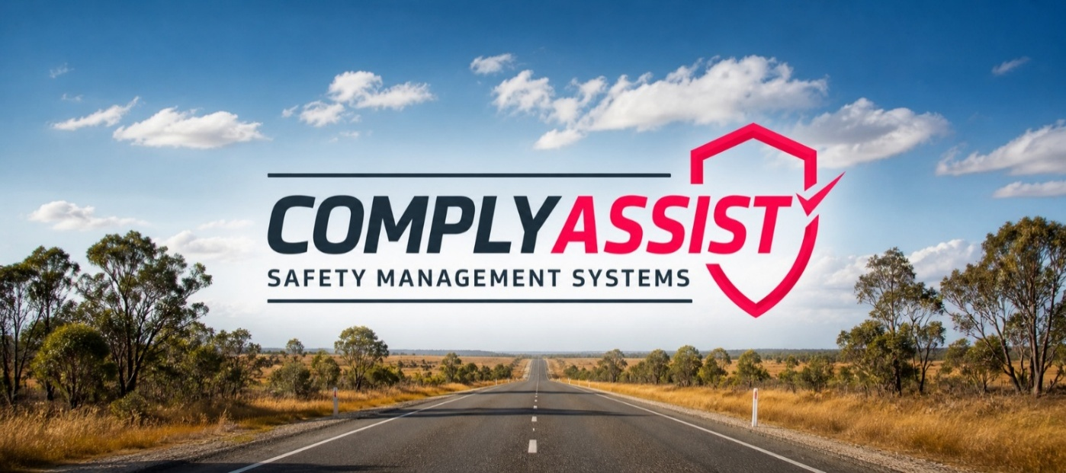
The clock is ticking on HVNL compliance. Here's how forward-thinking operators are staying ahead of the biggest regulatory shift in a generation.
If you're running stock or bulk across regional and rural Australia, you already know the roads are unforgiving. Long distances, variable loads, seasonal pressures, and the constant demands of keeping animals and product moving safely, it's a demanding operation at the best of times. Now add the most significant overhaul of heavy vehicle regulation since the Heavy Vehicle National Law was first introduced in 2013, and the compliance picture becomes considerably more complex.
The good news? There is a purpose-built solution, and it's changing the way operators approach their Safety Management System entirely.
The Reform Landscape: What Every Operator Needs to Know
The HVNL Reform program, progressed through the National Transport Commission (NTC) and the National Heavy Vehicle Regulator (NHVR), is fundamentally reshaping the obligations that apply to every operator on Australian roads. This is not incremental change. Key reform measures directly relevant to livestock and bulk rural operators include:
- Strengthened Chain of Responsibility (CoR) duties — Broader definitions of who constitutes a "responsible party" mean that everyone from the property owner loading livestock or grain, through to the transport operator and the end receiver, carries a share of the compliance burden. The expectation that you have documented systems in place to manage your part of that chain has never been higher.

- Revised fatigue management frameworks — With work and rest hour obligations and record-keeping requirements under ongoing review, operators running long-haul livestock and bulk routes face heightened scrutiny on driver fatigue management documentation.

- Updated vehicle standards and maintenance obligations — Defect management and roadworthiness records are under the microscope. For operators running large prime mover and trailer combinations on rural routes far from metropolitan maintenance facilities, having a structured, documented maintenance system is both a legal obligation and a practical safeguard.

- Mass, dimension, and loading compliance — Strengthened consignor and loader obligations place the documentation of load restraint, weight compliance, and livestock loading practices squarely within the compliance frame. For livestock carriers in particular, this intersects with animal welfare obligations, making thorough record-keeping doubly important.
Running in parallel with these legislative changes is a comprehensive review of the Heavy Vehicle Accreditation (HVA) Scheme — the framework under which most accreditation programs, including the National Heavy Vehicle Accreditation Scheme (NHVAS), operate. The revised scheme will place far greater emphasis on active, demonstrable safety management systems rather than point-in-time document submissions. The era of setting up an SMS and leaving it to gather dust in a filing cabinet is well and truly over.
The 1 August 2026 commencement of the new Heavy Vehicle Accreditation framework brings these changes into sharp relief. Operators holding current accreditation will be expected to demonstrate that their SMS is current, complete, and genuinely embedded in daily operations. Those who cannot may find their accreditation at risk, and with it, access to the contracts, routes, and hirer relationships that their business depends on.
Introducing ComplyAssist: Your Safety Management System — Live, Certified, and Always Current
ComplyAssist is a subscription-based Safety Management System service delivered under the CoRLink Accreditation Scheme, designed from the ground up to take the compliance burden off operators and place it in the hands of qualified professionals, permanently.
This is not a document package. It is not a consultant engagement that produces a folder of policies and then walks away. ComplyAssist is a living compliance function, continuously maintained, professionally certified, and always aligned to the current legislative framework.
How it works is straightforward. Every ComplyAssist subscriber receives a fully developed, CoRLink-certified Safety Management System tailored to their specific operations, their fleet type, their routes, their driver arrangements, and their business structure. That system is then kept live for the duration of the subscription. When the HVNL changes, when accreditation standards are revised, when your business grows or changes, your documentation is updated accordingly, automatically, at no additional cost.
For livestock and bulk rural operators, this means your Policies and Procedures Manual, your fatigue records, your pre-start checklists, your maintenance and defect registers, your load restraint records, your incident registers, and your driver training records are all professionally managed, version-controlled, and audit-ready, accessible at any time through a secure Operator Portal.
Two Tiers. One Goal: Peace of Mind.
ComplyAssist is structured across two service tiers, allowing operators to choose the level of support that suits their size and appetite.
Tier 1 — LiveSMS is the core subscription. It provides a fully developed, certified Safety Management System maintained continuously for a straightforward monthly fee. For the owner-operator running cattle and sheep across western New South Wales, or the small fleet hauling grain and fodder through the Riverina and Central West, this tier delivers enterprise-grade compliance infrastructure at a cost that makes sense.
Tier 2 — Full Management goes further. For operators who want to remove the compliance administration function from their business entirely, the Full Management add-on places your records management, regulatory monitoring, compliance reporting, incident documentation, driver and subcontractor records, and compliance calendar in the hands of the ComplyAssist team. You run your operation. We run your compliance.
Why the Subscription Model Changes Everything
The traditional model required operators to commission a consultant, pay a substantial upfront fee, receive a set of documents, and then somehow keep those documents current themselves as legislation evolved and their business changed. In practice, most purchased SMS products become outdated within 12 to 24 months. In a reform environment as active as the current one, that exposure is unacceptable.
ComplyAssist changes this fundamentally. No upfront capital outlay. No chasing updates. No periodic re-accreditation costs. No administrative burden on your team. A fixed monthly subscription that covers not just development, but the entire ongoing life of your Safety Management System.
Built for the Realities of Rural and Regional Transport
ComplyAssist understands that livestock and bulk rural carriers operate differently from metropolitan fleets. Longer runs. Remote loading points. Variable seasonal demands. Animal welfare obligations layered on top of transport compliance. Owner-drivers wearing every hat in the business.
That is precisely why a managed, continuously current SMS, delivered by professionals who understand the HVNL, the HVA Scheme, and the Chain of Responsibility inside and out, represents not just a compliance solution, but a genuine competitive advantage.
Your Safety Management System should be working for you. With ComplyAssist, it always is.
To find out how ComplyAssist can be tailored to your livestock or bulk transport operations, visit http://www.complyassist.com.au, call on 1300 001 605, or email to admin@complyassist.com.au.
Tier 1 LiveSMS subscriptions available now. Ask about Tier 2 Full Management for a complete compliance solution.

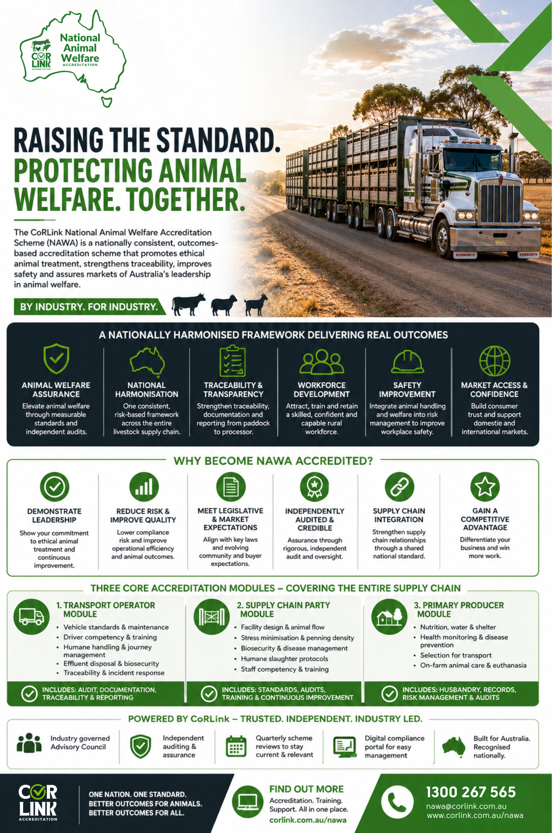

NHVR Updates Notices Ahead of HVNL Reforms
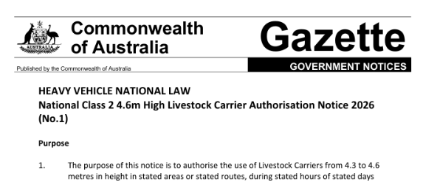
LBRCA members are advised that the NHVR is progressing updates to several heavy vehicle notices ahead of the amended Heavy Vehicle National Law commencing on 1 August 2026.
The updates are being made to ensure notices remain legally enforceable, accurate and aligned with the new legislation.
For most impacted notices, the changes are administrative only. These include updating terminology from Mass Management Accreditation to Alternative Compliance Accreditation (ACA) – Mass and removing references to Concessional Mass Limits (CML) where applicable.
The NHVR has advised that these administrative amendments are not expected to affect existing access arrangements or road manager consents.
Notices that remain in effect when the amended HVNL commences will be updated from 1 August 2026. Notices that are due for renewal will continue to be managed through the standard review process.
Several national and state-based notices will be impacted, including several that are relevant to livestock, grain and rural freight operators. These include the:
- National Class 2 Heavy Vehicle 4.6m High Livestock Carrier Authorisation Notice
- National Class 2 4.6m High and/or 25m Long Vehicle Carrier Authorisation Notice
- National Class 2 PBS Level 1 & 2A Truck and Dog Trailer Authorisation Notice
- New South Wales Class 3 Grain Harvest Management Scheme Mass Exemption Notice
- New South Wales Class 3 Converter Dolly Mass and Dimension Exemption Notice
- New South Wales Class 3 Zero Emission Vehicle Mass and Dimension Exemption Notice
The NHVR has also identified several notices that will require broader amendments or redrafting.
These will be provided to affected road managers for consent prior to publication. Notices requiring broader work include several Queensland and South Australian notices relating to farm gate grain transport, concessional mass limits, grain harvest, sugar and timber transport.
LBRCA will continue to monitor the update process closely to ensure important access arrangements for livestock, bulk and rural carriers are maintained through the transition to the amended HVNL.
LBRCA will be watching to ensure there are no unintended changes to network access, mass entitlements, vehicle eligibility or road manager consent arrangements as terminology is updated and notices are republished.
Members operating under affected notices should familiarise themselves with the updated instruments once they commence on 1 August 2026 and ensure accreditation, permit and access requirements remain current.
Members with questions or concerns about how the notice updates may affect their operations are encouraged to contact LBRCA or call the NHVR Contact Centre on 13 NHVR (13 64 87).

Tax for Truckies: Tax Tips
By Michael Gallagher, Tax for Truckies
Overtime Meal and Travelling Allowance
There are misinformation and confusion in this area.
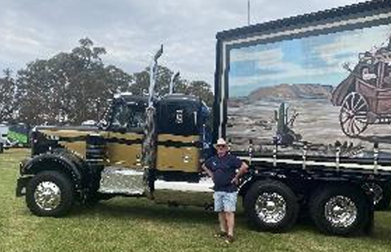
The interaction between travel allowances, substantiation rules, reasonable amounts, and the (Commissioner of Taxation v Daniel Shaw (2026) FCA197) (Shaw) has caused considerable discussion among tax practitioners because the AAT and Federal Court decisions were not fully aligned with the ATO's historical administrative approach.
Michael Gallagher at the Castlemaine Truck Show in Victoria

The decisions in Shaw differed from the Commissioner's position regarding the evidence required to establish deductible meal expenses where the employer paid a travel allowance.
What Shaw confirms is that:
The reasonable amounts allowed in TD 2025/4 are not automatic deductions.
ATO TD 2025/4 does not create an automatic deduction entitlement. Taxpayers must still establish that deductible expenses were actually incurred. Shaw is significant because both the MG 2026 Tax Tips for Truckies Tribunal and later the Federal Court accepted that the taxpayer could establish expenditure through evidence other than a complete set of receipts. Evidence included:
- travel records;
- bank statements;
- work patterns;
- credible oral evidence;
- employer allowance arrangements


- If an employer fully reimburses an expense, the employee has not borne the cost and generally cannot claim a deduction for that expense. In Shaw, the taxpayer received a travel allowance, not a reimbursement. The distinction is important. A travel allowance may support a deduction claim, whereas a reimbursement generally removes the employee's entitlement to a deduction.
- If no travel allowance is received, then there may be no substantiation exception, and the taxpayer must prove the expense was incurred and work-related.
- Full receipts may not always be required where a substantiation exception applies and there is other persuasive evidence that the expenditure was incurred. However, taxpayers should retain as much documentary evidence as possible, including receipts, bank statements, travel diaries, logbooks and employer records.
Good Practices: Keeping a detailed diary or log of trips and meals, along with bank and credit statements, can help support deductions and reduce the risk of ATO challenges.
Superannuation and Self-Funding Contributions
The concessional contributions cap was $30,000 for 2024–25 and remains $30,000 for 2025–26.
Under the carry-forward concessional contribution rules, an individual can contribute and claim more than the annual cap if:
- They have unused concessional cap amounts from the previous five financial years; and
- Their total superannuation balance was less than $500,000 at the previous 30 June. Some taxpayers with substantial unused concessional cap amounts accumulated over several years can contribute and claim well over $100,000.
However, not every truck driver or employee will qualify. It depends on:
- Available carry-forward caps;
- Total super balance being under $500,000; and
- Having sufficient taxable income to make the deduction worthwhile.
In some cases, a large deductible super contribution can produce a substantial tax refund.
Since the removal of the old "10% rule," both employees and self-employed taxpayers can claim deductions for personal concessional contributions, provided all requirements are met.
Concessional contributions are generally taxed at 15% within the fund.
Division 293 tax imposes an additional 15% tax on concessional superannuation contributions for individuals whose income exceeds the Division 293 threshold.
For the 2025–26 income year, the threshold is $250,000. Broadly, if your:
- Taxable income,
- Reportable fringe benefits,
- Net investment losses,
- Reportable employer super contributions, and
- Low-tax super contributions – ($30,000)
combine to exceed $250,000, Division 293 tax may apply.
The effect is that concessional contributions are taxed at:
- 15% in the super fund for most people; and
- 30% in total (15% contributions tax + 15% Division 293 tax) on the affected contributions for higher-income earners.
Summary
Superannuation remains one of the most effective tax-planning opportunities.
The concessional contributions cap is $30,000 for 2024–25 and 2025–26.
Taxpayers may be able to claim deductions for contributions above this amount using the carry-forward concessional contribution rules, provided they have unused concessional cap amounts from the previous five financial years and their total superannuation balance was less than $500,000 at the previous 30 June.
In some cases, individuals can make deductible contributions exceeding $100,000 and obtain substantial tax savings.
This opportunity is available to both employees and self-employed taxpayers.
Concessional contributions are generally taxed at 15% within the superannuation fund, and normal fund fees may also apply.

Super Funds and Property
Self-Managed Superannuation Funds (SMSFs) can provide greater flexibility and control over investment decisions than many industry and retail superannuation funds. However, SMSFs also involve significant trustee responsibilities and compliance obligations.
SMSFs may allow members to invest directly in property, shares and other assets, subject to superannuation law requirements. In some circumstances, SMSFs can also provide greater control over estate planning and the payment of death benefits.
We have assisted clients at their request, including truck drivers, to establish SMSFs where they can invest in property where this strategy was appropriate to their circumstances. As with any superannuation strategy, professional advice should be obtained before proceeding.

SMSFs offer significant flexibility in investments, but the rules surrounding property, borrowing, pensions, death benefits and related-party transactions are complex, and professional advice should always be obtained before implementing a strategy.
Be ‘Bearing’ – Seek Professional advice and consider starting up your own SMSF. It is not a best fit for everyone
- Keep Records of Work-Related Expenses
The strongest tax deductions are those supported by records. Retain:
- Receipts and invoices
- Bank and credit card statements
- Logbooks and trip records
- Work diaries
- Employer correspondence where relevant
The ATO expects you to be able to show both that you incurred the expense and that it was work related.
- Overnight Travel Expenses
If your work requires you to sleep away from home overnight:
- Meal and accommodation expenses may be deductible.
- Receiving a travel allowance does not automatically entitle you to a deduction.
- You must still be able to demonstrate that deductible expenses were actually incurred.
The recent Shaw v Commissioner of Taxation decision reinforced the importance of proving expenditure rather than simply relying on the allowance received.
- Protective Clothing and Safety Equipment
You may be able to claim deductions for:
- High-visibility clothing
- Steel-capped boots
- Protective gloves
- Safety glasses
- Sunscreen and protective gear used for work
Conventional everyday clothing is generally not deductible.
- Union Fees and Professional Memberships
Membership fees paid to:
- Transport unions
- Industry associations
- Professional bodies
are often deductible.
- Phone and Internet Expenses
If you use your personal phone or internet for:
- Dispatch communications
- Electronic logbooks
- Route management
- Work-related phone calls
you may be able to claim the work-related portion.

- Self-Education
Training directly related to your current employment may be deductible, including:
- Heavy vehicle licence upgrades
- Dangerous goods accreditation
- Industry compliance courses
- Fatigue management training
- Superannuation Contributions
Many truck drivers overlook one of the largest tax-saving opportunities available.
You may be able to make additional concessional superannuation contributions and claim a tax deduction. For many taxpayers:
- The annual concessional cap is $30,000.
- Unused cap amounts from previous years may be available.
- Significant tax savings can be achieved through careful planning.

- Consider an SMSF Carefully
For drivers interested in property investment:
- An SMSF may provide greater control over investments.
- Commercial and residential property investments may be possible.
- Borrowing arrangements can be available through specialised structures.
However, SMSFs involve substantial trustee responsibilities and are not suitable for everyone.
- Owner-Drivers: Review Asset Purchases Before 30 June
If you operate your own business, consider:
- Truck purchases
- Trailers
- Equipment
- Workshop tools
- Technology upgrades
Timing purchases before year-end may affect depreciation deductions and cash flow.
- Review Your Structure Regularly
As income grows, it may be worthwhile reviewing whether operating as:
- A sole trader,
- Through a company, or
- Through a trust structure continues to be appropriate.

- Don't Ignore Small Deductions
Many truck drivers miss legitimate deductions such as:
- Parking related to work duties
- Tolls
- Work-related stationery
- GPS subscriptions
- Electronic logbook subscriptions
- Industry publications
- Tools
- Truck washing
- Stationery - logbooks

- Tax Planning Before 30 June
The best tax savings usually occur before year-end, not after it. Consider:
- Additional super contributions
- Timing of deductible purchases
- Collection of outstanding debts (owner-drivers)
- Review of trust distributions and company dividends where relevant
A brief tax-planning review before 30 June can often identify opportunities that are unavailable once the financial year has ended.
About Michael
Michael Gallagher is Principal of Tax for Truckies. He is a Certified Practising Accountant, Chartered Tax Adviser and a Registered Tax Agent. He is a fellow of the Taxation Institute of Australia and holds a Master of Taxation degree from the University of New South Wales.
Phone:1300 263 260 or 0408 149 250 Email: michael@taxfortruckies.com.au


Safer Local Roads and Heavy Vehicle Rest Area
Fuel Relief Ending 1 July: What Members Need to Know

LBRCA is continuing to advocate for members as the Federal Government’s temporary fuel relief measures are due to end on 30 June 2026.
During the recent fuel crisis, the Federal Government reduced fuel excise and cut the Heavy Vehicle Road User Charge (RUC) to zero for the period 1 April to 30 June 2026.
This provided short-term relief for heavy vehicle operators at a time of significant fuel price pressure and supply uncertainty.
From 1 July 2026, normal fuel tax credit arrangements are expected to resume, including the reinstatement of the Heavy Vehicle Road User Charge.
While the next scheduled increase in the charge has been deferred until 1 January 2027, the return of the existing charge from 1 July will still increase the effective cost of diesel for operators.
For LBRCA members, this means fuel costs are likely to rise again at a time when many businesses are already managing tight margins, high operating costs, driver shortages and increasing compliance pressures.
LBRCA’s position is clear: rural freight operators should not be hit with a sudden cost cliff.
Livestock, bulk and rural carriers kept freight moving throughout the fuel crisis. Our members continued transporting livestock, grain, fodder, fertiliser, fuel and essential supplies across regional and remote communities. These costs cannot simply be absorbed by transport businesses.
LBRCA has raised these concerns with government, regulators and national industry bodies. We are making it clear that fuel cost increases flow through the entire supply chain — from transport operators to producers, processors, regional businesses and consumers.
We have sought that the Federal Government consider extending the temporary RUC relief and phase the charge back in gradually.
Members should now review their own business arrangements and prepare for the 1 July change.

This includes:
- speaking with your accountant or tax adviser about fuel tax credit changes;
- checking BAS calculations use the correct fuel tax credit rates;
- reviewing fuel levy clauses in contracts;
- communicating early with customers about fuel cost increases;
Members are encouraged to contact LBRCA with examples of how the 1 July changes will affect their business, including impacts on cashflow, freight rates, customer contracts and regional supply chains.
Your feedback helps strengthen LBRCA’s advocacy and ensures government understands the real impact on rural freight operators.
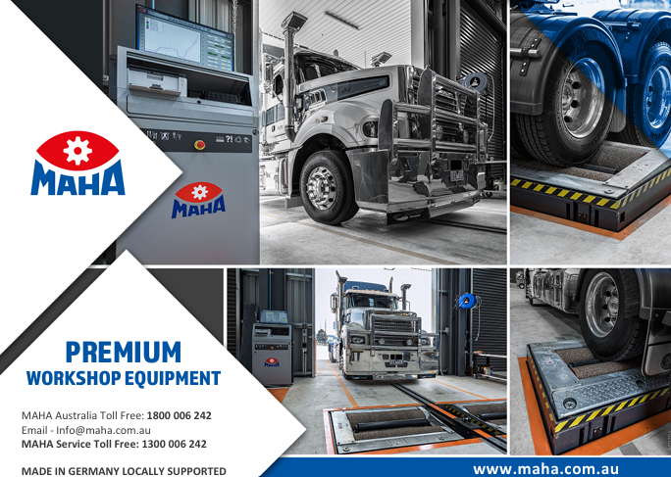

Five Things Worth Knowing Before You Finance Your Next Truck or Trailer

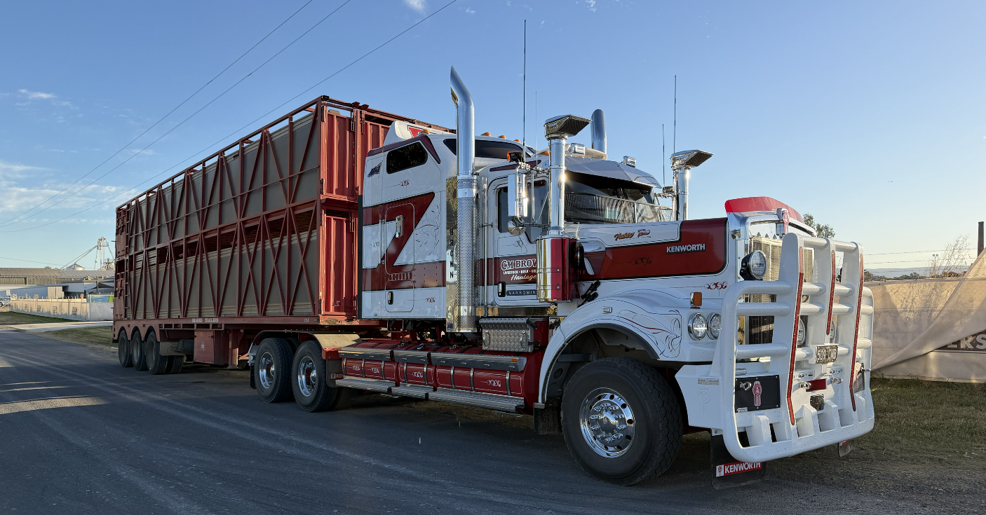

Margins in transport have never been tighter. Fuel, tyres, insurance, registration - every line on the P&L is under pressure. So, it's worth making sure the finance on your trucks and trailers is as low cost and as easy as it should be. A few simple things, understood early, can make a real difference to your cashflow and your flexibility down the track.

The finance offered by the manufacturer or dealer is a starting point, not a final answer.

It's convenient, and sometimes it's competitive. But it's one option from one source. You can't know if you're getting a good deal until you've seen what else is available.

There are around ten genuinely competitive finance companies would compete your business.

That competition can work in your favour by maximising the chance of lower rates and better conditions.

Having all your debt with one bank is worth thinking carefully about.

When a single bank holds a General Security Agreement over your business, they have a claim over your assets.


Most owners don't fully appreciate what that means until the bank has leverage, they'd rather it didn't have. Spreading debt across more than one lender reduces that exposure and gives you more room to move when things get tight.

Low doc finance is more accessible than most people think.

If last year's financials don't reflect the true strength of your business (which happens often in transport) there are lenders who will look at providing competitive finance without the need for full financial assessment. Very different to the documentation a bank would typically require. Additionally, it’s not unusual for a truck to be financed with one lender, the A trailer with a second, and the B trailer with a third - each structured separately to get the best available terms.

A good finance broker creates competition between lenders on your behalf.

They know what a strong approval looks like, they negotiate the conditions as well as the interest rate, and they stay across your situation over time. When business gets difficult, as it sometimes does, having someone who understands your history, wants to be assisting you for the next 20 years and knows how to talk to lenders is genuinely useful.

Finlease has been working with transport businesses since 1989. Single-truck operators through to large fleets, we've seen it all. With access to 30+ lenders, we handle new and used equipment, dealer and private sales, capital raises, and working capital facilities, with no age restrictions on assets.

If you have a finance question, or a quote you'd like a plain-English second opinion on, it's worth a conversation. No obligation. And if the deal you already have is the right one, that's exactly what we'll tell you.

Michael Abberton

Equipment Finance Specialist

mabberton@finlease.com.au | 0488 480 463

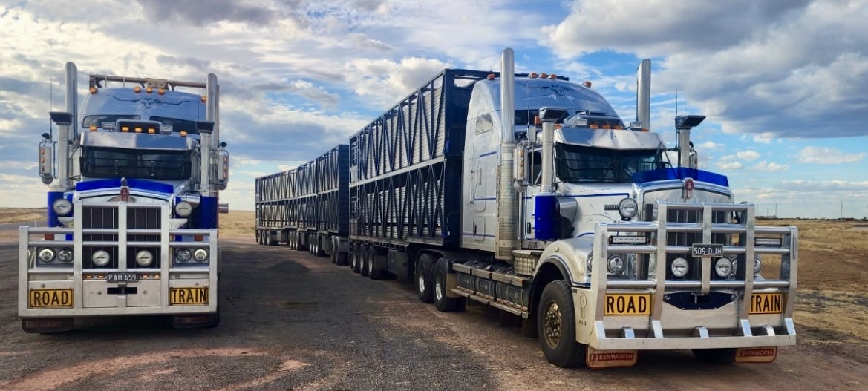
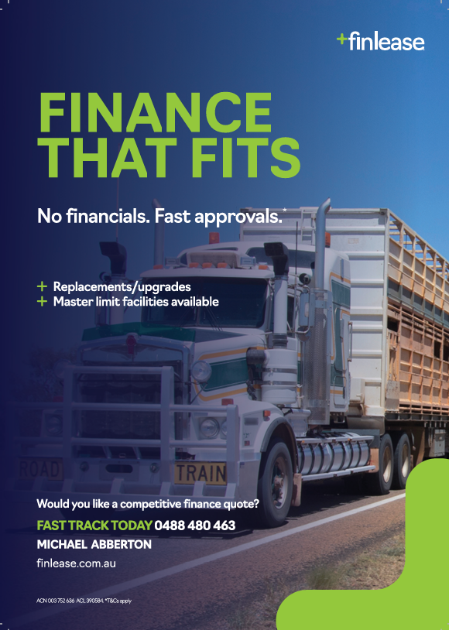
Notice of LBRCA Member Meeting – Tamworth Saturday 1 August

LBRCA members are invited to attend a member meeting in Tamworth on Saturday 1 August.
The meeting will provide an opportunity for members to come together, discuss current industry issues, receive updates on LBRCA’s advocacy work, and raise matters affecting livestock, bulk and rural carriers.
Meeting details
Date: Saturday 1 August 2026
Time: 9.30am – 2.30pm
Venue: McCulloch Bulk Haulage, 1 Workshop Lane Westdale
A member dinner will also be held on the Friday evening.
Dinner details
Date: Friday 31 July 2026
Time: 6.00pm
Venue: Wests Tamworth
An agenda for the member meeting will be sent separately.
Members are encouraged to attend and take the opportunity to contribute to discussions on the key issues impacting our industry.
RSVP to the LBRCA Secretariat by emailing office@lbrca.org.au or calling 0432 336 718 by Wednesday 29 July.


2026 LBRCA Executive Committee
The Annual General Meeting of the LBRCA was held on Saturday 28 February, in conjunction with the LBRCA Rural Carriers Convention.
During the meeting, members reviewed the Association’s progress over the past year and formally elected the Executive Committee for the coming term, reaffirming the organisation’s commitment to strong leadership and continued advocacy for rural and regional transport operators.
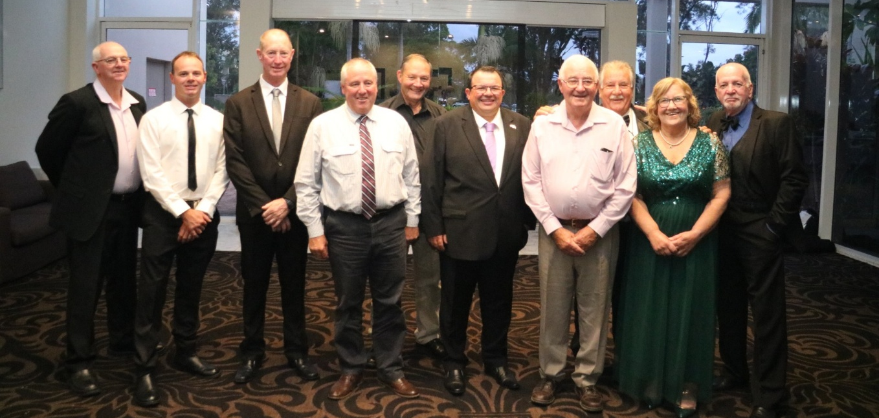
President | Wade Lewis | 0477 609 070
Vice President Livestock | Lynley Miners | 0412 780 673
Vice President Bulk | Kelvin Baxter | 0428 575 059
Treasurer | Alan McKenzie | 0418 147 961
Secretary | Tracey Boschetti | 0427 820 715
Regulator Representative | Timmy Mitton | 0439 267 645
Sponsorship Representative | Stephen Haslem | 0428 669 542
Young Driver Representative | Jack Cooke | 0475 425 648
Livestock Fleet Operator | Peter Dawson | 0428 695 529
Livestock Fleet Operator | Joe Sepos Snr | 0428 497 781
Bulk Fleet Operator | Andy Divall | 0427 298 200
Bulk Fleet Operator | Lyndon Jay | 0417 287 027

